FOR IMMEDIATE RELEASE
APRIL 9, 2021

LIL EAZZYY RECRUITS LABELMATE BIZZY BANKS FOR “HUNNID OR BETTER”
STREAM: LILEAZZYY.LNK.TO/HUNNIDORBETTER
WATCH: LILEAZZYY.LNK.TO/HUNNIDORBETTERVID

CHICAGO RAPPER REVEALS 4/30 RELEASE OF MAJOR LABEL
DEBUT MIXTAPE ROOKIE OF THE YEAR
PRE-ORDER HERE

UNDERRATED EP NOW STREAMING
LILEAZZYY.LNK.TO/UNDERRATED

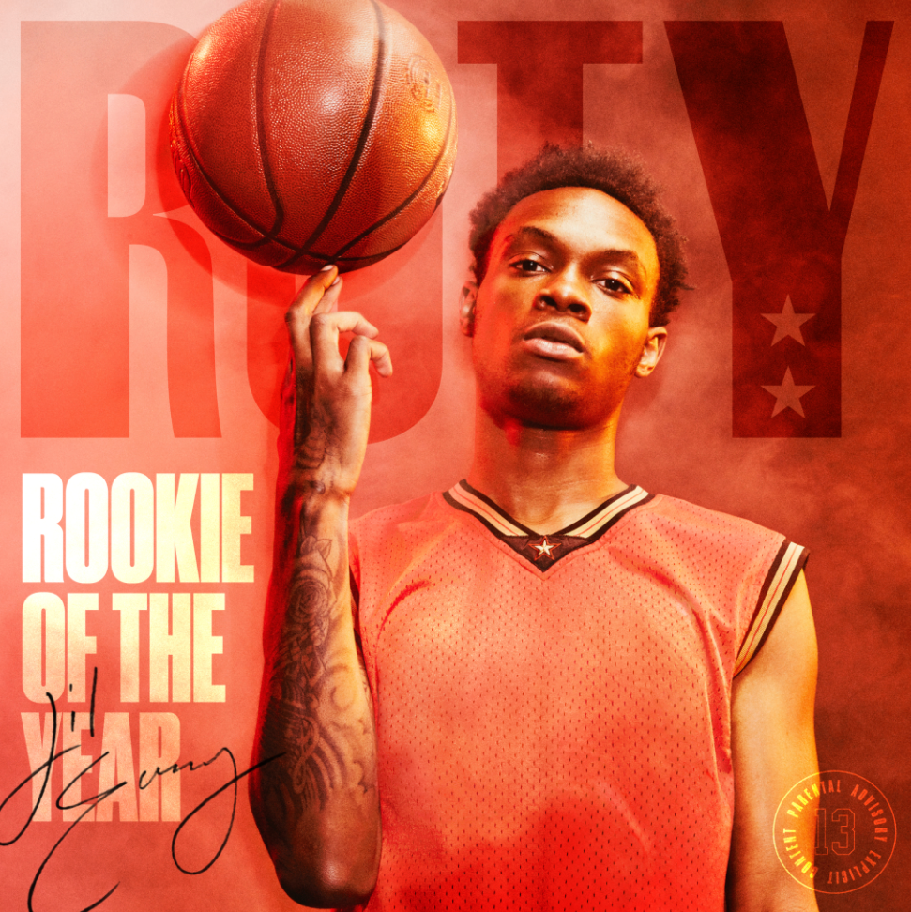
DOWNLOAD HIGH-RES COVERART

“The new movement of voices for the Chicago streets is in full swing, and Lil Eazzyy is chief among them.”
COMPLEX: Rappers to Watch in 2021

“Eazzyy raps in rolling, rapid, and sometimes melodic cadence that other journalists have compared to Polo G and G Herbo. You can hear shades of both fellow Chicagoans in that respect, but Eazzyy raps with such polish and athleticism that similarities fade. You’re only focused on catching every bar.
SPIN: Blue Chips Column

Chicago rapper Lil Eazzyy recruits labelmate Bizzy Banks for the debut single “Hunnid or Better” off his major label debut mixtape Rookie of the Year. The single comes alongside an official video, available to stream HERE. Rookie of the Year will drop April 30th and is available for pre-order HERE.

Currently in the running for XXL’s Freshman Class, Lil Eazzyy dropped his critically-acclaimed initial offering Underrated at the tail-end of 2020, which features the massive breakthrough hit “Onna Come Up.” It lit the fuse for the project by reaching 1 million streams per week in September 2020 and continues to trend upward on the Spotify US Top 200 while amassing over 65 million streams to date. The track was featured in video montages by top Fortnite players such as Chronic Hazard, Cultures, Yusa, Keeny, Fakeify, and more. Underrated also features the pensive yet poetic victory lap “Finally Rich” alongside powerful tracks like “Feeling Different,” “Activated” and more. Each track is accompanied by an official video, available to stream via YouTube. The Chicago rapper covered prominent playlists such as Spotify’s Rap Caviar and Most Necessary, Tidal’s Viral Hype and New Midwest, Amazon’s Breakthrough Hip Hop. Spotify’s premier playlist Rap Caviar named him one of the top ten artists to watch in 2020.

The new year saw Lil Eazzyy team up with fellow Chicago native G Herbo for the “Onna Come Up Remix,” racking up more than 26.2 million streams and over 2 million views of its official video. Most recently IV JAY jumped on Lil Eazzyy’s “Yes Or No,” which quickly follows his latest freestyle, where he showcased his rapid spitfire ability over a haunting production. All three tracks will be featured on his upcoming mixtape Rookie of the Year.

For additional information + press assets, visit his press site HERE.
PHOTO CREDIT: thatgoodwork productions

CONNECT WITH LIL EAZZYY
TWITTER | INSTAGRAM | SPOTIFY | YOUTUBE | SOUNDCLOUD

LIL EAZZYY PRESS CONTACT
BRITTANY BELL
BRITTANY.BELL@ATLANTICRECORDS.COM

