FOR IMMEDIATE RELEASE
APRIL 17TH, 2020

ISSA RAE’S RAEDIO, ATLANTIC RECORDS AND HBO® DROP LATEST SINGLE OFF FORTHCOMING
INSECURE®: MUSIC FROM THE HBO ORIGINAL SERIES, SEASON 4 SOUNDTRACK

MEMPHIS RAPPER JUCEE FROOT RELEASES HIGHLY-ANTICIPATED NEW TRACK “EAT ITSELF”
TO BE FEATURED ON SECOND EPISODE OF INSECURE SEASON 4
SUNDAY, APRIL 19TH ON HBO®

BRAND NEW AND EXCLUSIVE TRACKS TO BE RELEASED WEEKLY AHEAD OF EACH EPISODE

SOUNDTRACK SET FOR A SUMMER RELEASE

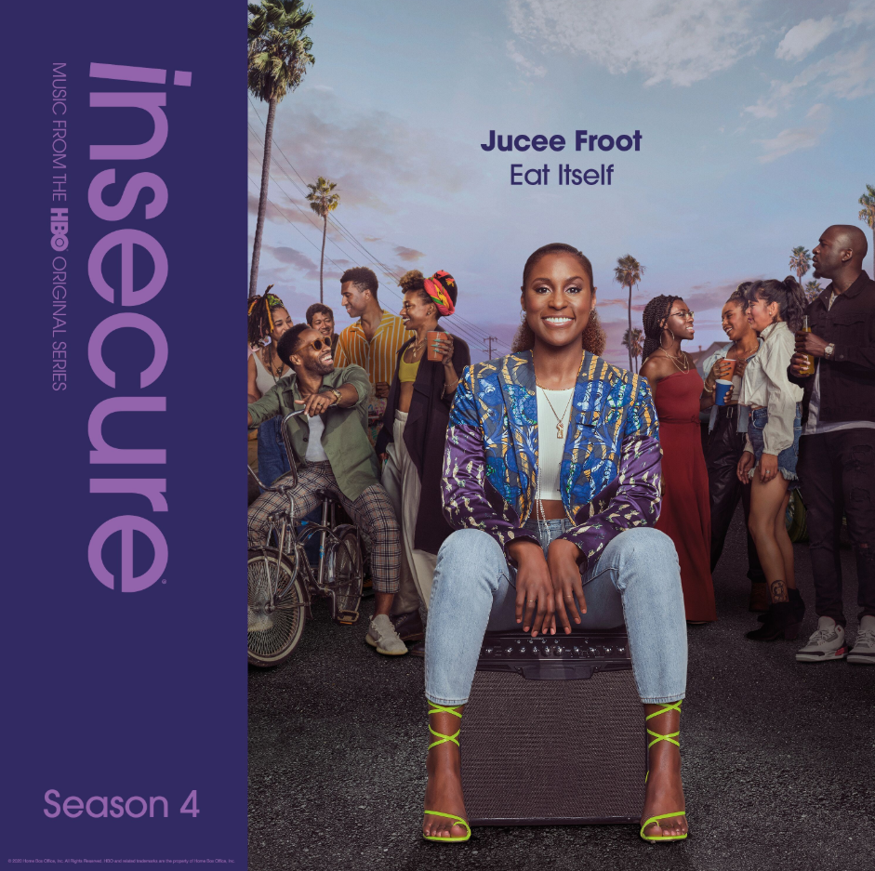
DOWNLOAD HIGH-RES COVER ART HERE

Raedio, the new label founded by EMMY® Award-nominated and two-time Golden Globe® Award-nominated writer, producer, and actress Issa Rae, Atlantic Records and HBO announced last week the forthcoming arrival of INSECURE: Music From the HBO Original Series, Season 4 soundtrack. The official companion music will set the mood each week for the award-winning HBO series, INSECURE. The soundtrack is guaranteed to elevate the bar for music culture and will arrive later this summer. This week’s soundtrack release features Loyal 100 Entertainment/Art@War/Atlantic Records recording artist Jucee Froot’s irresistible new track, “Eat Itself,” now available to stream and download. Listen for it during this Sunday’s second episode of INSECURE Season 4 at 10:00 p.m. (ET/PT) on HBO® . The series will also be available on HBO NOW, HBO GO, HBO On Demand and partners’ streaming platforms.

Last week’s launch was highlighted by the release of Cautious Clay’s “Reaching” (Feat. Alex Isley) and St. Panther’s “Infrastructure,” – both featured in the INSECURE Season 4 debut episode, while Yung Baby Tate’s “Never Lonely” (Feat. Jozzy) was featured on the INSECURE Season 4 trailer streaming now on HBO HERE. Issa Rae spoke exclusively to HYPEBEAST, detailing her curation process and the soundtrack formation.

“I absolutely love working on the music for INSECURE and this season is no different. Not only did we continue to select songs that elevate our storytelling, but we also had artists and songwriters create original music for the season. The soundtrack is the perfect mix of some of my favorite songs from the season and I'm excited to share it with fans of the show,” says Issa Rae.

“Atlantic Records is excited to partner with Issa Rae, Raedio and HBO to break new ground together by releasing an array of exclusive music each week in connection with this season of INSECURE,” says Kevin Weaver, Atlantic Records President, West Coast. “Issa Rae is a cultural icon, a unique tastemaker and a creator of tomorrow’s trends. We believe this series, and this new season of the show, are the perfect vehicle to support her musical vision to curate and A&R music from a diverse arsenal of incredibly special artists that speak so uniquely to the series she has created.”

"Every season we work really hard to get the freshest new music from artists we are excited for our audience to discover,” says INSECURE Music Supervisor, Kier Lehman. “I'm really excited because this season has the best soundtrack we've ever put together."

INSECURE: Music From the HBO Original Series, Season 4 will feature brand new tracks from a diverse array of major artists and rising stars.

ABOUT JUCEE FROOT
Jucee Froot has quickly become a vital presence in hip-hop, an honest voice equally hailed for her fearless approach as well as her bulletproof bars, confessional choruses, and clever adlibs. The Memphis, TN-based rapper earned every bit of that acclaim and now has a major label deal with Loyal 100 Entertainment/Art@War/Atlantic Records. Tracks like “Life’s A Bitch,” an electric “Psycho” remix featuring Rico Nasty, and the hard-hitting “Sidewalk” – all streaming now on all DSPs - affirm Jucee Froot as a one-of-a-kind new artist with a remarkable true story to share with the world.

The artist ignites the next phase with her 2020 mixtape Black Sheep. The project lives up to its name as it appeals to outcasts everywhere while also touting features from A Boogie Wit Da Hoodie, Juicy J, and more. “I’ve always been considered the black sheep just because I took an unexpected path and was always a little more rebellious growing up,” Jucee stated. “I feel like an outcast because I’m a threat to people that try to look past me.” In the end, Jucee remains an open book and builds an unbreakable connection.

ABOUT RAEDIO
Launched in 2019, Raedio serves artists and creators at the highest level as an “audio everywhere company,” operating as the home to a dynamic roster of talent. Most importantly, Raedio extends a platform across media to align acts with film and television projects, commercials, podcasts, and beyond. Raedio also provided music supervision services for HBO’s critically acclaimed A Black Lady Sketch Show℠.

For more information, please visit: insecuresoundtrack.com, twitter.com/theraedio and
www.instagram.com/theraedio.

ABOUT INSECURE
Returning for its ten-episode, fourth season on Sunday, April 12th (10:00-10:30 p.m. ET/PT), INSECURE follows our favorite characters as they evaluate their relationships, both new and old, in an effort to figure out who and what comes with them in this next phase of their lives. The series will also be available on HBO NOW, HBO GO, HBO On Demand and partners’ streaming platforms.

Season Four follows the main characters in the aftermath of the decisions they made in the last season. Issa pursues a passion project she actually cares about, Molly navigates a real relationship for the first time, Lawrence figures out what leveling-up means for him, and we see the effect of Tiffany’s new baby on the dynamic of the friend group. Along the way, we’ll see these characters evaluating relationships, both new and old, in an effort to figure out who and what comes with them in this next phase of their lives.

INSECURE stars Issa Rae. Other series regulars include Yvonne Orji, Jay Ellis, Natasha Rothwell, Amanda Seales, Kendrick Sampson and Alexander Hodge. Created by Issa Rae & Larry Wilmore, INSECURE is executive produced by Issa Rae, Prentice Penny, Melina Matsoukas, Michael Rotenberg, Dave Becky, Jonathan Berry, Amy Aniobi and Jim Kleverweis; co-executive producers, Laura Kittrell and Phil Augusta Jackson.

ABOUT HBO®
HBO® is one of the most respected and innovative entertainment brands in the world, serving iconic, award-winning programming to 140 million subscribers globally. A subsidiary of WarnerMedia, HBO is the world’s most successful pay TV service with an extensive array of programming that includes some of the most notable titles to be on television, including drama series Succession®, Watchmen®, Westworld®, Big Little Lies®, Game of Thrones®, The Sopranos®, Band of Brothers® and The Wire®, as well as comedy series Barry®, Insecure® and Sex and the City®. In the United States, HBO® and sister network Cinemax® are available across multiple platforms including HBO On Demand®, Cinemax On Demand®, HBO GO® andMAX GO®, as well as HBONOW®. Internationally, HBO branded services, including television networks and the standalone streaming product HBO GO®, are available in more than 70 countries across Asia, Europe, Latin America and the Caribbean. HBO and Cinemax programming is also sold into more than 150 countries worldwide.

INSECURE is available to stream now on www.hbo.com.

For more information, please visit www.hbo.com/insecure.

PRESS CONTACTS
Fairley McCaskill | Fairley.McCaskill@atlanticrecords.com (Insecure Soundtrack)
Ashley Kalmanowitz | Ashley.Kalmanowitz@atlanticrecords.com (Jucee Froot)
Vanessa Anderson | Vanessa@amprgroup.com (Issa Rae)
Emily Weichert | Emily.Weichert@hbo.com (HBO)

