FOR IMMEDIATE RELEASE
APRIL 30, 2021

ALANA MARIA TAPS MIDAS THE JAGABAN FOR NEW SINGLE & VIDEO

“CHARGIE” FT. MIDAS THE JAGABAN AVAILABLE NOW
LISTEN: LNK.TO/CHARGIE
WATCH: ALANAMARIA.LNK.TO/CHARGIEVIDEO

FLAUNT EXCLUSIVELY PREMIERES “CHARGIE” FT. MIDAS THE JAGABAN

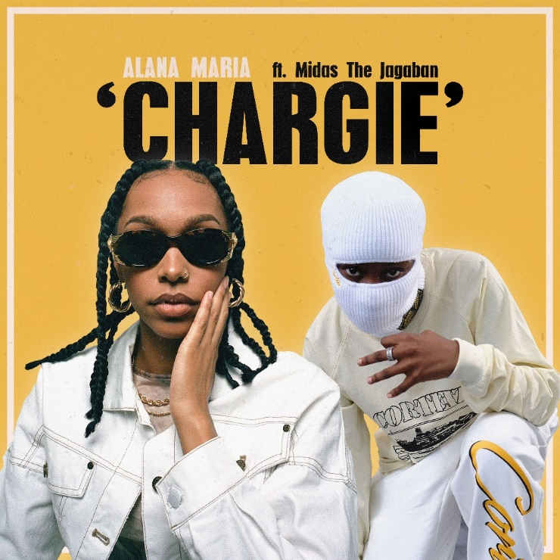

Atlantic Recording artist Alana Maria releases her latest single “Chargie” featuring the UK’s burgeoning afro pop artist, Midas the Jagaban. Produced by Mike Brainchild (Kojo Funds, Rebecca Garton) and premiered by FLAUNT, “Chargie” is a feel-good song focusing on the love of being in a relationship and never wanting that feeling of happiness to end. The track showcases Alana’s unmistakable sweet-toned vocals entwined with the infectious beat. Directed by Meeks & Frost (Pa Salieu, Shaybo), “Chargie” is accompanied by a fun-loving official video celebrating friends, love and life.

“I was originally working on a chorus for another artist which didn’t go into production, so I decided to do a little more work on it and use it for one of my songs,” notes Alana on her inspiration. “I was travelling to Birmingham with family and was listening to Nines’ album Crabs in the Bucket for the first time, and as soon as I heard the track ‘Ringaling’ I was instantly caught by the emotional production and as always, started singing a chorus to it which was later to become the chorus for ‘Chargie.’ It worked so perfectly I knew I had to finish the song, so I called my producer Mike and went into the studio the following day and created the full track.”

Born and raised in West London, 19-year-old Alana has amassed over 300k views to date with her Instagram and freestyle covers and is rapidly establishing her status on TikTok with over 350k likes since joining the platform a few months ago. The former model has already earned co-signs from the likes of PA Salieu, Tion Wayne and Pink Sweats. With 2020’s single “My Heart” ft. Kranium and “Chargie” ft. Midas the Jagaban alongside a catalogue of soon-to-be released R&B anthems, Alana Maria is well on her way to cementing her status as a rising star.

Inspired by the sounds of classic R&B and neo-soul, Alana’s sound is expressive, soulful yet versatile with pop roots. She cites the likes of Brandy, Kehlani, Summer Walker and Kiana Lede as some of the musicians that have inspired her sound, she explains: “My music stands for being yourself. Understanding that things may not always work out the way that they do but that it's destined to happen in that way, it’s about being happy, loving yourself, treating yourself right and being around good people. That's what my music is about, that's what I want it to stand for.”

CONNECT WITH ALANA MARIA
INSTAGRAM|TWITTER|FACEBOOK

PRESS CONTACT
FAIRLEY MCCASKILL | FAIRLEY.MCCASKILL@ATLANTICRECORDS.COM

