FOR IMMEDIATE RELEASE

MAY 22ND, 2020

**PRINCE TAEE SIGNS TO ART@WAR/ATLANTIC RECORDS**

**VIA TML (THE MUSIC LIFE)**

**LAS VEGAS RAPPER CELEBRATES RELEASES “FREE CRACK”**

**FEATURING YBN AMLIGHTY JAY & MYCRAZYRO**

**WATCH THE KHRAVE-DIRECTED VIDEO:**

[**PRINCETAEE.LNK.TO/FREECRACKVIDEO**](https://PrinceTaee.lnk.to/FreeCrackVideo)

**STREAM/DOWNLOAD “FREE CRACK”:**

[**PRINCETAEE.LNK.TO/FREECRACK**](https://princetaee.lnk.to/FreeCrack)

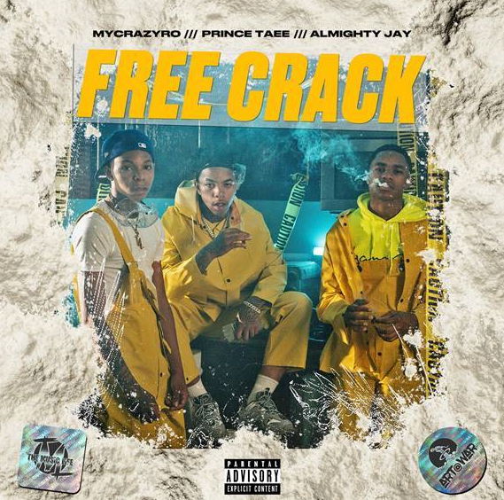

[*HIGH-RES COVER ART DOWNLOAD HERE*](https://warnermusicgroup.app.box.com/s/wefdsdv77u2yj9091qqx8u97m61gu75f)

Announced today, Art@War/Atlantic Records has signed **Prince Taee** to an exclusive label deal via TML (The Music Life). The Las Vegas-bred rapper Prince Taee has announced the release of the highly anticipated “[Free Crack”](https://princetaee.lnk.to/FreeCrack) featuring labelmate **YBN Almighty Jay** and **MyCrazyRO**, which is available today at all DSPs and streaming services via TML/Art@War/Atlantic Records [HERE](https://princetaee.lnk.to/FreeCrack).

The single, produced by **Hasani Buchanan**, is accompanied by an electric, Khrave-directed (**YBN Almighty Jay**, **Kaliwae**) companion visual, now available to stream [HERE](https://youtu.be/A8VBivnw6Lw). Additionally, Prince Taee released “Wraith Ryder” via SoundCloud last week. Stream “Wraith Ryder” [HERE](https://soundcloud.com/prince_taee24/wraith-rider) and watch the companion visual via YouTube [HERE](https://youtu.be/A8VBivnw6Lw).

“He’s a great kid with excellent talent,” says Dallis Martin, VP of A&R at Atlantic Records, of Prince Taee. “I predict he’ll have a bright future at Atlantic.”

"Prince Taee’s an undeniable talent who possesses a natural magnetism that is fresh and appealing,” says Art@War label chief James McMillan. “He has a really solid team behind him, The Music Life (TML), and together there’s no limit to what we can accomplish with our partners Atlantic Records.”

**ABOUT PRINCE TAEE**

With a fresh flow, smooth style, and unbreakable spirit, Prince Taee presents an irresistible, inventive, and intoxicating strain of hip-hop all his own. Endorsed by YBN Nahmir, he could walk off the set from a classic nineties video or turn up in your Instagram feed and exude the same timeless charisma. However, he went through it all on his journey, watching friends die, losing family members, and working two-to-three jobs while going to school in order to make it. After generating millions of streams independently, gaining co-signs from Fabolous and Jazze Pha, and attracting looks from WorldStarHipHop and more, the Compton-born, Victorville-raised, and Las Vegas-based rapper introduces a signature sound unlike anything else in the game on a series of singles for TML/ART@WAR/Atlantic Records and his forthcoming 2020 debut. He kicks off this barrage with “Free Crack” [feat. MyCrazyRo & YBN Almighty Jay] with more to come.

*PHOTO CREDIT: LOS*

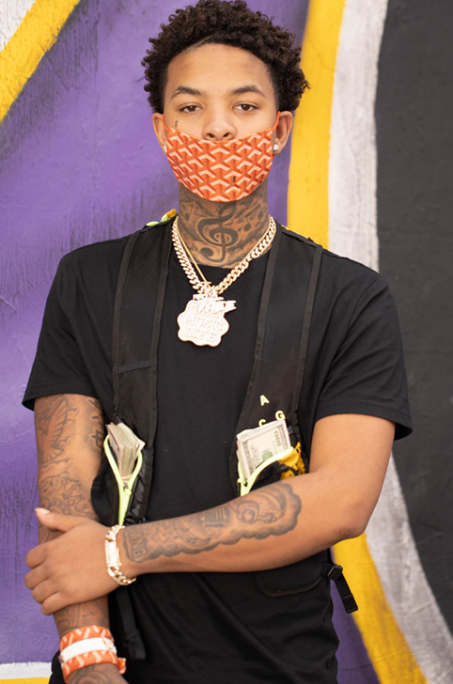

**CONNECT WITH PRINCE TAEE**

[Instagram](https://nam04.safelinks.protection.outlook.com/?url=https%3A%2F%2Fwww.instagram.com%2Fprincetaee_6&data=02%7C01%7CChandler.Owen%40atlanticrecords.com%7C78ebae8107954cf6b85f08d7fd9564df%7C8367939002ec4ba1ad3d69da3fdd637e%7C0%7C0%7C637256691454190951&sdata=1sji9%2F5ZwhltS7w0jG%2BjuhWraWnCkcndj6479f0w6gQ%3D&reserved=0) |[Facebook](https://nam04.safelinks.protection.outlook.com/?url=https%3A%2F%2Fwww.facebook.com%2Fprofile.php%3Fid%3D100008311310683&data=02%7C01%7CChandler.Owen%40atlanticrecords.com%7C78ebae8107954cf6b85f08d7fd9564df%7C8367939002ec4ba1ad3d69da3fdd637e%7C0%7C0%7C637256691454200947&sdata=xNFO161PkWEJaCSvjFP%2BkO04QD%2FxAAu3Y1fwHPV8GJE%3D&reserved=0) | [YouTube](https://nam04.safelinks.protection.outlook.com/?url=https%3A%2F%2Fwww.youtube.com%2Fchannel%2FUCJOTd4t6U3b9aeXD9w_Eeiw&data=02%7C01%7CChandler.Owen%40atlanticrecords.com%7C78ebae8107954cf6b85f08d7fd9564df%7C8367939002ec4ba1ad3d69da3fdd637e%7C0%7C0%7C637256691454200947&sdata=xWiBTPTBn8cesFMb1xlu%2Bd6ieNPIUTUncjCtAw2jnYs%3D&reserved=0) | [Soundcloud](https://nam04.safelinks.protection.outlook.com/?url=https%3A%2F%2Fsoundcloud.com%2Fprince_taee24&data=02%7C01%7CChandler.Owen%40atlanticrecords.com%7C78ebae8107954cf6b85f08d7fd9564df%7C8367939002ec4ba1ad3d69da3fdd637e%7C0%7C0%7C637256691454210940&sdata=UHy3dlKqFTTvbBY%2FNIKyZslxJi0LXHZDocrzkPlZ3Bk%3D&reserved=0) | [Twitter](https://nam04.safelinks.protection.outlook.com/?url=https%3A%2F%2Ftwitter.com%2Fprincetaee_5&data=02%7C01%7CChandler.Owen%40atlanticrecords.com%7C78ebae8107954cf6b85f08d7fd9564df%7C8367939002ec4ba1ad3d69da3fdd637e%7C0%7C0%7C637256691454210940&sdata=7vYSBZFr5gf3XMKbjlxS4zVloRdFpZmBPCLeuCc%2Bt8c%3D&reserved=0) | [Spotify](https://nam04.safelinks.protection.outlook.com/?url=https%3A%2F%2Fopen.spotify.com%2Fartist%2F3Fi3zsujEOjlfb1YQnvzkQ%3Fsi%3DCSl17BsPQBOQrwyG_W1DDQ&data=02%7C01%7CChandler.Owen%40atlanticrecords.com%7C78ebae8107954cf6b85f08d7fd9564df%7C8367939002ec4ba1ad3d69da3fdd637e%7C0%7C0%7C637256691454210940&sdata=d1jWPih%2FMZBecmW0qkTRhOW94hDyWs7OAfUeotedGJs%3D&reserved=0)

**PRESS CONTACT**

Brittany Bell | [Brittany.Bell@atlanticrecords.com](mailto:Brittany.Bell@atlanticrecords.com)

