FOR IMMEDIATE RELEASE
MAY 26, 2021

FENIX FLEXIN SHARES NEW VIDEO & SINGLE "FOR ME"
FROM UPCOMING DEBUT SOLO PROJECT
WATCH | LISTEN

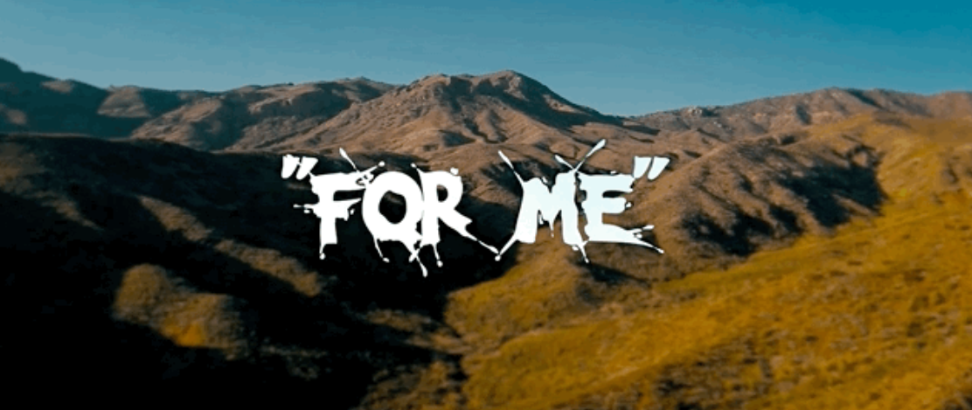

“Shoreline Mafia’s Fenix Flexin starts a new chapter” – The FADER
"Fenix Flexin is tied into the skate culture of Los Angeles" – All Hip Hop
"It’s Time for Fenix Flexin to Enter the Spotlight" – The Young Folks

Former Shoreline Mafia member, Fenix Flexin has just shared his first video single as a solo artist, “For Me.” The Ron Ron and Menace produced track sees Fenix leaning into his newfound autonomy, lacing a laidback trap melody with boastful bars detailing his capricious lifestyle. The new track also arrives with an After Pangea directed video featuring cameos from former Shoreline members Rob Vicious and Master Kato as well as Fenix and riders from his new Burnt Co skate team dropping in on the recently opened bowl at Lee Spielman and Garrett Stevenson's new West Adams clothing store, Babylon. "For Me" is the first single from Fenix Flexin's upcoming debut project which he'll be announcing soon. In addition to his new music, Fenix has also been forging a deeper connection to Los Angeles' skate scene with the recent launch of his new skateboard and lifestyle apparel brand, Burnt Company.
After the overwhelmingly positive response from fans to his solo songs on 2020's Mafia Bidness, including “Hoe Sh*t” and “Change Ya Life,” as well as his massive hit, "Fell In Love" off 2019's Party Pack Vol. 2, Fenix Flexin is ready to manifest the solo career he's always envisioned. “The group had a bunch of respect, a huge following, and a whole lot of people behind us,” affirms Fenix. “Now, I’m claiming all of those things for myself as an individual, and I’m off to a good start.” In the opening hours of 2021, Fenix released “10 Toes,” a video single which has since achieved nearly five million views, affirming his do-for-self mantra. “In the group, I never really spoke on my trials and tribulations,” admits the charismatic 25-year-old Atlantic Records artist. “Now, I can express all of that in my music.” Carrying his seven-figure streaming audience and viewership with him, Fenix Flexin is moving with lots of momentum. He touts, “I’m as real as it gets, and I’m solid all the way through.”

FENIX FLEXIN – "FOR ME"
WATCH | LISTEN

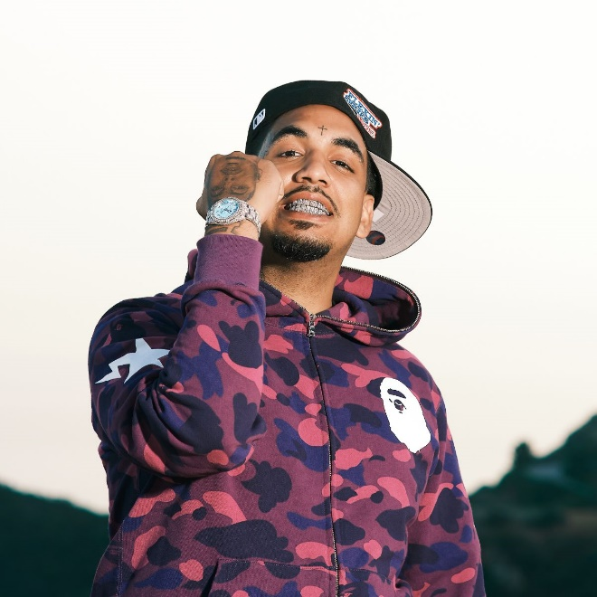
Photo Credit: Ifster Oluyide

ABOUT FENIX FLEXIN:
After a heavy hand in three platinum singles and several acclaimed full-length projects with Shoreline Mafia, Fenix Flexin has stepped away from the group to manifest the solo career he always envisioned. Being on his own is something that is not new to Fenix Rypinski, who is of Black, Mexican, and Polish heritage. While the rapper’s mother and father each battled addiction, he bounced around between his grandmother and siblings’ houses, staying in West LA, East Hollywood, Downey, and Huntington Park.
Along with skating and graffiti, rap was a creative outlet that allowed the kid on the move to make fast friends. For now, Fenix Flexin is focused on branding his individuality, “I have to reclaim that respect and attention.” The founder of the skate-inspired lifestyle company Burnt self-released “10 Toes” to kickstart his 2021 campaign. On his own, Fenix Flexin has a plan. “I’m ready to show people what I’m capable of,” he asserts. That proper introduction will take place across three mixtapes and a solo debut project. Tapping into some Bay area sounds as well as some Midwest production, he says, “It’s all about growth and expansion."

ABOUT FENIX FLEXIN:
Spotify | Instagram | Twitter | Facebook

PRESS CONTACT:
BRITTANY.BELL@ATLANTICRECORDS.COM

