FOR IMMEDIATE RELEASE

MAY 29, 2020

**PRINCE TAEE TAPS YK OSIRIS FOR “JUST MY TYPE”**

**VEGAS RAPPER RELEASES LATEST HIGH-ENERGY SINGLE**

**VIA TML/ART@WAR/ATLANTIC**

**“JUST MY TYPE” FT. YK OSIRIS PREMIERED TODAY ON** [**COMPLEX**](https://www.complex.com/music/2020/05/prince-taee-yk-osiris-just-my-type-video)

**ARRIVES ON THE HEELS OF “**[**FREE CRACK**](https://princetaee.lnk.to/FreeCrack)**” FT. YBN AMLIGHTY JAY & MYCRAZYRO**

**WATCH THE OFFICIAL** [**COMPANION VISUAL**](https://princetaee.lnk.to/FreeCrackVideo)

**STREAM/DOWNLOAD “JUST MY TYPE” FT. YK OSIRIS** [**HERE**](https://PrinceTaee.lnk.to/JustMyType)

**WATCH THE OFFICIAL COMPANION VISUAL** [**HERE**](https://PrinceTaee.lnk.to/JustMyTypeVideo)

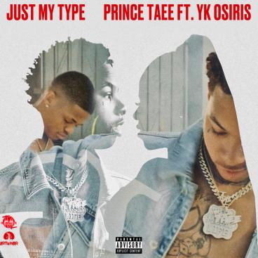

[*HIGH-RES COVER ART DOWNLOAD HERE*](https://warnermusicgroup.app.box.com/s/aky6nmtr02hhfra3io9k1zric5f08dh7)

TML/Art@War/Atlantic Records announces today **Prince Taee**’s latest single “Just My Type” featuring **YK** **Osiris**. The track interpolates Tamia’s 1998 hit single “So Into You,” and its official [companion visual](https://PrinceTaee.lnk.to/JustMyTypeVideo) – directed by **Joe Yung Spike** – features **Fabolous,** who also used the song in his 2003 version, “Into You.” The **Sons of Mary**-produced track premiered via [**Complex**](https://www.complex.com/music/2020/05/prince-taee-yk-osiris-just-my-type-video), noting how the track “sees the rising 18-year-old rapper tap into his more sensitive side. To coincide with the release of the track, the video shows the pair in full-on R&B classic mode complete with a white grand piano.” “Just My Type” ft. YK Osiris is available today at all DSPs and streaming services via TML/Art@War/Atlantic Records [HERE](https://PrinceTaee.lnk.to/JustMyType).

The single arrives on the heels of last week’s announcement of Prince Taee’s exclusive label deal with Art@War/Atlantic Records via TML (The Music Life). The Las Vegas-bred rapper celebrated the announcement with the release of the highly anticipated “[Free Crack”](https://princetaee.lnk.to/FreeCrack) featuring labelmate **YBN Almighty Jay** and **MyCrazyRO**, which is available at all DSPs and streaming services via TML/Art@War/Atlantic Records [HERE](https://princetaee.lnk.to/FreeCrack).

“Free Crack,” produced by **Hasani Buchanan**, was accompanied by an electric, Khrave-directed (**YBN Almighty Jay**, **Kaliwae**) companion visual, now available to stream [HERE](https://youtu.be/A8VBivnw6Lw). Additionally, Prince Taee released “Wraith Ryder” via SoundCloud the week prior. Stream “Wraith Ryder” [HERE](https://soundcloud.com/prince_taee24/wraith-rider) and watch the companion visual via YouTube [HERE](https://youtu.be/A8VBivnw6Lw).

**ABOUT PRINCE TAEE**

With a fresh flow, smooth style, and unbreakable spirit, Prince Taee presents an irresistible, inventive, and intoxicating strain of hip-hop all his own. Endorsed by YBN Nahmir, he could walk off the set from a classic nineties video or turn up in your Instagram feed and exude the same timeless charisma. However, he went through it all on his journey, watching friends die, losing family members, and working two-to-three jobs while going to school in order to make it. After generating millions of streams independently, gaining co-signs from Fabolous and Jazze Pha, and attracting looks from WorldStarHipHop and more, the Vegas born and based rapper introduces a signature sound unlike anything else in the game on a series of singles for TML/ART@WAR/Atlantic Records and his forthcoming 2020 debut. He kicks off this barrage with “Free Crack” [feat. MyCrazyRo & YBN Almighty Jay] with more to come.

*PHOTO CREDIT: LOS*

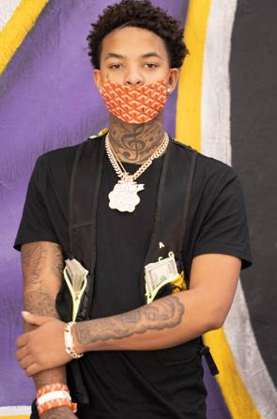

**CONNECT WITH PRINCE TAEE**

[Instagram](https://nam04.safelinks.protection.outlook.com/?url=https%3A%2F%2Fwww.instagram.com%2Fprincetaee_6&data=02%7C01%7CChandler.Owen%40atlanticrecords.com%7C78ebae8107954cf6b85f08d7fd9564df%7C8367939002ec4ba1ad3d69da3fdd637e%7C0%7C0%7C637256691454190951&sdata=1sji9%2F5ZwhltS7w0jG%2BjuhWraWnCkcndj6479f0w6gQ%3D&reserved=0) |[Facebook](https://nam04.safelinks.protection.outlook.com/?url=https%3A%2F%2Fwww.facebook.com%2Fprofile.php%3Fid%3D100008311310683&data=02%7C01%7CChandler.Owen%40atlanticrecords.com%7C78ebae8107954cf6b85f08d7fd9564df%7C8367939002ec4ba1ad3d69da3fdd637e%7C0%7C0%7C637256691454200947&sdata=xNFO161PkWEJaCSvjFP%2BkO04QD%2FxAAu3Y1fwHPV8GJE%3D&reserved=0) | [YouTube](https://nam04.safelinks.protection.outlook.com/?url=https%3A%2F%2Fwww.youtube.com%2Fchannel%2FUCJOTd4t6U3b9aeXD9w_Eeiw&data=02%7C01%7CChandler.Owen%40atlanticrecords.com%7C78ebae8107954cf6b85f08d7fd9564df%7C8367939002ec4ba1ad3d69da3fdd637e%7C0%7C0%7C637256691454200947&sdata=xWiBTPTBn8cesFMb1xlu%2Bd6ieNPIUTUncjCtAw2jnYs%3D&reserved=0) | [Soundcloud](https://nam04.safelinks.protection.outlook.com/?url=https%3A%2F%2Fsoundcloud.com%2Fprince_taee24&data=02%7C01%7CChandler.Owen%40atlanticrecords.com%7C78ebae8107954cf6b85f08d7fd9564df%7C8367939002ec4ba1ad3d69da3fdd637e%7C0%7C0%7C637256691454210940&sdata=UHy3dlKqFTTvbBY%2FNIKyZslxJi0LXHZDocrzkPlZ3Bk%3D&reserved=0) | [Twitter](https://nam04.safelinks.protection.outlook.com/?url=https%3A%2F%2Ftwitter.com%2Fprincetaee_5&data=02%7C01%7CChandler.Owen%40atlanticrecords.com%7C78ebae8107954cf6b85f08d7fd9564df%7C8367939002ec4ba1ad3d69da3fdd637e%7C0%7C0%7C637256691454210940&sdata=7vYSBZFr5gf3XMKbjlxS4zVloRdFpZmBPCLeuCc%2Bt8c%3D&reserved=0) | [Spotify](https://nam04.safelinks.protection.outlook.com/?url=https%3A%2F%2Fopen.spotify.com%2Fartist%2F3Fi3zsujEOjlfb1YQnvzkQ%3Fsi%3DCSl17BsPQBOQrwyG_W1DDQ&data=02%7C01%7CChandler.Owen%40atlanticrecords.com%7C78ebae8107954cf6b85f08d7fd9564df%7C8367939002ec4ba1ad3d69da3fdd637e%7C0%7C0%7C637256691454210940&sdata=d1jWPih%2FMZBecmW0qkTRhOW94hDyWs7OAfUeotedGJs%3D&reserved=0)

**PRESS CONTACT**

Brittany Bell | [Brittany.Bell@atlanticrecords.com](mailto:Brittany.Bell@atlanticrecords.com)

