FOR IMMEDIATE RELEASE
JUNE 1ST, 2020

RAEDIO, ATLANTIC RECORDS AND HBO® RELEASE LATEST SINGLE OFF FORTHCOMING
INSECURE®: MUSIC FROM THE HBO ORIGINAL SERIES, SEASON 4 SOUNDTRACK

BABY ROSE’S “SHOW YOU” REMIX FEAT. Q DEBUTED ON THE EIGHTH EPISODE OF INSECURE SEASON 4
SUNDAY, MAY 31ST ON HBO®

SOUNDTRACK AVAILABLE JUNE 5TH

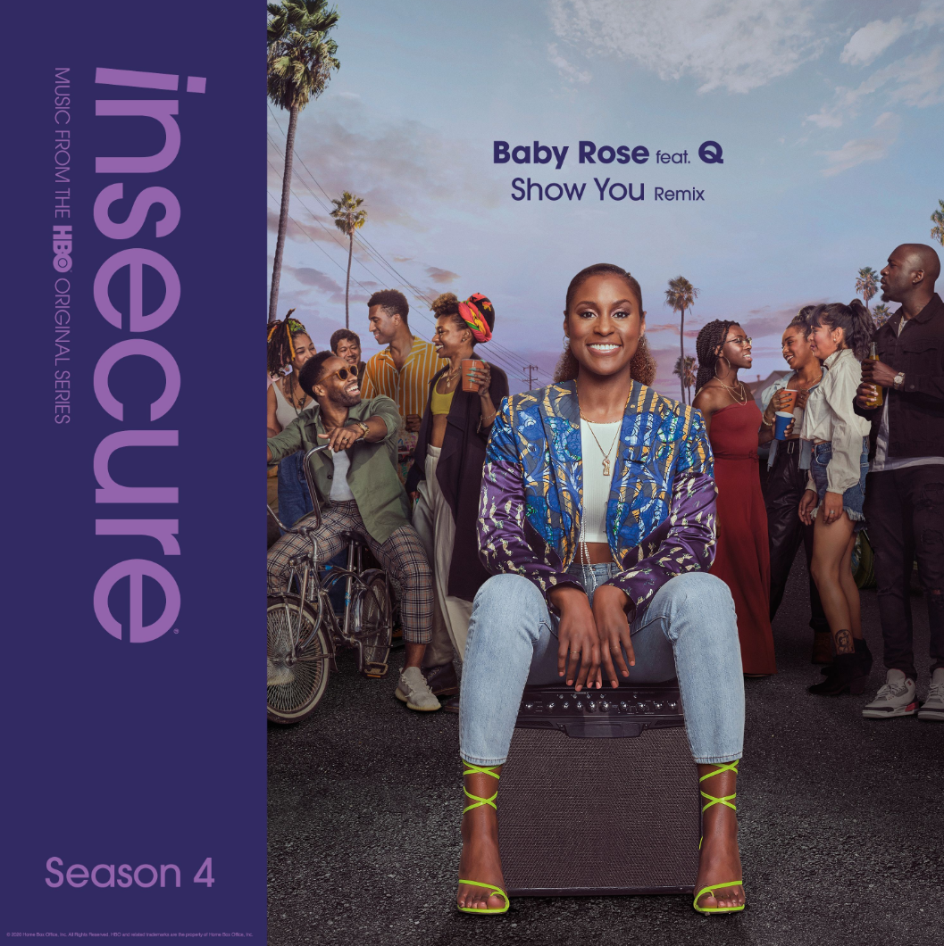
DOWNLOAD HIGH-RES COVER ART HERE

Raedio, Atlantic Records and HBO® release the latest track off the forthcoming INSECURE: Music From the HBO Original Series, Season 4 soundtrack. Baby Rose’s “Show You” Remix feat. Q delivered the musical backdrop for last night’s episode of the award-winning HBO® series, INSECURE. Listen to “Show You” Remix feat. Q HERE. The series will be available on HBO NOW, HBO GO, HBO On Demand and partners’ streaming platforms. INSECURE: Music From the HBO Original Series, Season 4 soundtrack is set for a June 5th release

"’Show You’ is an ode to letting go, in the pettiest, and messiest ways one can,” note Baby Rose. “The lyrics start off confident and self-assured, but by the end they’re tinged with insecurity and sadness over moving on from the past. The irony is that these sentiments are married with the production of my dreams and have solidified me as the artist I’ve always wanted to be. I am grateful to Q, Itai Shapira, Coco O and Paris Strother for bringing this to life, and Issa Rae for having ‘Show You’s’ remix on Insecure’s soundtrack, stamping me into the brilliant legacy of her show."

Last month, TeaMarrr’s “Temperature” brought her quintessential ‘really really raw’ element to the soundtrack. The track dropped alongside a colorful companion visual, bringing the visceral, euphoric single to life. Previous releases included Jidenna’s “Feng Shui,” Ravyn Lenae’s “Rewind,” Poe Leos’ “Look At Me” and Yung Baby Tate’s “Do Me Like That” (ft. Buddy). Further, the soundtrack includes Jucee Froot’s irresistible “Eat Itself,” Cautious Clay’s “Reaching” (ft. Alex Isley), St. Panther’s “Infrastructure,” and Yung Baby Tate’s “Never Lonely” (ft. Jozzy).

INSECURE: Music From the HBO Original Series, Season 4 will feature brand new tracks from a diverse array of major artists and rising stars. The soundtrack is guaranteed to elevate the bar for music culture.

ABOUT RAEDIO
Launched in 2019, Raedio serves artists and creators at the highest level as an “audio everywhere company,” operating as the home to a dynamic roster of talent. Most importantly, Raedio extends a platform across media to align acts with film and television projects, commercials, podcasts, and beyond. Raedio also provided music supervision services for HBO’s critically acclaimed A Black Lady Sketch Show℠.

For more information, please visit: insecuresoundtrack.com, twitter.com/theraedio and
www.instagram.com/theraedio.

ABOUT BABY ROSE
Baby Rose (born Jasmine Rose Wilson), is a Grammy-nominated recording artist, Atlanta-based singer, songwriter, and producer. She was born on August 5th in Washington, D.C. Growing up, she constantly had a mix of genres in her ears, from traditional gospel hymns to hip-hop, r&b, psychedelic, funk, alternative, soul, jazz, and folk music. Her desire to create art was encouraged by her family at an early age, and she began to write poetry, and read her poems at family holidays and reunions.

For her 9th birthday, Rose’s uncle gifted her a piano. After moving to Fayetteville, North Carolina, Rose spent long stretches of time in her home’s foyer on the piano, experimenting with her voice, writing songs and listening to artists such as Nina Simone, Janis Joplin and Donny Hathaway who were sonically and lyrically pushing boundaries. After moving to Atlanta, Rose collaborated with one of her first musical friends in Atlanta, producer Casey Graham, to work on her debut project EP, From Dusk ‘Til Dawn. Buzz around Rose’s name began to pick up, with SZA, Kehlani, and J.Cole co-signing her talent. Rose was also part of studio sessions for Dreamville’s third compilation album, Revenge of the Dreamers III. Along with Ari Lennox and Bas, Baby Rose lends her voice to “Self Love.” Released on July 5, 2019, the album went on to go Platinum and be nominated for Best Rap Album at the 2019 Grammy Awards.

By the time Rose signed a distribution deal with Human Re-Sources, she had already released a series of singles and projects on her Soundcloud, and her debut album, To Myself, was complete. To Myself, released on August 22, 2019, is a critically acclaimed debut album and collection of tracks in which the ebbs and flows of going through love and life changes are on full display. Since then, she’s toured with Ari Lennox, Snoh Aalegra, and has had her own debut U.S and European tour. She later upstreamed to sign with Island Records.

ABOUT INSECURE
Returning for its ten-episode, fourth season on Sunday, April 12th (10:00-10:30 p.m. ET/PT), INSECURE follows our favorite characters as they evaluate their relationships, both new and old, in an effort to figure out who and what comes with them in this next phase of their lives. The series will also be available on HBO NOW, HBO GO, HBO On Demand and partners’ streaming platforms.

Season Four follows the main characters in the aftermath of the decisions they made in the last season. Issa pursues a passion project she actually cares about, Molly navigates a real relationship for the first time, Lawrence figures out what leveling-up means for him, and we see the effect of Tiffany’s new baby on the dynamic of the friend group. Along the way, we’ll see these characters evaluating relationships, both new and old, in an effort to figure out who and what comes with them in this next phase of their lives.

INSECURE stars Issa Rae. Other series regulars include Yvonne Orji, Jay Ellis, Natasha Rothwell, Amanda Seales, Kendrick Sampson and Alexander Hodge. Created by Issa Rae & Larry Wilmore, INSECURE is executive produced by Issa Rae, Prentice Penny, Melina Matsoukas, Michael Rotenberg, Dave Becky, Jonathan Berry, Amy Aniobi and Jim Kleverweis; co-executive producers, Laura Kittrell and Phil Augusta Jackson.

ABOUT HBO®
HBO® is one of the most respected and innovative entertainment brands in the world, serving iconic, award-winning programming to 140 million subscribers globally. A subsidiary of WarnerMedia, HBO is the world’s most successful pay TV service with an extensive array of programming that includes some of the most notable titles to be on television, including drama series Succession®, Watchmen®, Westworld®, Big Little Lies®, Game of Thrones®, The Sopranos®, Band of Brothers® and The Wire®, as well as comedy series Barry®, Insecure® and Sex and the City®. In the United States, HBO® and sister network Cinemax® are available across multiple platforms including HBO On Demand®, Cinemax On Demand®, HBO GO® and MAX GO®, as well as HBONOW®. Internationally, HBO branded services, including television networks and the standalone streaming product HBO GO®, are available in more than 70 countries across Asia, Europe, Latin America and the Caribbean. HBO and Cinemax programming is also sold into more than 150 countries worldwide.

INSECURE is available to stream now on www.hbo.com.

For more information, please visit www.hbo.com/insecure.

PRESS CONTACTS
Fairley McCaskill | Fairley.McCaskill@atlanticrecords.com (Insecure Soundtrack)
Brittany Bell | Brittany.Bell@atlanticrecords.com (Insecure Soundtrack)
Vanessa Anderson | Vanessa@amprgroup.com (Issa Rae)
Emily Weichert | Emily.Weichert@hbo.com (HBO)

