FOR IMMEDIATE RELEASE
JUNE 4, 2021

BRELAND & KEITH URBAN "THROW IT BACK" ON NEW COLLAB

INFECTIOUS ANTHEM & VIDEO OUT NOW
STREAM | WATCH

BRELAND NAMED YOUTUBE ARTIST ON THE RISE

TICKETS FOR HEADLINE CROSS COUNTRY TOUR ON SALE NOW

SET FOR CMT MUSIC AWARDS PERFORMANCE (6/9)

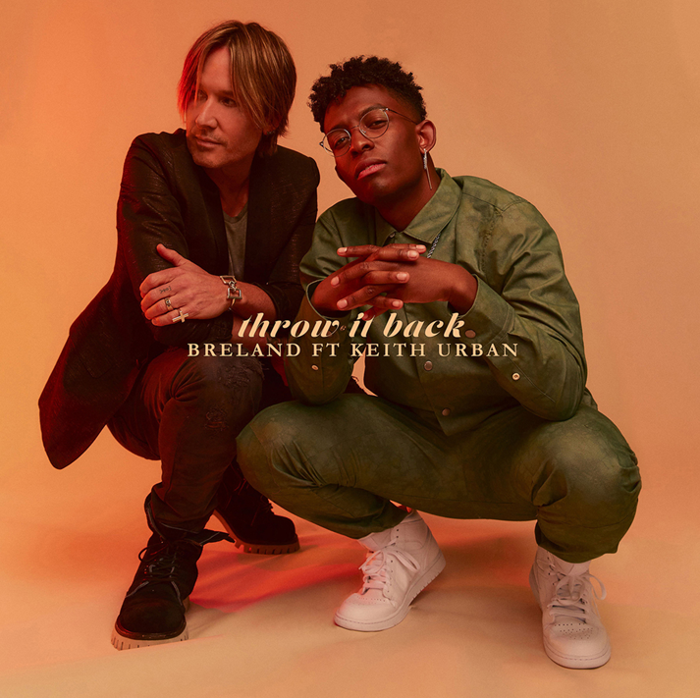
DOWNLOAD HIGH-RES ARTWORK

Bad Realm Records / Atlantic Records breakout talent BRELAND continues to make waves in Country music, enlisting superstar Keith Urban for the new collaboration, “Throw It Back.”

Throwing down a rootsy blast of dance-floor fire, the track finds the two artists partnering for a second time on the banjo-laced banger with a love-drunk theme. Matching BRELAND’s sheer boldness and dynamic flow with Urban’s effortless charisma and string-bending prowess, “Throw It Back” makes for a true Country anthem.

The stars both appear in an official video for the standout collab – directed by Bobby Bruderle and filmed at Analog in Nashville’s Hutton Hotel. Both the track and video are available now.

’Throw it Back’ is the first song Keith and I ever worked on together, and despite it being so sonically left of center, he immediately recognized it as a special song and started adding his iconic flavor to the record,” shares BRELAND. “You’ll be able to feel my and Keith’s energy flowing not only on the song but in the video, which we helped shape together as well. With the world finally opening up, and live music coming back, I feel like we’ve got a real summer anthem on our hands.”

“BRELAND is my brother from another mother,” adds Urban. “I LOVE creating with him. Everything is so simpatico and matter of fact - here it is! I’m stoked that a song written from our very first time writing together (June of last year) is finally coming out.”

Tune in today, as BRELAND takes ET exclusively behind the scenes of the “Throw It Back” music video. To hear from the two artists on their undeniable musical connection, check your local listings.

Marking their second high-profile collaboration, “Throw It Back” follows “Out The Cage,” which featured BRELAND and was included on Urban’s The Speed of Now Part 1 album. On the rise since his PLATINUM debut “My Truck” dropped in 2019, BRELAND’s stable of all-star collaborators also includes Rascal Flatts’ Gary LeVox, Lauren Alaina, Chase Rice, and Sam Hunt, who was featured on a remix of “My Truck” that The New York Times and NPR recognized as one of the Best Songs of 2020.

Accolades continue to pour in for the game-changing artist, who released his self-titled debut EP in 2020 and was announced this week (6/1) as YouTube’s next Artist on the Rise. BRELAND will perform with Mickey Guyton at the 2021 CMT Music Awards (airing Wednesday, June 9), and the pair released a duet version of BRELAND’s self-discovery anthem, “Cross Country.”

BRELAND will kick off his CROSS COUNTRY TOUR at Bonnaroo Music Festival on September 5, embarking on his first-ever headline tour. The coast-to-coast trek runs through October and tickets for all dates are on sale now, with more details here.

ABOUT BRELAND
With the arrival of his instantly iconic, PLATINUM-certified debut single “My Truck,” singer/songwriter/producer BRELAND emerged as a bold new force on today’s music landscape. Originally from New Jersey, BRELAND moved to Atlanta after graduating from Georgetown University, kicking off his songwriting career by scoring cuts with artists like YK Osiris and Ann Marie. Soon after releasing “My Truck” in late 2019, he saw the wildly catchy hybrid of Hip-Hop and Country hit #1 on Spotify’s Global Viral 50, with a remix featuring Country-hitmaker Sam Hunt landing on best-of-the-year lists from leading outlets like NPR and The New York Times. The song’s breakout success also paved the way for his signing to Bad Realm Records/Atlantic Records, and led to collaborations with heavy-hitters from the Country, Pop, and Hip-Hop worlds (including Gary LeVox of Rascal Flatts, Nelly, Blanco Brown, Lauren Alaina, Chase Rice, and Keith Urban). BRELAND’s early-2021 single “Cross Country” further reveals his passion for transcending boundaries, and continues his mission of breaking down genre barriers and redefining the possibilities of Country music. Now at work on the follow-up to his 2020 self-titled debut EP, the Nashville-based artist made his national TV debut with “Cross Country” on The Kelly Clarkson Show, where she surprised him with a PLATINUM plaque for “My Truck”. He has also been praised by Rolling Stone as “1,000 percent the whole package,” featured on Billboard’s “Emerging Artists Spotlight,” and earned acclaim from major press outlets like Genius, Paper, and USA TODAY. Check out his weekly radio show, Land of the BRE Radio, airing exclusively on Apple Music.

CONNECT WITH BRELAND
INSTAGRAM | FACEBOOK | TWITTER | YOUTUBE | SOUNDCLOUD

MEDIA CONTACTS
For BRELAND:
Fairley McCaskill | Fairley.McCaskill@atlanticrecords.com
Jensen Sussman | jensen@sweettalkpr.com

For Keith Urban:
Paul Freundlich / paulf@pfamedia.net

