LISTEN UP: BRELAND SHARES RAGE & SORROW

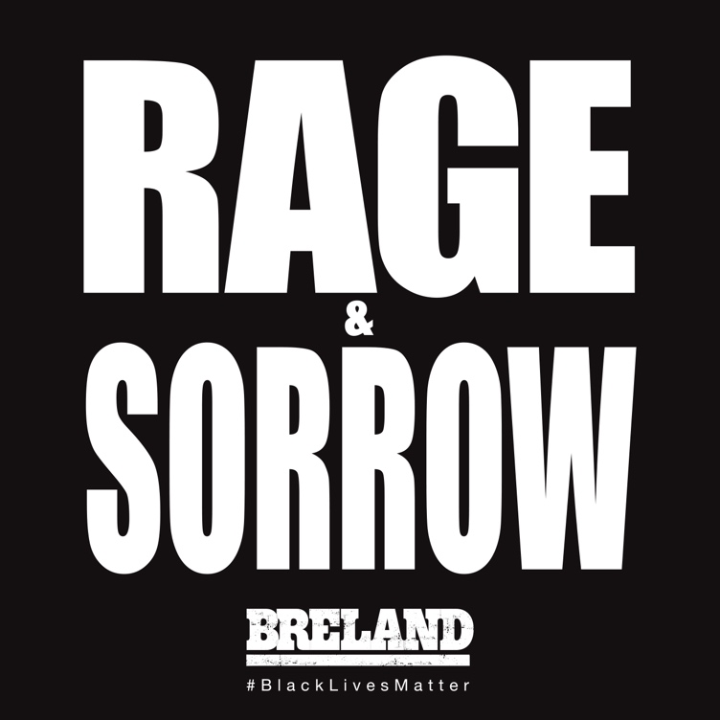

Many of us have been oscillating between inspiration and desperation over the past few weeks, and I haven’t always known what to do or say about it. Inside me at any given moment lie two distinct emotions: Rage & Sorrow. We focus a lot on the rage because it makes us feel powerful, but without acknowledging the sorrow, sometimes we end up only hurting ourselves. It is okay to feel both of these emotions, and to feel them deeply. The two songs I’m dropping tonight speak to my journey toward this emotional balance, and I hope everyone who listens finds similar peace. Happy Juneteenth. – BRELAND

LISTEN TO Rage & Sorrow: http://breland.lnk.to/RageandSorrow

MEDIA CONTACTS:
Fairley McCaskill / Fairley.McCaskill@atlanticrecords.com
Jensen Sussman / jensen@sweettalkpr.com

