FOR IMMEDIATE RELEASE

JUNE 23, 2021

**LIL EAZZYY IS THE “MVP”**

[**YOUTUBE PREMIERE**](https://youtu.be/EH7W1HUWZ5Q) **TODAY 11:40AM PT / 2:20PM ET**

[**WATCH HERE**](https://lileazzyy.lnk.to/MVPvideo)

**HOT OFF THE DROP OF “**[**WHY**](https://www.youtube.com/watch?v=yaS6FQoGJxA)**”**

**FILMED IN LANCASTER, CA AT THE ICONIC KILL BILL CHURCH**

**MAJOR LABEL DEBUT MIXTAPE** [***ROOKIE OF THE YEAR***](Https://lileazzyy.lnk.to/RookieOfTheYear) **AVAILABLE NOW**

**CHICAGO RAPPER SLATED TO PERFORM ICONIC FESTIVAL STAGES**

**ROLLING LOUD MIAMI, NEW YORK CITY & LOS ANGELES**

**PLUS HIVE MUSIC FESTIVAL & LYRICAL LEMONADE SUMMER SMASH**

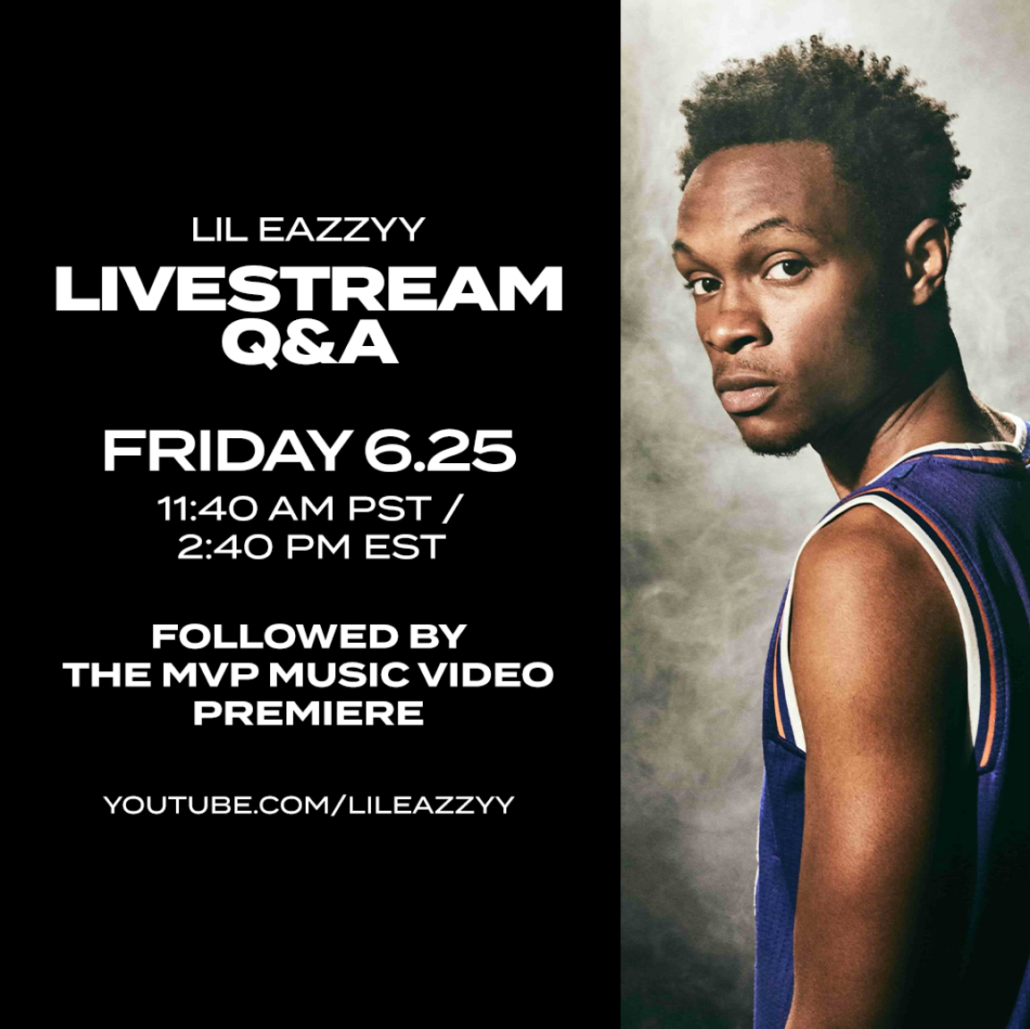

Lil Eazzyy continues to put up points as [*Rookie of the Year*](Https://lileazzyy.lnk.to/RookieOfTheYear) with the cinematic companion to “[MVP](https://lileazzyy.lnk.to/MVPvideo).” Tune into the YouTube premiere for a livestream Q&A at 11:40am PT / 2:40pm ET via his [YouTube channel](https://youtu.be/EH7W1HUWZ5Q). It arrives just after the [official video](https://www.youtube.com/watch?v=yaS6FQoGJxA) to “[Why](https://www.youtube.com/watch?v=yaS6FQoGJxA),” where the Chicago native took to the California desert, shooting the Henry McGowan-directed visual at the culturally iconic Kill Bill church in Lancaster, CA. His major label debut mixtape [*Rookie of the Year*](Https://lileazzyy.lnk.to/RookieOfTheYear) release was received with incredible playlisting support from Apple’s *New Music Daily*, *New In Hip Hop*, *The Plug* and more. Spotify included him on the coveted *New Music Friday*, *Most Necessary* and more while covering the *New Midwest* playlist at Tidal. Praised by the likes of [HipHopDX](https://nam04.safelinks.protection.outlook.com/?url=https%3A%2F%2Fhiphopdx.com%2Fnews%2Fid.61863%2Ftitle.new-music-friday-new-albums-from-dj-khaled-shelley-fka-dram-the-alchemist-more%23&data=04%7C01%7CChandler.Owen%40atlanticrecords.com%7C174b1de3e6474aef96e408d90c147050%7C8367939002ec4ba1ad3d69da3fdd637e%7C0%7C0%7C637554104208707302%7CUnknown%7CTWFpbGZsb3d8eyJWIjoiMC4wLjAwMDAiLCJQIjoiV2luMzIiLCJBTiI6Ik1haWwiLCJXVCI6Mn0%3D%7C1000&sdata=vPz8iJElYD9hfQF16ZmDtIRZ8vQxUVA%2Bpb%2BgR4gdgus%3D&reserved=0), [HotNewHipHop](https://nam04.safelinks.protection.outlook.com/?url=https%3A%2F%2Fwww.hotnewhiphop.com%2Flil-eazzyy-declares-himself-rookie-of-the-year-on-his-debut-mixtape-new-mixtape.121483.html&data=04%7C01%7CChandler.Owen%40atlanticrecords.com%7C174b1de3e6474aef96e408d90c147050%7C8367939002ec4ba1ad3d69da3fdd637e%7C0%7C0%7C637554104208707302%7CUnknown%7CTWFpbGZsb3d8eyJWIjoiMC4wLjAwMDAiLCJQIjoiV2luMzIiLCJBTiI6Ik1haWwiLCJXVCI6Mn0%3D%7C1000&sdata=TFaSAMuywEg8tqWdejuUZFL5jMXyMPkzMAn8Mtyw7GU%3D&reserved=0), [XXL](https://nam04.safelinks.protection.outlook.com/?url=https%3A%2F%2Fwww.xxlmag.com%2Fdj-khaled-shelley-fka-dram-morray-new-projects%2F&data=04%7C01%7CChandler.Owen%40atlanticrecords.com%7C174b1de3e6474aef96e408d90c147050%7C8367939002ec4ba1ad3d69da3fdd637e%7C0%7C0%7C637554104208717258%7CUnknown%7CTWFpbGZsb3d8eyJWIjoiMC4wLjAwMDAiLCJQIjoiV2luMzIiLCJBTiI6Ik1haWwiLCJXVCI6Mn0%3D%7C1000&sdata=%2Ff2SivheB5%2FLEt3%2BRFraFPOI9OP0wESDa66bpJ0TUc4%3D&reserved=0) and more, [*Rookie of the Year*](Https://lileazzyy.lnk.to/RookieOfTheYear) is definitely setting the tone for the future of Lil Eazzyy.

Lil Eazzyy plans to keep a buzzing live schedule this summer with an onslaught of festival performances. He’s currently confirmed to perform at Rolling Loud Miami, Rolling Loud New York City and Rolling Loud Los Angeles. Lil Eazzyy is also slated to perform at Hive Music Festival and Lyrical Lemonade’s Summer Smash.

The Chicago native backed up his claim of *Rookie of the Year* by locking himself in the studio, logging marathon sessions and devoting countless hours to his craft. In early 2021, he flew out to Los Angeles and recorded the bulk of *Rookie of the Year* on the West Coast. Lil Eazzyy teamed up with fellow Chicago native G Herbo for the “[Onna Come Up Remix](https://nam04.safelinks.protection.outlook.com/?url=https%3A%2F%2Flileazzyy.lnk.to%2FOnnaComeUpRemix&data=04%7C01%7CChandler.Owen%40atlanticrecords.com%7C2eb5c8ab3117413a8f5a08d8e577d00e%7C8367939002ec4ba1ad3d69da3fdd637e%7C0%7C0%7C637511650413209080%7CUnknown%7CTWFpbGZsb3d8eyJWIjoiMC4wLjAwMDAiLCJQIjoiV2luMzIiLCJBTiI6Ik1haWwiLCJXVCI6Mn0%3D%7C1000&sdata=1K1Lor7OhdUAozOxG4C1SJe5no69LRDQorQBSJrELdQ%3D&reserved=0),” racking up more than 31.4 million streams and over 3.1 million views of its official video. He continued to charged up this next chapter with “[Freestyle](https://nam04.safelinks.protection.outlook.com/?url=https%3A%2F%2Flileazzyy.lnk.to%2FFreestyleVideo&data=04%7C01%7CChandler.Owen%40atlanticrecords.com%7C2eb5c8ab3117413a8f5a08d8e577d00e%7C8367939002ec4ba1ad3d69da3fdd637e%7C0%7C0%7C637511650413199092%7CUnknown%7CTWFpbGZsb3d8eyJWIjoiMC4wLjAwMDAiLCJQIjoiV2luMzIiLCJBTiI6Ik1haWwiLCJXVCI6Mn0%3D%7C1000&sdata=BVL8ZSqd6LXF750V1TkE%2BqbOQTrzO7%2B5zS7wrnPB2cU%3D&reserved=0),” where he punched in with relentless rhymes, illuminating his dizzying lyricism. He maintained this momentum with the hypnotic grind of “[Yes Or No](https://nam04.safelinks.protection.outlook.com/?url=https%3A%2F%2Flileazzyy.lnk.to%2FYesOrNo&data=04%7C01%7CChandler.Owen%40atlanticrecords.com%7C2eb5c8ab3117413a8f5a08d8e577d00e%7C8367939002ec4ba1ad3d69da3fdd637e%7C0%7C0%7C637511650413199092%7CUnknown%7CTWFpbGZsb3d8eyJWIjoiMC4wLjAwMDAiLCJQIjoiV2luMzIiLCJBTiI6Ik1haWwiLCJXVCI6Mn0%3D%7C1000&sdata=n2cjEj8imV3i9Dckh4EBkRnp7G9jSGcweSMRGXbhMPc%3D&reserved=0)” [feat. IV JAY]. Meanwhile, the single “[Hunnid or Better](https://lileazzyy.lnk.to/HunnidOrBetter)” [feat. Bizzy Banks] hinges on his rapid-fire flow punctuated by lyrical acrobatics. Brooklyn drill phenomenon Bizzy Banks pulls up with an equally menacing guest spot, cutting through the airy synths.

*The new movement of voices for the Chicago streets is in full swing, and Lil Eazzyy is chief among them.*

**COMPLEX**

*Does Lil Eazzyy live up to his debut mixtape's title? In short, he very well may. Deeming himself the Rookie Of The Year, Lil Eazzyy obviously wanted to come through with one of the strongest projects of the entire year and it feels like he definitely makes his case.*

**HOT NEW HIP HOP**

*Eazzyy raps in rolling, rapid, and sometimes melodic cadence that other journalists have compared to Polo G and G Herbo, but Eazzyy raps with such polish and athleticism that similarities fade. You’re only focused on catching every bar.*

**SPIN**

*Lil Eazzyy has clearly made a beyond sturdy case as to why he is a completely different kind of artist . . . he is on a mission to blaze a trail of his own in the Chicago music scene.*

**LYRICAL LEMONADE**

*His latest tape Rookie of the Year continues to drive this point home: that he is the best rapper out right now. The tape features songs that carry a soulful melody and songs like "Trials" that are just straightforward lyrical storytelling. Eazzyy even dabbles in Brooklyn Drill on "Hunnid or Better," and then hits an off-the-dome freestyle.*

**POPDUST**

|  |  |  |
| --- | --- | --- |
|  |  |  |

For additional information + press assets, visit his press site [HERE](https://nam04.safelinks.protection.outlook.com/?url=https%3A%2F%2Fpress.atlanticrecords.com%2Flil-eazzyy%2F&data=04%7C01%7CChandler.Owen%40atlanticrecords.com%7C2eb5c8ab3117413a8f5a08d8e577d00e%7C8367939002ec4ba1ad3d69da3fdd637e%7C0%7C0%7C637511650413239062%7CUnknown%7CTWFpbGZsb3d8eyJWIjoiMC4wLjAwMDAiLCJQIjoiV2luMzIiLCJBTiI6Ik1haWwiLCJXVCI6Mn0%3D%7C1000&sdata=seuGewz0p6H37a70L84FWAo7%2BdsLRylazIBrpQ%2FRszY%3D&reserved=0).

*PHOTO CREDIT: JIMMY FONTAINE*

[*DOWNLOAD ROOKIE OF THE YEAR HIGH-RES COVERART*](https://nam04.safelinks.protection.outlook.com/?url=https%3A%2F%2Fwarnermusicgroup.box.com%2Fs%2Fka7fou280u4wekhj4tky4ugbd449rue7&data=04%7C01%7CChandler.Owen%40atlanticrecords.com%7C91158be9a1ca4d26724c08d8fac15b84%7C8367939002ec4ba1ad3d69da3fdd637e%7C0%7C0%7C637535055666445469%7CUnknown%7CTWFpbGZsb3d8eyJWIjoiMC4wLjAwMDAiLCJQIjoiV2luMzIiLCJBTiI6Ik1haWwiLCJXVCI6Mn0%3D%7C1000&sdata=n4Eg7h0LyT%2B60YHyrEynntM2UFonKE%2FHGoX1YG9XEBQ%3D&reserved=0)

**CONNECT WITH LIL EAZZYY**

[TWITTER](https://nam04.safelinks.protection.outlook.com/?url=https%3A%2F%2Ftwitter.com%2FLileazzyy&data=04%7C01%7CChandler.Owen%40atlanticrecords.com%7C2eb5c8ab3117413a8f5a08d8e577d00e%7C8367939002ec4ba1ad3d69da3fdd637e%7C0%7C0%7C637511650413249058%7CUnknown%7CTWFpbGZsb3d8eyJWIjoiMC4wLjAwMDAiLCJQIjoiV2luMzIiLCJBTiI6Ik1haWwiLCJXVCI6Mn0%3D%7C1000&sdata=ELCSwtxqjkqk5Z4IFcbdyXDSy9kDZYx3SpxmMDmJMxg%3D&reserved=0) | [INSTAGRAM](https://nam04.safelinks.protection.outlook.com/?url=https%3A%2F%2Fwww.instagram.com%2Flileazzyyy%2F&data=04%7C01%7CChandler.Owen%40atlanticrecords.com%7C2eb5c8ab3117413a8f5a08d8e577d00e%7C8367939002ec4ba1ad3d69da3fdd637e%7C0%7C0%7C637511650413249058%7CUnknown%7CTWFpbGZsb3d8eyJWIjoiMC4wLjAwMDAiLCJQIjoiV2luMzIiLCJBTiI6Ik1haWwiLCJXVCI6Mn0%3D%7C1000&sdata=Br0Pv%2B3YpTxdfBDHO6vFpVo44w1nf1OBE2Lh3rSfYng%3D&reserved=0) | [SPOTIFY](https://nam04.safelinks.protection.outlook.com/?url=https%3A%2F%2Fopen.spotify.com%2Fartist%2F0rpUnzu4JIoRkKkGvdcm7b%3Fsi%3D1uNNTgilQoGmeaZKdqrPHA&data=04%7C01%7CChandler.Owen%40atlanticrecords.com%7C2eb5c8ab3117413a8f5a08d8e577d00e%7C8367939002ec4ba1ad3d69da3fdd637e%7C0%7C0%7C637511650413259049%7CUnknown%7CTWFpbGZsb3d8eyJWIjoiMC4wLjAwMDAiLCJQIjoiV2luMzIiLCJBTiI6Ik1haWwiLCJXVCI6Mn0%3D%7C1000&sdata=ntfswzoclfnYjjGnb7zxFRMKfHmQOHx%2Bvp6Id40sPww%3D&reserved=0) | [YOUTUBE](https://nam04.safelinks.protection.outlook.com/?url=https%3A%2F%2Fwww.youtube.com%2Fchannel%2FUC-NZcM4AM16ACXPv43IrvsA&data=04%7C01%7CChandler.Owen%40atlanticrecords.com%7C2eb5c8ab3117413a8f5a08d8e577d00e%7C8367939002ec4ba1ad3d69da3fdd637e%7C0%7C0%7C637511650413259049%7CUnknown%7CTWFpbGZsb3d8eyJWIjoiMC4wLjAwMDAiLCJQIjoiV2luMzIiLCJBTiI6Ik1haWwiLCJXVCI6Mn0%3D%7C1000&sdata=XPhqklwJLNvDUgRP%2FNmztNuosi%2FoksBq8nKncL3CQsc%3D&reserved=0) | [SOUNDCLOUD](https://nam04.safelinks.protection.outlook.com/?url=https%3A%2F%2Fsoundcloud.com%2Flileazzyy&data=04%7C01%7CChandler.Owen%40atlanticrecords.com%7C2eb5c8ab3117413a8f5a08d8e577d00e%7C8367939002ec4ba1ad3d69da3fdd637e%7C0%7C0%7C637511650413269045%7CUnknown%7CTWFpbGZsb3d8eyJWIjoiMC4wLjAwMDAiLCJQIjoiV2luMzIiLCJBTiI6Ik1haWwiLCJXVCI6Mn0%3D%7C1000&sdata=Ux%2BmU1dEyXpAPmXb3W01Hs8AaZWKQ%2ByNFGg7MfL8rU0%3D&reserved=0)

**LIL EAZZYY PRESS CONTACT**

BRITTANY BELL | [BRITTANY.BELL@ATLANTICRECORDS.COM](mailto:BRITTANY.BELL@ATLANTICRECORDS.COM)