FOR IMMEDIATE RELEASE
JULY 9, 2021

SAM AUSTINS TAPS NORWAY’S JIMI SOMEWHERE FOR “KILOS (JIMI’S VERSION)”
STREAM: LNK.TO/KILOSREMIX

KICKED OFF HIS HOMELESS STAR SAGA WITH “KILOS”
STREAM: LNK.TO/KILOS
WATCH: LNK.TO/KILOSVIDEO

DEBUT PROJECT HOMELESS STAR COMING THIS FALL
SECOND ALBUM SINGLE ARRIVING THIS SUMMER

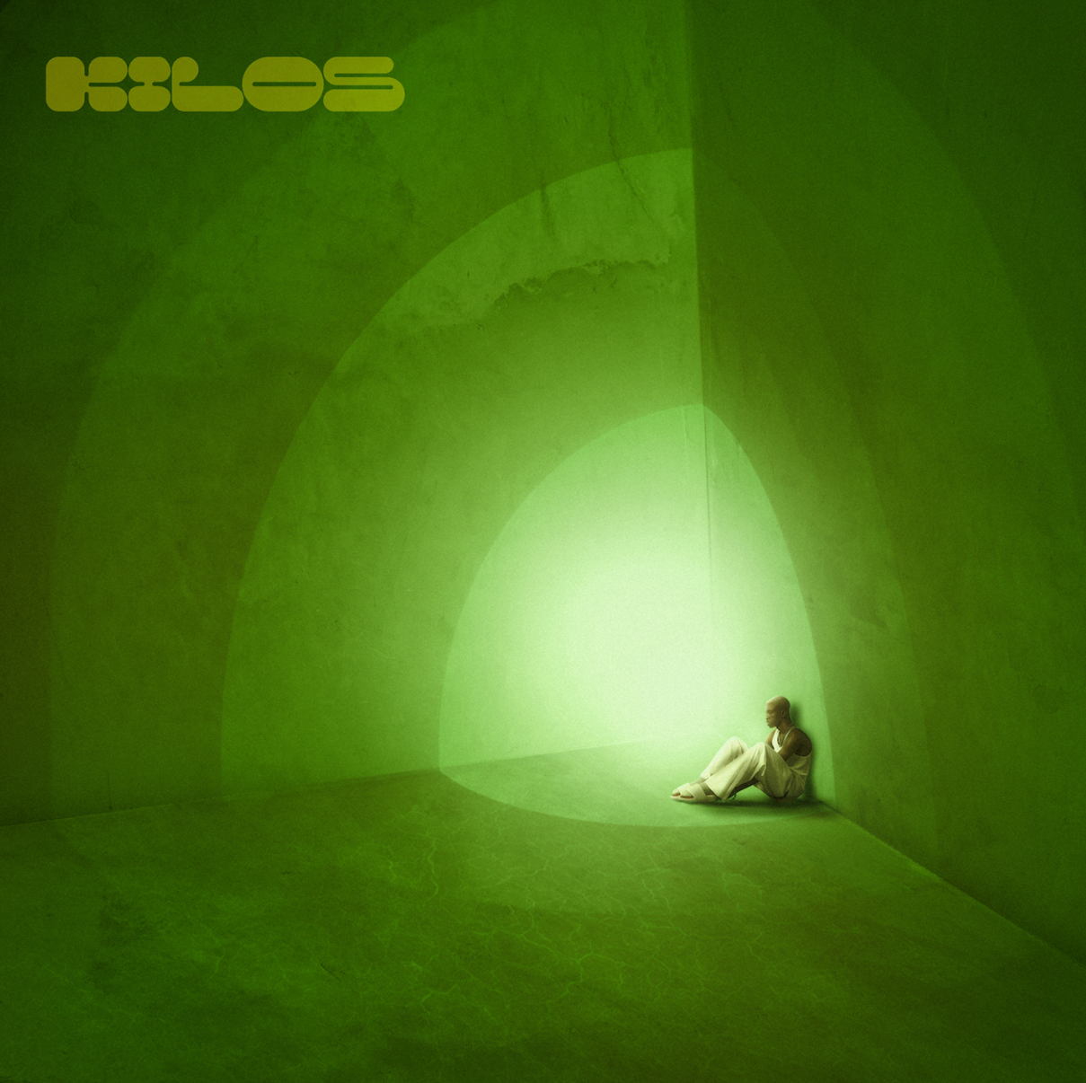
COVER ART | HIGH-RES PRESS PHOTO | PC: SWURVE

Detroit-born and Los Angeles-based artist, model, and maverick creative Sam Austins tapped Norway alt-pop, against-the-grain musician Jimi Somewhere to breathe new life into “KILOS,” bringing us “KILOS (Jimi’s Version).” Although Jimi Somewhere recreating a song about the fireworks and gunshots of Detroit may seem left-of-center, it’s a true testament to the transcendent quality of incredible songwriting. The original "KILOS" uses metaphors to highlight complicated forces that have shaped Austins’ young adult life, while Jimi Somewhere’s lush, lo-fi reinterpretation transforms that personal story into something altogether universal.

Last month Austins revealed “KILOS,” his debut album single that hinges on an evocative guitar line offset by a lo-fi beat as melodies bubble up over the backdrop. The surreal accompanying visual brought his words to life as he leaves a shady motel to roam the empty streets at night before joining a giant Donnie Darko-style bunny in a diner. If Frank Ocean and Johnny Greenwood collaborated, it might sound something like Sam Austins. As Billboard noted in the visual premiere, “With his musical style, Austins is a boundary-breaker, challenging long-held ideas of what it means to be an alternative artist.”

He has quietly infiltrated music, fashion, and film and television. With buzzing acclaimed tracks under his belt, including a co-write on Big Sean’s gold-selling “Wolves” [feat. Post Malone], he notably just joined Sir Chloe and Kaytranada for a Vogue interview and spread in book and online. Vogue observed how he “went down rabbit holes of creativity.” However, everything sets the stage for the release of his debut project, HOMELESS STAR, due out this fall. Stay tuned for more as Sam Austins redefines “alternative” in 2021.

ABOUT SAM AUSTINS
Sam Austins doesn’t just make music; he’s building out a world. This place is equally inspired by the likes of the defiantly vulnerable Frank Ocean, the melodies of nineties alternative, and mythologies of sci-fi classics such as Star Wars. Following high school, he slept on floors, bounced from friend to friend, and crashed in the back of his beat-up Impala. He moved in with an aunt in the inner city of Detroit and turned the focus to music. He dropped the GOAT EP on Soundcloud and opened for the likes of Vince Staples, Juicy J, Danny Brown, and Playboi Carti. During a random encounter in the studio, fashion magnate Phillip Lim heard Sam Austins’ ANGST EP and invited him to be an honorary guest at his 2017 NYFW show. linked up with multiplatinum producers Take A Daytrip and dropped “Fiji Water,” amassing 774K Spotify streams. He joined forces with Black Milk on “Black NASA.” Along the way, he landed placements in VH1’s Love & Hip-Hop and HBO’s Euphoria. In late 2019, he became the recipient of TIDAL’s Unplugged Grant and recorded “LAST MONEY,” “WINGS,” and “STAR.” By 2020, he caught the attention of APG/Atlantic Records. Not to mention, he co-wrote the gold-selling “Wolves” [feat. Post Malone] from Big Sean’s #1 blockbuster Detroit 2. After amassing millions of streams and attracting looks from the likes of Vogue, HYPEBEAST, and Pigeons & Planes, the Los Angeles-based multi-hyphenate opens up this world on his 2021 project HOMELESS STAR led by the single “KILOS.”

PRESS CONTACTS:
Fairley McCaskill | Fairley.McCaskill@atlanticrecords.com
& Chandler Owen | Chandler.Owen@atlanticrecords.com

