FOR IMMEDIATE RELEASE
AUGUST 18, 2020

BANKROL HAYDEN GOT GUCCI LIPSTICK FOR HIS “RICH BITCH”

MODESTO, CA RAPPER UNVEILS CINEMATIC VISUAL TO HIS BREAKOUT SINGLE “RICH BITCH”
WATCH “RICH BITCH” HERE

ON THE HEELS OF HIS DEBUT MIXTAPE PAIN IS TEMPORARY

PAIN IS TEMPORARY INCLUDES THE VIRAL HIT “COSTA RICA” WITH OVER 130M COMBINED STREAMS
WATCH OFFICIAL VIDEO HERE

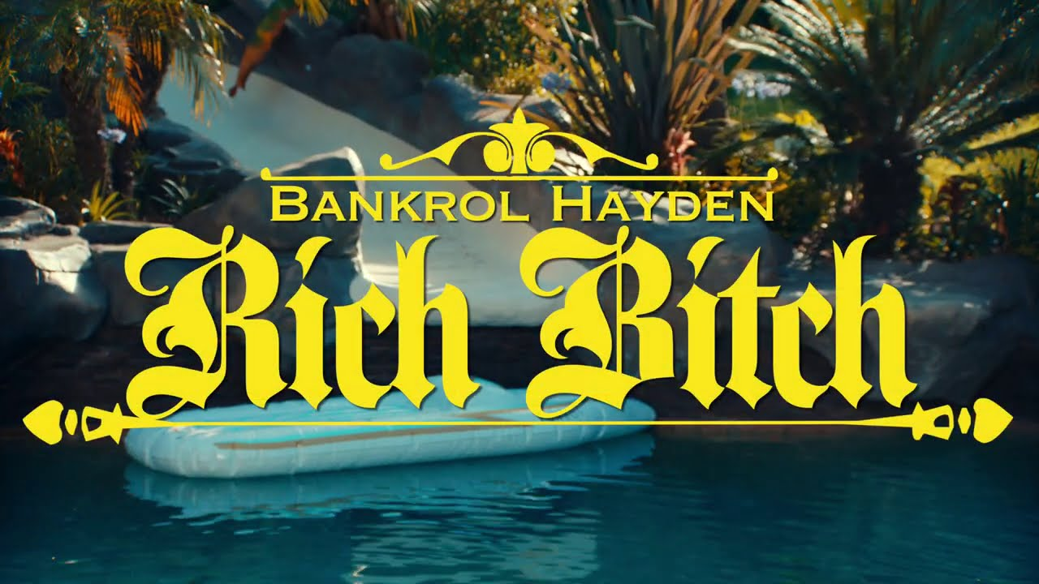
FOR PRESS ASSETS, VISIT HIS PRESS SITE HERE.

Nothing will stop the momentum of Bankrol Hayden. – THE SOURCE

At 18 years old, Bankrol Hayden has already cemented his name in the rap game. – FLAUNT

Atlantic recording artist Bankrol Hayden takes you to the Hollywood hills in his latest visual for “Rich Bitch.” The breakout single from his debut mixtape, Pain is Temporary, the track has already accumulated over 40 million combined streams. Riding on the momentum of its success, Bankrol Hayden teams up with Nicholas Jandora to give you the cinematic “Rich Bitch,” available to stream via YouTube HERE.

Released in June, Pain is Temporary includes lauded features from the likes of Polo G, Lil Baby, The Kid LAROI and Luh Kel. Pain Is Temporary includes his viral hit “Costa Rica,” which recently amassed over 130 million combined streams alongside it’s official music video, which has over 17 million views. The “Costa Rica ft. The Kid LAROI” remix is also featured on the Modesto, CA-native’s debut mixtape. Pain Is Temporary was met with critical acclaim upon its release, with Hot New Hip Hop noting “Bankrol Hayden is further solidifying himself as one of the next artists to blow up with his debut project, Pain Is Temporary.” The incredible mixtape caught the attention of HipHopDX, who commented “There is something to be said for a combination of infectious music and a great story. California native Bankrol Hayden possesses both.” UPROXX also included in their roundup of the best hip-hop albums out that week.

Bankrol Hayden has seen incredible streaming success and has been featured on Spotify’s premiere rap playlist Rap Caviar (13.2m followers) as well as Teen Party (4m followers), Most Necessary (2.4m followers), Pop Rising (2m followers) and more. He’s also been featured on popular Apple Music playlists including The Plug, Hip-Hop Hits, New Fire and The New Bay. YouTube recently featured the young rapper as their Artist on the Rise.

Bankrol was recruited to support Lil Mosey on his Certified Hitmaker European Tour 2020. Watch Bankrol Hayden’s European tour leg vlog HERE; watch the crowd go wild to his viral hit “Costa Rica” at his Norway tour date HERE.

The California native heralded “Costa Rica” with an exclusive preview on his hugely influential Instagram page, joined by fellow social media sensation/artist Einer Bankz. The track marks the latest in a series of increasingly well-liked singles for Bankrol Hayden, following such viral smashes as “B.A.N.K.R.O.L.,” “29,” and “Brothers (Feat. Luh Kel),” the latter now boasting over 100 million worldwide streams thus far.

At just 18 years old, and recently graduating from high school in the midst of the pandemic, Bankrol Hayden is fast proving to be a phenomenon, earning fans around the globe with his positive brand of soulful, pop-forward hip-hop. Along with his musical efforts, Bankrol Hayden is also a major digital influencer and entrepreneur with a combined social media reach exceeding 1.5 million, including a tremendously popular Instagram earning over 150,000 likes per post.

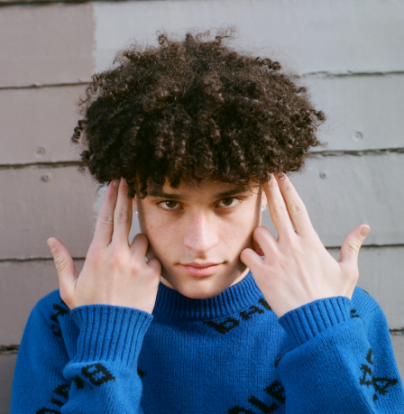
DOWNLOAD HIGH RES PRESS PHOTO HERE
PHOTO CREDIT AIDAN CULLEN

CONNECT WITH BANKROL HAYDEN
INSTAGRAM | TWITTER | YOUTUBE

For additional press assets, please visit his press site HERE.

PRESS CONTACT
FAIRLEY.MCCASKILL@ATLANTICRECORDS.COM

