FOR IMMEDIATE RELEASE

AUGUST 20, 2021

**PRINCE TAEE TAPS EST GEE & HITTA J3 FOR “CERTIFIED STEPPAS”**

[**STREAM**](https://nam04.safelinks.protection.outlook.com/?url=https%3A%2F%2Fprincetaee.lnk.to%2FCertifiedSteppas&data=04%7C01%7CChandler.Owen%40atlanticrecords.com%7C23937aa877d84a00485b08d9638f7957%7C8367939002ec4ba1ad3d69da3fdd637e%7C0%7C0%7C637650290136569324%7CUnknown%7CTWFpbGZsb3d8eyJWIjoiMC4wLjAwMDAiLCJQIjoiV2luMzIiLCJBTiI6Ik1haWwiLCJXVCI6Mn0%3D%7C1000&sdata=fNsBst6iMK4ZWSx34TJr4nhqzI6TZNyI6eSXuEO1IKA%3D&reserved=0) **|** [**WATCH**](https://nam04.safelinks.protection.outlook.com/?url=https%3A%2F%2Fprincetaee.lnk.to%2FCertifiedSteppasVideo&data=04%7C01%7CChandler.Owen%40atlanticrecords.com%7C23937aa877d84a00485b08d9638f7957%7C8367939002ec4ba1ad3d69da3fdd637e%7C0%7C0%7C637650290136579278%7CUnknown%7CTWFpbGZsb3d8eyJWIjoiMC4wLjAwMDAiLCJQIjoiV2luMzIiLCJBTiI6Ik1haWwiLCJXVCI6Mn0%3D%7C1000&sdata=OTvdU6NEWlI%2BF300a40M0Z5mA4VoxgNly1U7hXVvoRA%3D&reserved=0)

**YBN NAHMIR HOPPED ON “BRACES”**

[**STREAM**](https://nam04.safelinks.protection.outlook.com/?url=https%3A%2F%2Fprincetaee.lnk.to%2FBRACES&data=04%7C01%7CChandler.Owen%40atlanticrecords.com%7C03894bb91e174ad2d46b08d8faaa43ef%7C8367939002ec4ba1ad3d69da3fdd637e%7C0%7C0%7C637534956485461771%7CUnknown%7CTWFpbGZsb3d8eyJWIjoiMC4wLjAwMDAiLCJQIjoiV2luMzIiLCJBTiI6Ik1haWwiLCJXVCI6Mn0%3D%7C1000&sdata=M%2FSKUQCudyjoSiquzu9o%2B1AlGj2UXtN1PcgKIGT71XQ%3D&reserved=0) **|** [**WATCH**](https://nam04.safelinks.protection.outlook.com/?url=https%3A%2F%2Fprincetaee.lnk.to%2FBRACESVideo&data=04%7C01%7CChandler.Owen%40atlanticrecords.com%7C03894bb91e174ad2d46b08d8faaa43ef%7C8367939002ec4ba1ad3d69da3fdd637e%7C0%7C0%7C637534956485461771%7CUnknown%7CTWFpbGZsb3d8eyJWIjoiMC4wLjAwMDAiLCJQIjoiV2luMzIiLCJBTiI6Ik1haWwiLCJXVCI6Mn0%3D%7C1000&sdata=0G32FpTFSi6J22hoPIS14oNNLRgcwDiWcvpiJJGflmc%3D&reserved=0)

**PRINCE TAEE’S MAJOR LABEL DEBUT PROJECT COMING THIS YEAR**

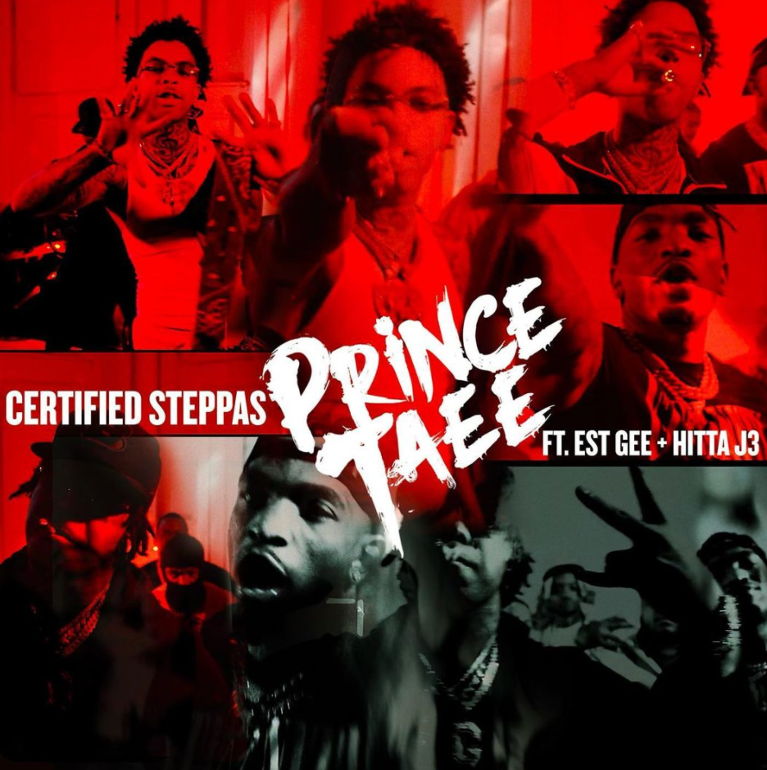

TML/Art@War/Atlantic Records artist Prince Taee explodes back on the scene with the hard-hitting “[Certified Steppas](https://nam04.safelinks.protection.outlook.com/?url=https%3A%2F%2Fprincetaee.lnk.to%2FCertifiedSteppas&data=04%7C01%7CChandler.Owen%40atlanticrecords.com%7C23937aa877d84a00485b08d9638f7957%7C8367939002ec4ba1ad3d69da3fdd637e%7C0%7C0%7C637650290136569324%7CUnknown%7CTWFpbGZsb3d8eyJWIjoiMC4wLjAwMDAiLCJQIjoiV2luMzIiLCJBTiI6Ik1haWwiLCJXVCI6Mn0%3D%7C1000&sdata=fNsBst6iMK4ZWSx34TJr4nhqzI6TZNyI6eSXuEO1IKA%3D&reserved=0).” Recruiting EST Gee and Hitta J3, Taee’s lyrical firepower and iron-clad flow tears through “Certified Steppas.” Watch the official video [HERE](https://nam04.safelinks.protection.outlook.com/?url=https%3A%2F%2Fprincetaee.lnk.to%2FCertifiedSteppasVideo&data=04%7C01%7CChandler.Owen%40atlanticrecords.com%7C23937aa877d84a00485b08d9638f7957%7C8367939002ec4ba1ad3d69da3fdd637e%7C0%7C0%7C637650290136579278%7CUnknown%7CTWFpbGZsb3d8eyJWIjoiMC4wLjAwMDAiLCJQIjoiV2luMzIiLCJBTiI6Ik1haWwiLCJXVCI6Mn0%3D%7C1000&sdata=OTvdU6NEWlI%2BF300a40M0Z5mA4VoxgNly1U7hXVvoRA%3D&reserved=0). Most recently, Taee tapped labelmate YBN Nahmir for “[BRACES](https://nam04.safelinks.protection.outlook.com/?url=https%3A%2F%2Fprincetaee.lnk.to%2FBRACES&data=04%7C01%7CChandler.Owen%40atlanticrecords.com%7C03894bb91e174ad2d46b08d8faaa43ef%7C8367939002ec4ba1ad3d69da3fdd637e%7C0%7C0%7C637534956485461771%7CUnknown%7CTWFpbGZsb3d8eyJWIjoiMC4wLjAwMDAiLCJQIjoiV2luMzIiLCJBTiI6Ik1haWwiLCJXVCI6Mn0%3D%7C1000&sdata=M%2FSKUQCudyjoSiquzu9o%2B1AlGj2UXtN1PcgKIGT71XQ%3D&reserved=0),” the initial offering from his forthcoming debut project. Dropped alongside an [official video](https://nam04.safelinks.protection.outlook.com/?url=https%3A%2F%2Fprincetaee.lnk.to%2FBRACESVideo&data=04%7C01%7CChandler.Owen%40atlanticrecords.com%7C03894bb91e174ad2d46b08d8faaa43ef%7C8367939002ec4ba1ad3d69da3fdd637e%7C0%7C0%7C637534956485461771%7CUnknown%7CTWFpbGZsb3d8eyJWIjoiMC4wLjAwMDAiLCJQIjoiV2luMzIiLCJBTiI6Ik1haWwiLCJXVCI6Mn0%3D%7C1000&sdata=0G32FpTFSi6J22hoPIS14oNNLRgcwDiWcvpiJJGflmc%3D&reserved=0), Prince Taee’s fresh flow and smooth style is further augmented by YBN Nahmir’s unbreakable lyricism to present an irresistible, inventive, and intoxicating track. “BRACES” quickly followed Taee’s “[BeatBox Remix](PrinceTaee.lnk.to/BeatBoxRemix),” where he recruited Moviemode for the [high-energy visual](https://www.youtube.com/watch?v=Pb7JBqWkTVY).

In 2020, Prince Taee’s kept busy with “[Just My Type](https://princetaee.lnk.to/JustMyType)” ft. YK Osiris. The track interpolates Tamia’s 1998 hit single “So Into You,” and its official [companion visual](https://PrinceTaee.lnk.to/JustMyTypeVideo) – directed by Joe Yung Spike – features Fabolous, who also used the song in his 2003 version, “Into You.” The Sons of Mary-produced track premiered via [Complex](https://www.complex.com/music/2020/05/prince-taee-yk-osiris-just-my-type-video), noting how the track “sees the rising 18-year-old rapper tap into his more sensitive side. To coincide with the release of the track, the video shows the pair in full-on R&B classic mode complete with a white grand piano.” “Just My Type” shortly followed the announcement of Prince Taee’s exclusive label deal with Art@War/Atlantic Records via TML (The Music Life). The Las Vegas-bred rapper celebrated the announcement with the release of the highly anticipated “[Free Crack”](https://princetaee.lnk.to/FreeCrack) featuring labelmate YBN Almighty Jay and MyCrazyRO. “Free Crack,” produced by Hasani Buchanan, was accompanied by an electric, Khrave-directed (YBN Almighty Jay, Kaliwae) companion visual, now available to stream [HERE](https://youtu.be/A8VBivnw6Lw).

**CONNECT WITH PRINCE TAEE**

[Instagram](https://nam04.safelinks.protection.outlook.com/?url=https%3A%2F%2Fwww.instagram.com%2Fprincetaee_6&data=02%7C01%7CChandler.Owen%40atlanticrecords.com%7C78ebae8107954cf6b85f08d7fd9564df%7C8367939002ec4ba1ad3d69da3fdd637e%7C0%7C0%7C637256691454190951&sdata=1sji9%2F5ZwhltS7w0jG%2BjuhWraWnCkcndj6479f0w6gQ%3D&reserved=0) |[Facebook](https://nam04.safelinks.protection.outlook.com/?url=https%3A%2F%2Fwww.facebook.com%2Fprofile.php%3Fid%3D100008311310683&data=02%7C01%7CChandler.Owen%40atlanticrecords.com%7C78ebae8107954cf6b85f08d7fd9564df%7C8367939002ec4ba1ad3d69da3fdd637e%7C0%7C0%7C637256691454200947&sdata=xNFO161PkWEJaCSvjFP%2BkO04QD%2FxAAu3Y1fwHPV8GJE%3D&reserved=0) | [YouTube](https://nam04.safelinks.protection.outlook.com/?url=https%3A%2F%2Fwww.youtube.com%2Fchannel%2FUCJOTd4t6U3b9aeXD9w_Eeiw&data=02%7C01%7CChandler.Owen%40atlanticrecords.com%7C78ebae8107954cf6b85f08d7fd9564df%7C8367939002ec4ba1ad3d69da3fdd637e%7C0%7C0%7C637256691454200947&sdata=xWiBTPTBn8cesFMb1xlu%2Bd6ieNPIUTUncjCtAw2jnYs%3D&reserved=0) | [Soundcloud](https://nam04.safelinks.protection.outlook.com/?url=https%3A%2F%2Fsoundcloud.com%2Fprince_taee24&data=02%7C01%7CChandler.Owen%40atlanticrecords.com%7C78ebae8107954cf6b85f08d7fd9564df%7C8367939002ec4ba1ad3d69da3fdd637e%7C0%7C0%7C637256691454210940&sdata=UHy3dlKqFTTvbBY%2FNIKyZslxJi0LXHZDocrzkPlZ3Bk%3D&reserved=0) | [Twitter](https://nam04.safelinks.protection.outlook.com/?url=https%3A%2F%2Ftwitter.com%2Fprincetaee_5&data=02%7C01%7CChandler.Owen%40atlanticrecords.com%7C78ebae8107954cf6b85f08d7fd9564df%7C8367939002ec4ba1ad3d69da3fdd637e%7C0%7C0%7C637256691454210940&sdata=7vYSBZFr5gf3XMKbjlxS4zVloRdFpZmBPCLeuCc%2Bt8c%3D&reserved=0) | [Spotify](https://nam04.safelinks.protection.outlook.com/?url=https%3A%2F%2Fopen.spotify.com%2Fartist%2F3Fi3zsujEOjlfb1YQnvzkQ%3Fsi%3DCSl17BsPQBOQrwyG_W1DDQ&data=02%7C01%7CChandler.Owen%40atlanticrecords.com%7C78ebae8107954cf6b85f08d7fd9564df%7C8367939002ec4ba1ad3d69da3fdd637e%7C0%7C0%7C637256691454210940&sdata=d1jWPih%2FMZBecmW0qkTRhOW94hDyWs7OAfUeotedGJs%3D&reserved=0)

**PRESS CONTACTS**

PRINCE TAEE: [Brittany.Bell@atlanticrecords.com](mailto:Brittany.Bell@atlanticrecords.com)

