FOR IMMEDIATE RELEASE
AUGUST 27, 2020

JASON DERULO BRINGS THE HEAT WITH “TAKE YOU DANCING” MUSIC VIDEO

TUNE INTO THE MULTI-PLATINUM GLOBAL SUPERSTAR’S YOUTUBE RED-CARPET PREMIERE
TODAY AT 11:30AM PT / 2:30PM ET HERE

JASON DEURLO HOSTED JIMMY KIMMEL LIVE LAST NIGHT
WATCH HIM TEASE THE “TAKE YOU DANCING” VIDEO HERE

WATCH JASON PERFORM “TAKE YOU DANCING” ABC’s GOOD MORNING AMERICA
“SUMMER CONCERT SERIES”

WATCH THE “TAKE YOU DANCING” TIK TOK DANCE VIDEO HERE

“TAKE YOU DANCING” AVAILABLE EVERYWHERE TODAY EXCLUSIVELY VIA ATLANTIC RECORDS

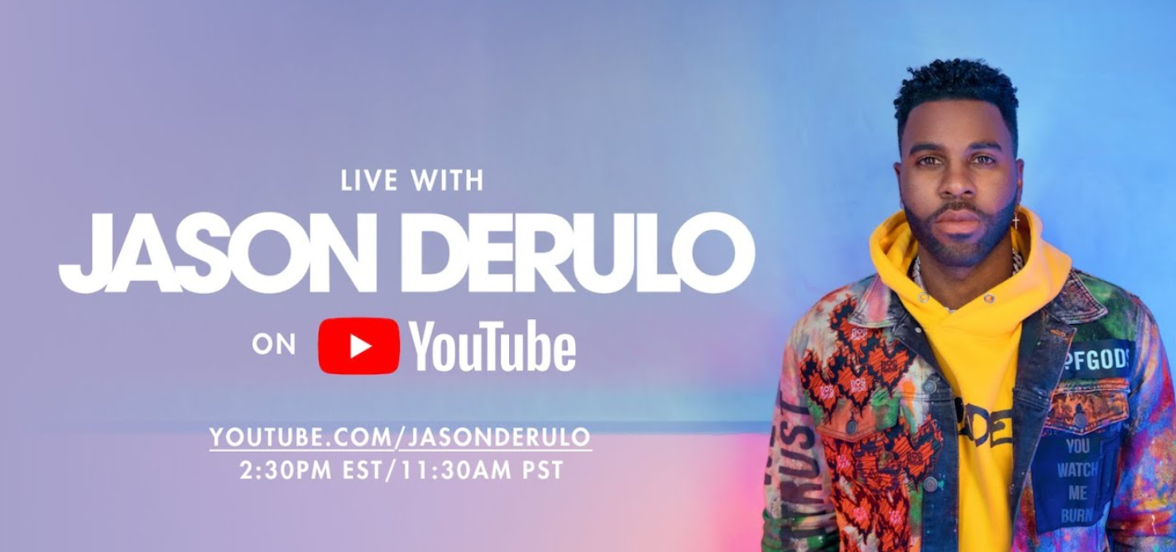
PHOTO CREDIT: DAVID STRBIK| DOWNLOAD HERE
DOWNLOAD “TAKE YOU DANCING” PRESS ASSETS HERE

Multi-platinum global superstar Jason Derulo has announced the official visual companion to “Take You Dancing,” his latest single released exclusively via Atlantic Records. Tune in HERE to the live Red-Carpet premiere via YouTube today at 11:30am PT / 2:30pm ET. The sultry track, which is available now via Atlantic Records HERE – was released alongside an official Tik Tok dance video HERE. Jason Derulo hosted Jimmy Kimmel Live last night on ABC. He teased the unreleased “Take You Dancing” music video during his intro last night – watch it HERE.

“Take You Dancing” has seen incredible success in the first weeks since its release, with over 20 million streams to date. 42 million streams to date. The high-energy Tik Tok video, which has over 15 million views via YouTube, has inspired over 177k videos on the platform, with support from Hannah Stocking (16M Followers), Einer Banks (2.2M Followers), and more. Further, the single was featured on the cover of Apple Music’s influential New Music Daily playlist. Derulo celebrated the track’s arrival with a highly-anticipated live appearance on ABC’s Good Morning America “Summer Concert Series.”

With over 33.6 million followers, Derulo is TikTok‘s most popular active platinum-selling musician across the entire platform. “Take You Dancing” marks the latest in a seemingly infinite series of hit releases from Derulo, including such current favorites as Alok, Martin Jensen & Jason Derulo’s “Don’t Cry For Me“ and Jason Derulo x Puri x Jhorrmountain’s club classic, “Coño,” the latter featured in more than 25 million TikTok videos. In addition, Jawsh 685 & Jason Derulo’s “Savage Love“ has proven a worldwide summer sensation, now boasting well over 130 million global streams and counting. The track is currently ascending towards the top 10 at CHR/Pop radio outlets nationwide having already reached #1 in Ireland, Austria, Australia, New Zealand, Norway, Scotland, Sweden, Switzerland, and the United Kingdom – Derulo’s fifth #1 single in the UK. What’s more, “Savage Love” was recently joined by an official music video, now with over 50 million views via YouTube alone.

A true multi-platform powerhouse, Jason Derulo undoubtedly ranks among the top pop and urban artists of this or any era, with 11 RIAA platinum certified singles, 14 billion combined global streams, close to 6.5 billion YouTube views, and worldwide singles sales well in excess of 190 million. The wildly talented singer, songwriter, dancer, and entertainer first drew acclaim through songwriting collaborations with such like-minded icons as Lil Wayne, Pitbull, Diddy, and Sean Kingston. Derulo kicked off his remarkable solo career with 2009’s chart-topping, 5x platinum certified “Whatcha Say” and never looked back, rolling out five acclaimed albums and an epic string of hugely successful hit single including “In My Head,” “Ridin’ Solo,” “Talk Dirty (Feat. 2 Chainz),” and “Want You To Want Me,” all of which received 4x platinum certification from the RIAA. Additional platinum and multi-platinum hits include the 3x platinum “Wiggle (Feat. Snoop Dogg),” the 2x platinum “Swalla (Feat. Nicki Minaj & Ty Dolla $ign)” and “Trumpets,” and the platinum certified “Don’t Wanna Go Home,” “It Girl,” “The Other Side,” and “Marry Me.” As if all that weren’t enough, Derulo has been an in-demand featured artist, creating international hits with such diverse stars as Pitbull, Florida Georgia Line, Little Mix, Flo Rida, Gucci Mane, and Sofía Reyes.

Among his countless career accomplishments, Derulo is among social media’s biggest stars of any genre, currently boasting over 115 million fans and followers across all platforms. In addition to his prolific musical output, Derulo has made countless TV appearances, including live performances and guest roles on such popular competition series as Dancing With The Stars and So You Think You Can Dance. What’s more, Derulo has also embarked on what is proving a very successful acting career, with highlights including TV’s Empire and Lethal Weapon as well as last year’s big-screen adaptation of Cats. Derulo will next be seen starring as soul legend Ron Isley in the upcoming biographical film, Spinning Gold.

CONNECT WITH JASON DERULO
OFFICIAL | INSTAGRAM | TWITTER | FACEBOOK | YOUTUBE | TIKTOK

PRESS CONTACT
FAIRLEY MCCASKILL | FAIRLEY.MCCASKILL@ATLANTICRECORDS.COM

