FOR IMMEDIATE RELEASE
SEPTEMBER 10, 2021

ALANA MARIA RELEASES DEBUT EP LALA
STREAM HERE

HIGHLIGHTED BY NEW SINGLE “SHOW ME LOVE”

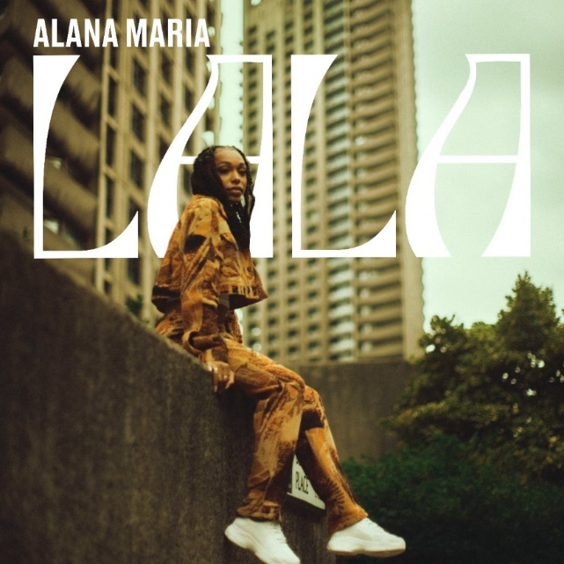

Today, London songstress Alana Maria releases her eagerly anticipated debut EP LALA. Produced by Captain the EP is available to stream/download HERE. LALA is a body of work that encompasses the feelings and emotions of young love, allowing us a sneak peek into the heart and mind of Alana Maria.
Although the tracks are delivered via her distinct and subtle RnB sound, the lyrics remind us of her no nonsense attitude to romance. Tracks like “Out The Mud” and “Switch it Up” exhibit her refusal to dim her light in order to find love. The EP’s undeniable 90’s flava gives us that old school nostalgic sound blended with Alana’s vigorous perspective. With features from Afroswing front woman Midas The Jagaban (“Chargie”), Backroad Gee (“Switch It Up”), and international dancehall star Kranium (“My heart”), LALA is just the beginning of her musical journey.

“My debut EP LALA is an insightful and creative piece of my journey. Making this EP was filled with different emotions and a blend of vibes from me and my squad,” notes Alana. “Choosing the songs for the EP was a little difficult as I’m so eager to show much more, but LALA is a great introduction to who I am.”

The lead single “Show Me Love” is the follow up to her last single “Switch It Up” feat. Backroad Gee and shows the jovial yet more vulnerable side to Alana. Flushed with an Afro vibe, the single highlights her honeyed vocals over this certified party track.

““Show Me Love” is pure vibes because the lyrics are so relatable. Because we want to be the only focus and want to be shown all the love,” explains Alana. “My music stands for being yourself. It’s about understanding that things may not always work out the way that you want, but if that’s the way it’s destined to happen then that’s how you have to embrace it. It’s about being happy, loving yourself, treating yourself right and being around good people. That's what my music is about, that's what I want it to stand for.”

Alana’s cites her music as expressive, versatile and soulful but still pop. Her sound always giving a creative nod to classic R&B influences from the likes of Brandy, SWV, Jhene Aiko and Summer Walker, and more. Born and raised in West London, 20 year old Alana has amassed over 500k views to date with her Instagram and freestyle covers and is rapidly establishing her status on TikTok with over 400k likes since joining the platform a few months ago. The former model and current face of JD Sports’ Back To School campaign, has already earned co-signs from the likes of PA Salieu, Tion Wayne and Pink Sweats and is well on her way to cementing her status as the princess of RnB.

LALA Track List:
- “Out The Mud”
- “Switch It Up” feat. Backroad Gee
- “Chargie” feat. Midas The Jagaban
- “Reasons”
- “Show Me Love”
- “My Heart” feat. Kranium

Connect With Alana Maria:
Instagram|Twitter|Facebook

Press Contact:
Fairley McCaskill | Fairley.McCaskill@atlanticrecords.com

