FOR IMMEDIATE RELEASE
OCTOBER 6, 2021

FAST-RISING STAR BRELAND UPS THE WATTAGE AT NASHVILLE’S THE HIGH WATT WITH A SOLD-OUT CROWD LAST NIGHT IN HIS NEWFOUND HOMETOWN (10/5)

THE SHOW WAS FULL OF EXCITING MOMENTS INCLUDING A SURPRISE VISIT FROM GLOBAL SUPERSTAR KEITH URBAN

ICYMI: BRELAND’S EPISODE OF CMT’S “VIRAL TO VERIFIED” IS AVAILABLE NOW

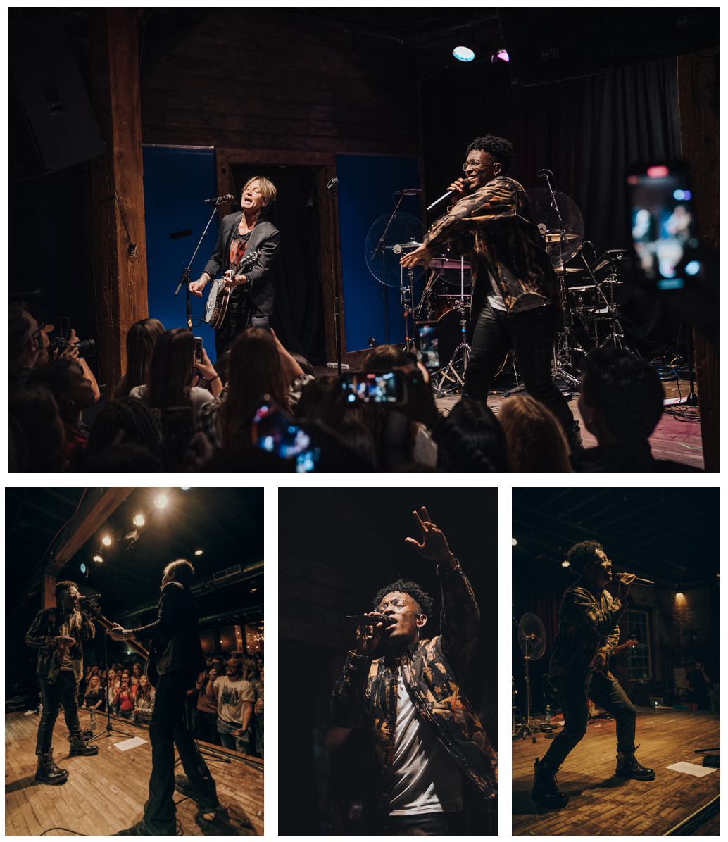
TOP ROW - KEITH URBAN JOINS BRELAND ON STAGE AT THE HIGH WATT, CREDIT: GARRETT RIZAN
SECOND ROW PICTURED (L-R): BRELAND, KEITH URBAN
CREDIT: SAM ALDRICH; BRELAND, CREDIT: GARRETT RIZAN; BRELAND, CREDIT: SAM ALDRICH

Last night at local hot spot The High Watt in Nashville, TN, rising star BRELAND packed the room for his first headlining show in Music City. Recently claiming Nashville as home, BRELAND surprised the SOLD-OUT crowd with a pop-up appearance by fellow collaborator: Keith Urban. The unexpected moment raised the roof off the club and had fans roaring with excitement.

“How badass is BRELAND? Come on,” said Urban as he joined BRELAND on stage. Performing the song they co-wrote off Urban’s most recent album, “Out The Cage,” they capped off their performance together with their current smash anthem that has amassed over 40 million on-demand streams to date, “Throw It Back.”
Showcasing his versatility in his music and style, BRELAND flaunted a jacket by PURPLE BRAND and pants and shoes by Alexander McQueen. He performed some of his standout collabs – “High Horse” with Nelly and Blanco Brown, “Beers On Me” with Dierks Bentley and HARDY – and fan-favorites like breakout PLATINUM track “My Truck,” “Hot Sauce,” and “Cross Country.” BRELAND demonstrated exactly what he promises – his Cross-Country genre blending tracks while delivering harmonies that have captured many fans across not only the U.S., but across the world. BRELAND celebrated the night with an official after-party at Nashville’s brand-new cocktail bar, The Twelve Thirty Club, hosted by GoodCopBadCop and WHY&HOW.
Also, in case you missed it, BRELAND’s episode of CMT’s latest short-form digital series “Viral to Verified” premiered yesterday (10/5). BRELAND is one of six fast-rising musicians to be featured in this new series discussing how they have made waves on social media and in Country music. The episode aired on CMT’s socials, including Instagram and TikTok — the very platforms that ignited BRELAND’s most recently successes. The series highlights one artist per weekly episode, including Lily Rose, Ashley Cooke, CB30, Alexandra Kay, BRELAND, and Priscilla Block. Watch BRELAND’s episode HERE now.

ABOUT BRELAND
With the arrival of his PLATINUM-certified debut single “My Truck,” singer/songwriter/producer BRELAND emerged as a bold new force on today’s music landscape. Originally from New Jersey, BRELAND moved to Atlanta after graduating from Georgetown University, kicking off his songwriting career by scoring cuts with artists like YK Osiris and Ann Marie. Soon after releasing “My Truck” in late 2019, he saw the Hip-Hop and Country hybrid hit #1 on Spotify’s Global Viral 50, with a remix featuring Country hitmaker Sam Hunt landing on best-of-the-year lists from NPR and The New York Times. The song’s success paved the way for his signing to Bad Realm Records/Atlantic Records, leading to collaborations with heavy-hitters from the Country, Pop, and Hip-Hop worlds (including Gary LeVox of Rascal Flatts, Nelly, Blanco Brown, Lauren Alaina, and Chase Rice). BRELAND’s 2021 single “Cross Country” further reveals his passion for transcending boundaries, continuing his mission of breaking down genre barriers in Country music. The Nashville-based artist made his national TV debut with “Cross Country” on The Kelly Clarkson Show, where she surprised him with a PLATINUM plaque for “My Truck.” Now at work on the follow-up to his 2020 self-titled debut EP, he enlisted superstar Keith Urban for the dynamic collaboration “Throw It Back.” Adding to his list of buzzy collaborations, he is currently featured on Dierks Bentley’s single with HARDY, “Beers On Me.” BRELAND has been praised by Rolling Stone as “1,000 percent the whole package,” featured on Billboard’s “Emerging Artists Spotlight,” and earned acclaim from Genius, Paper, USA TODAY, and more.

PRESS CONTACTS:
Fairley McCaskill, Atlantic Records / Fairley.McCaskill@atlanticrecords.com
Jensen Sussman, Sweet Talk Publicity / jensen@sweettalkpr.com

