FOR IMMEDIATE RELEASE
OCTOBER 25TH, 2019

RODDY RICCH ANNOUNCES HIGHLY ANTICIPATED DEBUT ALBUM + PARTNERSHIP WITH ATLANTIC RECORDS

PLEASE EXCUSE ME FOR BEING ANTISOCIAL DROPS ON FRIDAY, DECEMBER 6TH

“START WIT ME (FEAT. GUNNA)” HERALDS ACCLAIMED MC’S STAR-STUDDED NEW LP

COMPANION VIDEO STREAMING NOW VIA YOUTUBE HERE

DEBUT ALBUM FEATURES MEEK MILL, TY DOLLA $IGN, & A BOOGIE WIT DA HOODIE

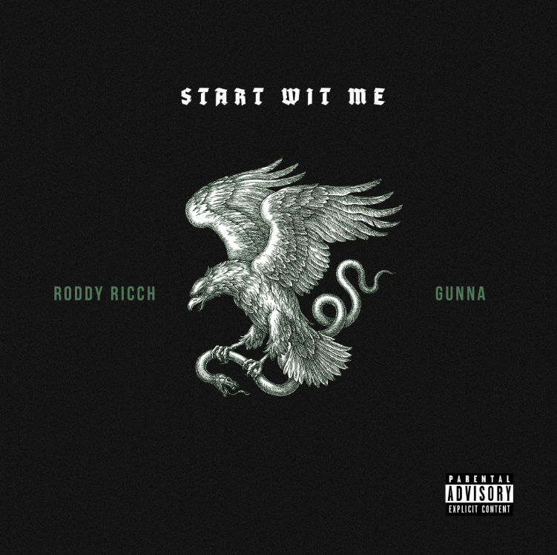
DOWNLOAD HIGH-RES COVER ART HERE

Atlantic Records have officially announced the eagerly awaited label debut album from rising rap superstar Roddy Ricch. PLEASE EXCUSE ME FOR BEING ANTISOCIAL arrives at last on Friday, December 6th. The LP is heralded by today’s release of the banging new single, “Start Wit Me (Feat. Gunna),” available for streaming and download HERE; the track is accompanied by an official companion video, directed by Spike Jordan, streaming HERE.

“I think we have one of the most talented artists coming out in this generation,” says Dallas Martin, SVP of A&R at Atlantic Records, of Roddy Ricch signing. “He makes music so effortlessly, and I think he will have the biggest album of the year.”

PLEASE EXCUSE ME FOR BEING ANTISOCIAL is star-studded with an array of iconic features, including Meek Mill, Ty Dolla $ign, and A Boogie wit Da Hoodie, among others. Highlights include the recently released single, “Big Stepper,” available for streaming and download HERE; the track is accompanied by an official companion video, directed by frequent collaborator JMP (XXXTentacion, G Herbo, Playboi Carti) and streaming HERE.

Roddy Ricch dropped the acclaimed hip-hop hit, “Out Tha Mud,” available for streaming and download HERE, earlier in the year. The track is joined by a companion video, directed by JMP and now boasting over 16 million YouTube views HERE. “Out Tha Mud” drew critical applause upon its release, with Pitchfork naming it among “The Ones,” noting, “Like usual with Roddy, his songwriting is catchy…and his gleaming melody calls for countless replays.”

Named earlier this year to the 2019 XXL Freshman Class, Ricch recently received two top nominations from the BET Hip Hop Awards, including “Best New Artist” and “Best Mixtape,” the latter honoring 2018’s FEED THA STREETS II, available for streaming and download HERE. The mixtape – which marked the 20-year-old Compton MC’s SoundScan/Billboard 200 chart debut – sees him teaming up with some of hip-hop’s top studio superstars, including Scott Storch (Post Malone, T.I., Young Thug), Cassius Jay (Cardi B, Migos, Gucci Mane), and hot emerging producer Sonic. FEED THA STREETS II is highlighted by such tracks as “Every Season” and “Die Young,” both available at all DSPs and streaming services. Produced by London On Tha Track (Lil Wayne, Drake, Post Malone), “Die Young” earned online applause, with Passion of the Weiss raving, “Roddy Ricch sounds like Future, but he expresses his emotions with clarity…He blurs the lines between rap and R&B, delivering cold-hearted lyrics in a crystal clear fashion, like a one-man Jagged Edge… Roddy Ricch doesn’t need anyone to tell you he’s going to be good. He’ll be good. He already is good. This song is great.”

The “Die Young” companion visual – directed by JD Films – also proved a viral favorite, with individual YouTube views approaching 76 million HERE. In addition, Roddy went in depth on “Die Young” in a popular installment of Genius’ “Verified,” streaming HERE.

Wise beyond his years, schooled in real-life struggles, and eloquently effective, Roddy Ricch clearly and concisely conveys truth by way of cinematic rhymes and catchy hooks. The self-proclaimed “illustrator of the streets” uploaded his first single, “Ricch N****” to SoundCloud in 2016 and immediately caught fire, generating more than 200,000 streams within two months. He followed up with his debut mixtape, FEED THA STREETS, streaming HERE. The project includes the breakthrough hit single, “Fucc It Up,” accompanied by a smash companion video, now boasting close to 30 million individual views via Roddy Ricch’s official YouTube channel HERE.

In addition, Roddy celebrated the first anniversary of FEED THA STREETS with the 2019 smash single, “Down Below.” The track’s companion visual –directed by JD Films – has now drawn YouTube views fast approaching 80 million HERE.

As if all that weren’t enough, Ricch teamed with Marshmello for 2018’s worldwide hit single, “Project Dreams,” prompting Billboard to rave, “There's something so funky about Ricch's sing-song flow. He brings the melody to Marshmello's snare-forward, drum-machine beat. The single is an instant earworm…and we definitely hope to hear more of Ricch's voice in the year to come.” “Project Dreams” is joined by an official video currently with over 59 million YouTube views HERE.

CONNECT WITH RODDY RICCH
TWITTER | SOUNDCLOUD | YOUTUBE | INSTAGRAM

PRESS CONTACT
Brittany Bell | Brittany.Bell@atlanticrecords.com

