FOR IMMEDIATE RELEASE
NOVEMBER 24, 2020

RODDY RICCH EARNS SIX GRAMMY NOMINATIONS AT THE 63rd ANNUAL GRAMMY AWARDS

STREAM PLEASE EXCUSE ME FOR BEING ANTISOCIAL HERE

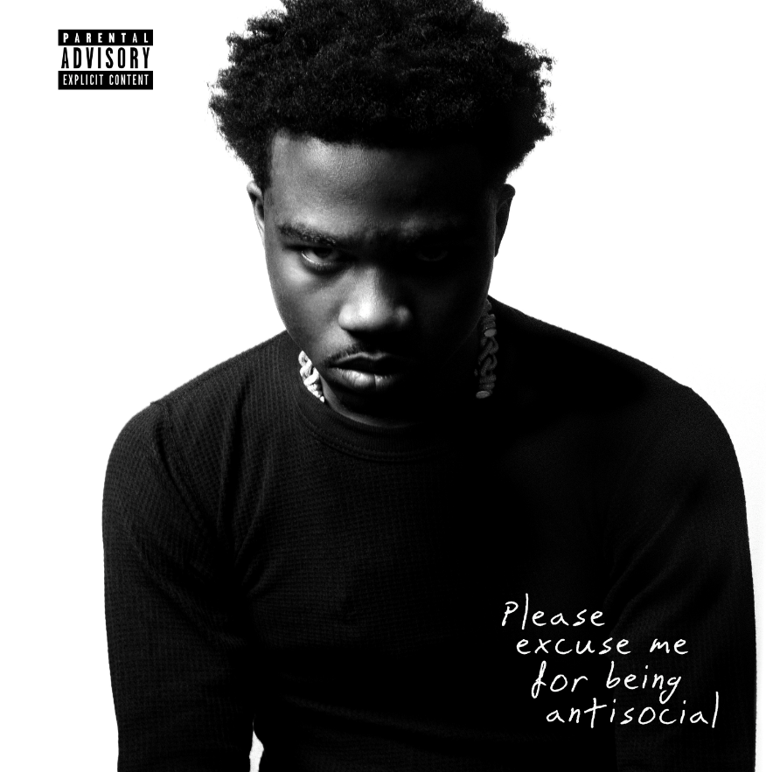
DOWNLOAD HIGH-RES COVER ART HERE

How high can Roddy Ricch climb in 2020? Based on this album, his ceiling should be higher than you think. -BILLBOARD

Roddy was able to craft an album that encapsulates his central appeal — an unnervingly effective ear for melody and a chameleonic ability to adapt to different beats — and imbuing it with an incredibly personal body of work. -ROLLING STONE

Recognized for his blend of melody and hip-hop, riding a lane of trap rap that’s taken over the streets and beyond. -VARIETY

Roddy Ricch has officially earned six additional GRAMMY nominations after today’s announcement for the 2021 GRAMMY Awards. “The Box,” a standout hit and a 2020 anthem from his critically-acclaimed debut album PLEASE EXCUSE ME FOR BEING ANTISOCIAL, earns three nominations in Best Rap Song, Best Melodic Rap Performance and Song of the Year. His feature on DaBaby’s “Rockstar” also garnered three nominations in Best Rap Song, Best Melodic Rap Performance and Record of the Year. The 63rd Annual GRAMMY Awards® will be held Sunday, January 31, 2021.

Wise beyond his years and eloquently effective, GRAMMY-winning Roddy Ricch clearly and concisely conveys truth by way of cinematic rhymes and catchy hooks. Praised by Pitchfork as “the West Coast’s premier melodic storyteller,” the Compton-based MC has quickly become a major musical force, a fact made clear by a 2019 GRAMMY Award win in “Best Rap Performance” for Nipsey Hussle’s “Racks In The Middle (Feat. Roddy Rich & Hit-Boy).” Ricch's debut album PLEASE EXCUSE ME FOR BEING ANTISOCIAL showcases how he separates himself from his contemporary counterparts - taking slow, measured + calculated steps to achieve his goals. Being the quietest in the room isn't a sign of weakness, rather Ricch has turned it into his greatest weapon of success.

The album made an explosive chart debut upon its December 2019 release, arriving at #1 on the SoundScan/Billboard 200 while also topping the “Top R&B/Hip-Hop Albums” and “Top Rap Albums” rankings. Roddy has been dominating the charts on all fronts as he maintained the #1 song and #1 album in the country for the three non-consecutive weeks. His breakout single “The Box” ruled at #1 on Billboard’s Hot 100 for 11 consecutive weeks and made a mark on the Hot R&B/Hip-Hop charts and Hot Rap Songs charts. “The Box” is 4x platinum with over 770 million streams. PLEASE EXCUSE ME FOR BEING ANTI SOCIAL hit #1 on the Billboard 200 Albums chart for four nonconsecutive weeks with over 1.5 million streams to date.

# # #

CONNECT WITH RODDY RICCH
OFFICIAL I TWITTER | SOUNDCLOUD | YOUTUBE | INSTAGRAM

PRESS CONTACT
Brittany Bell | Brittany.Bell@atlanticrecords.com

