FOR IMMEDIATE RELEASE
DECEMBER 13TH, 2019

HOTT LOCKEDN IS PULLING UP IN HIS “G-WAGON”

T.R.U. RECORDING ARTIST DROPS NEW SINGLE + VISUAL

DYNAMIC VIDEO SHOT BY ACCLAIMED DIRECTOR PG

STREAM “G-WAGON” HERE | WATCH OFFICIAL VISUAL HERE

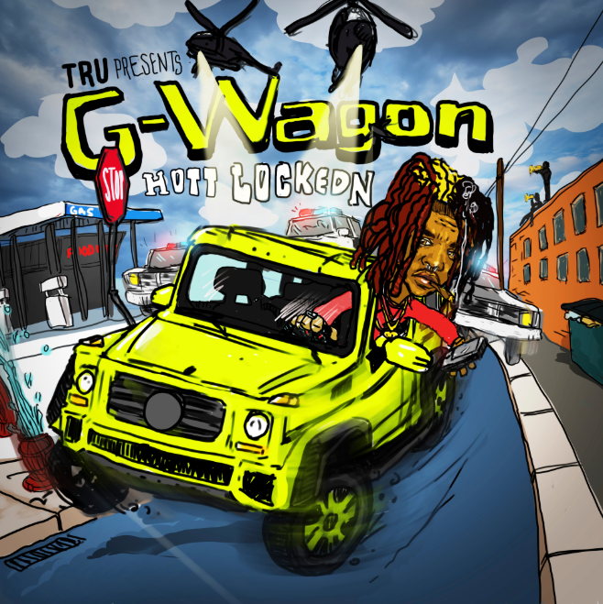
DOWNLOAD HIGH-RES COVER ART HERE

Atlantic Records and T.R.U. (The Real University) recording artist, Hott LockedN, drops his debut label single “G-Wagon,” produced by Zale. The track is accompanied by an electrically charged visual, shot in L.A. and directed by acclaimed director, PG. Stream the official video HERE. “G-Wagon” is available at all DSPs and streaming services HERE. Hott LockedN recently sat down with Dirty Glove Bastard for a candid “Off the Porch” conversation. Watch it HERE.

Earlier this season, GRAMMY® Award-winning 2 Chainz’s T.R.U. (The Real University) and Atlantic Records announced their groundbreaking new partnership with the release of the critically-acclaimed single “Shoot It Out” featuring 2 Chainz and flagship T.R.U. artists Skooly, Worl and Hott LockedN. Stream the track HERE. The track runs alongside a visual directed by Darius Turbak with Cloud Harvest; watch the video HERE.

Born and raised in the Southside Atlanta neighborhood of College Park, Hott LockedN picked up a microphone in 2017 but had his momentum derailed the following year by a gunshot wound to the neck that forced him to work even harder to find his voice. He developed his signature style of “slide music” on his breakthrough mixtape, LOCKED’N DA STREETZ, featuring the hit single, “Buddy Dem.” Having grown up on the same block as Sleepy Rose, 2 Chainz flew both MCs to Los Angeles for an explosive session and signed them both to T.R.U. in 2019.

“I made Hott fly to L.A. with no friends and no guns,” says 2 Chainz. “I told him to just come around be young. In three days, we did thirteen records in that time. If I don’t do anything else in my career, I’ve got to give back to the Southside. I grew up with Hott’s daddy and uncle. This kid got shot and came back. He has a story to tell. We’re bringing that energy in a way where he can make some money and build a life. He deserves it.”

2 Chainz first introduced the T.R.U. brand with 2011’s seminal mixtape, T.R.U. REALIGION, followed the next year by his RIAA platinum certified, GRAMMY® Award-nominated solo debut, BASED ON A T.R.U. STORY, and further developed over the course of eleven trailblazing mixtapes and five solo albums. In 2019, the acclaimed ATL superstar officially founded the T.R.U. label, teaming with Atlantic Records with a goal of formally presenting a new vanguard of Atlanta-based hip-hop talent with flagship artists Skooly, Worl, Hott LockedN and Sleepy Rose.

CONNECT WITH HOTT LOCKEDN
OFFICIAL | INSTAGRAM | FACEBOOK | TWITTER | YOUTUBE

For additional press assets, visit his press site at press.atlanticrecords.com/hott-lockedn.

PRESS CONTACT
Fairley McCaskill | Fairley.McCaskill@atlanticrecords.com

