ALL ACCESS/Shows/New Year’s Eve/NYEAdditionalPerformersAndCollaborations
Publicist: Mallory
To be Release on Friday, Dec. 10 – time TBD (part of TCA)
Approvals Needed:
Diane
Phil
Specials – saw the first draft
Legal
BA
Finance
Marketing
Chris/KK
Green Room/Producers
Copy to Marketing/Social/Debbie when done

Dec. 10, 2021

ADDITIONAL PERFORMERS ANNOUNCED FOR “NEW YEAR’S EVE LIVE: NASHVILLE’S BIG BASH,” A STAR-STUDDED ENTERTAINMENT SPECIAL, AIRING FRIDAY, DEC. 31 ON CBS

Additional Performers Include Lady A, Ingrid Andress, Breland, King Calaway,
Riley Green, Sam Hunt, Chris Janson, Jon Pardi, Carly Pearce and Lainey Wilson

The Five-Hour Celebration Will Ring in the New Year with High-Energy Performances of The Lineup’s Biggest Hits and Once-In-A-Lifetime Collaborations of Some of the Greatest Country Music Songs of All Time

Previously Announced Superstars to Perform on the Special Include Jason Aldean,
Jimmie Allen, Kelsea Ballerini, Gabby Barrett, Dierks Bentley, Brooks & Dunn,
Luke Bryan, Elle King, Miranda Lambert, Darius Rucker, Blake Shelton, Cole Swindell
and Zac Brown Band

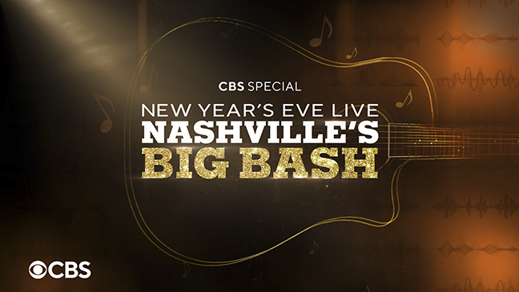

More performers were announced today for NEW YEAR’S EVE LIVE: NASHVILLE’S BIG BASH, a star-studded entertainment special hosted by radio and TV personality Bobby Bones and co-hosted by ENTERTAINMENT TONIGHT’s Rachel Smith. The celebration to ring in the New Year will air LIVE from Music City, Friday, Dec. 31 (8:00-11:00 PM, ET/PT, 11:30 PM-1:30 AM, ET/PT) on the CBS Television Network, and available to stream live and on demand on Paramount+*.

Additional performers who will ring in the New Year include Lady A, Ingrid Andress, Breland, King Calaway, Riley Green, Sam Hunt, Chris Janson, Jon Pardi, Carly Pearce and Lainey Wilson. They join the previously announced stellar lineup that includes Jason Aldean, Jimmie Allen, Kelsea Ballerini, Gabby Barrett, Dierks Bentley, Brooks & Dunn, Luke Bryan, Elle King, Miranda Lambert, Darius Rucker, Blake Shelton, Cole Swindell and Zac Brown Band. The five-hour broadcast will feature a staggering hit parade of more than 50 back-to-back performances and cross multiple time zones, live from the destination home of country music. Nashville will count down with the East Coast at midnight and keep the party going through midnight Central Time with the city’s renowned Music Note Drop®.

The special event will feature once-in-a-lifetime collaborations with artists inviting special guests and artist friends to perform together throughout the night. Taking on their biggest hits and performing covers of some of the most iconic country music songs of all time, collaborations will be stacked throughout the lineup, with details to be announced in the coming weeks.

NEW YEAR’S EVE LIVE: NASHVILLE’S BIG BASH is executive produced by Robert Deaton and Mary Hilliard Harrington in partnership with the Nashville Convention & Visitors Corp. The special will be directed by Sandra Restrepo.

*Paramount+ Premium subscribers will have access to stream live via the live feed of their local CBS affiliate on the service. Essential tier subscribers will also have access to on-demand the day after the special airs.

CHEAT TWEET: Performers added to NEW YEAR’S EVE LIVE: NASHVILLE’S BIG BASH! Ring in the New Year from #MusicCity with over 50 amazing performances including @DierksBentley @zacbrownband @SamHunt @ladya and more! 12/31 8:00 ET/PT!

Photos are available on http://www.viacomcbspressexpress.com/cbs-entertainment

Website: www.cbs.com

CBS Twitter: https://twitter.com/CBSTweet

RATING: To Be Announced

* * *

CBS Press Contacts:
Kate Fisher | khfisher@cbs.com
Mallory Mason | mallory.mason@cbs.com

