ATLANTIC RECORDS OFFICIALLY WELCOMES POP/SOUL SENSATION, BENNETT

NEWCOMER CELEBRATES WITH THE ARRIVAL OF HER DEBUT EP, THINGS I NEVER SAID

THINGS I NEVER SAID AVAILABLE NOW

DOWNLOAD HI-RES ARTWORK HERE

Today Atlantic Records has officially announced the signing of the newest pop/soul sensation, BENNETT. In celebration of her signing announce, the Connecticut songstress has unveiled her debut label EP, THINGS I NEVER SAID, available everywhere now. “I wanted to tell a whole story about the stages of a bad relationship,” she explains. “I discuss growing up without a father, all of my issues, and why I am the way I am. All of the songs connect.”

Download/stream THINGS I NEVER SAID: https://bennettgotbops.lnk.to/ThingsINeverSaid

The 21-year-old songstress introduces her project after her latest video release “Give Me A Reason” which has quickly racked up nearly 500K views. Her most recent releases also include “Come Home” (which was accompanied by an official lyric video highlighting fond memories via a montage of pictures), “Groupie,” “Gone” and “Never Yours.” The latter served as her debut single and without any promotion achieved upwards of 1.5 million streams and counting.

Growing up in the sleepy Connecticut suburb of Cromwell, music called to her at a young age. Her single mother worked long hours but managed to play everything from Pink Floyd to Mötley Crüe around the house, inspiring a love for music in the kids. Her older brother played trumpet, so BENNETT followed suit in middle school and eventually joined jazz band and pep band. She witnessed Wynton Marsalis live as her first concert and went on to dive headfirst into the music of The Weeknd, Amy Winehouse, Stevie Wonder, Nirvana, and more. Filtering emotions into early compositions, she soon began writing and recording songs at a local studio.

BENNETT matches the intensity of everyday emotional ebbs and flows with bold delivery and blunt lyrics befitting of diary entries. Amassing five million streams independently in under a year and receiving acclaim from OnesToWatch, Elevator, Lyrical Lemonade and more, she skirts the borders between R&B, soul and pop.
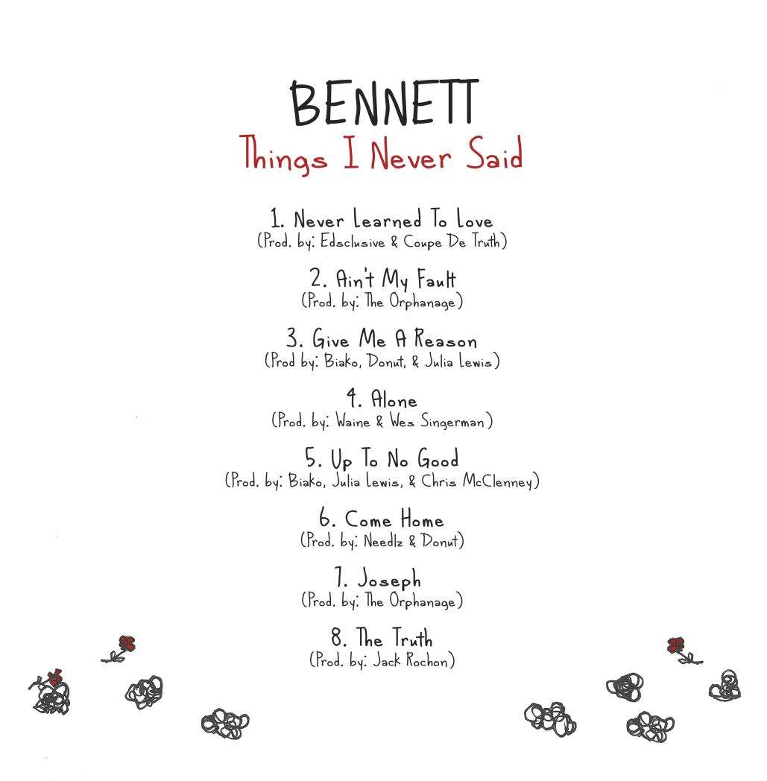

THINGS I NEVER SAID EP
BENNETT
(Atlantic Records)

Never Learned To Love
Ain’t My Fault
Give Me A Reason
Alone
Up To No Good
Come Home
Joseph
The Truth

DOWNLOAD OFFICIAL PRESS IMAGES

ATLANTIC RECORDS PRESS SITE | OFFICIAL WEBSITE | INSTAGRAM | FACEBOOK | TWITTER

PRESS CONTACT
SELAM BELAY // SELAM.BELAY@ATLANTICRECORDS.COM

