FOR IMMEDIATE RELEASE

JUNE 12, 2020

**ANNA CLENDENING MAKES ATLANTIC RECORDS DEBUT WITH “GET ME”**

**NEW SINGLE FROM RISING POP SINGER-SONGWRITER AVAILABLE NOW WITH MUSIC VIDEO**

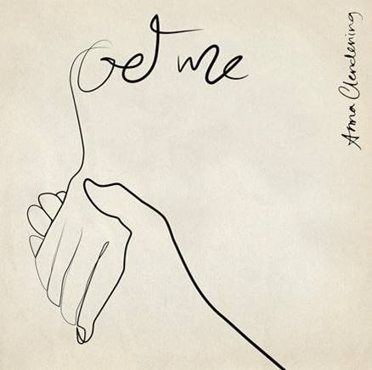

[DOWNLOAD HIGH-RES IMAGES](http://press.atlanticrecords.com/anna-clendening)

**WATCH/STREAM “GET ME”:** <https://annaclendening.lnk.to/GetMePR>

**Atlantic Records** is proud to announce the singing of rising pop singer-songwriter **Anna** **Clendening**, alongside the arrival her new single “**Get** **Me**” – available now with a stunningly shot visual companion. *“This music video is one of the most personal videos I’ve shot*,” explains Clendening of the video. *“To be able to use my home and my most intimate spaces to convey a song written about an ex relationship was amazing.”*

The Chapel Hill-born, Los Angeles-based singer-songwriter relates through unfiltered lyrics ripped right from her notebook, robust vocals quaking with emotion, and brutal honesty. These ingredients struck a chord with listeners everywhere when she released her RIAA-certified Gold single “**Boys Like You**” in 2017, amassing over 100 million streams and critical acclaim from the likes of **Billboard**, **Ones To Watch**, **Refinery29** & more. Meanwhile her debut EP, 2019’s ***Waves***, generated over 150 million streams in under six months as she joined **gnash** on the road and headlined her own ***Waves* *Tour***. Clendening has also lent her voice to high-profile collaborations with **Illenium** (“**Broken** **Ones**”), **Lost** **Kings** (“**Too** **Far** **Gone**”), **Phantoms** (“**Say** **It**”), and most recently **Matoma** (“**Let** **It** **Go**”). Signing to **Atlantic Records** earlier this year, she dove into writing her forthcoming 2020 EP and first full-length offering.

“**Get Me**” reflects her growth. Lone guitar reverberates against breathy verses as she recounts, *“I got you tattooed on my skin to remind myself that I’m better than this, so did you think you’d show up and I’d let you in?”* Her newfound confidence bleeds into the refrain, *“You didn’t get me then, so you don’t get me now*.*”*

In tandem with her honest songwriting, Clendening has proven to be a source of universal encouragement and an incredible advocate for mental health awareness. Following years of anxiety and personal struggles around the topic, she carefully relayed the ups and downs of these experiences into her music – eventually being diagnosed with borderline personality disorder. “**Get Me**” and her forthcoming releases continue to showcase her refreshing candor and strive to further normalize conversations around the topic.

“About five years ago, someone came up to me and said, *‘By fighting through your anxiety in this huge uncomfortable moment on stage, you made me feel so comfortable’*,” shares Clendening. “I was like, *‘Well shit, now I’m in it. I’ve got to be open about it*.*’* I want you to be able to scream my music in the car. I want you to feel like the things going through your head are normal. I want you to feel empowered. I want you to feel loved. I am loud. I am obnoxious. I am a potty mouth. I’m very emotional. I write music. I wear sweatpants. I’m myself. I’m just fucking human, man.”



[DOWNLOAD HIGH-RES IMAGES](http://press.atlanticrecords.com/anna-clendening)

**CONNECT:**

[OFFICIAL](https://www.annaclendening.com/) | [FACEBOOK](https://www.facebook.com/annaclendening) | [TWITTER](https://twitter.com/annaclendening) | [INSTAGRAM](https://www.instagram.com/annaclendening/) | [YOUTUBE](https://www.youtube.com/user/annaclendening08) | [TIKTOK](https://www.tiktok.com/@annaclendening) | [PRESS ASSETS](http://press.atlanticrecords.com/anna-clendening)

**CONTACT:**

[TED.SULLIVAN@ATLANTICRECORDS.COM](mailto:TED.SULLIVAN@ATLANTICRECORDS.COM)