FOR IMMEDIATE RELEASE

SEPTEMBER 4, 2020

**ANNA CLENDENING ANNOUNCES *EVOLVE EP***

**NEW TRACK “SORRY THAT I DO THAT” AVAILABLE NOW**

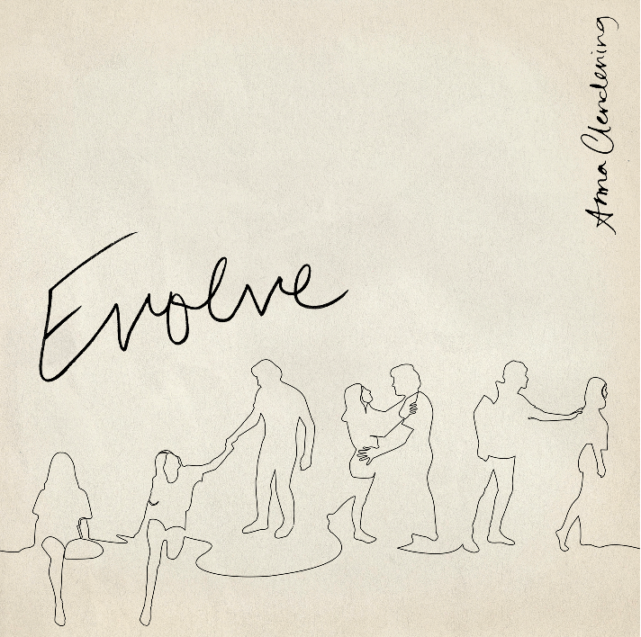

[DOWNLOAD HIGH-RES IMAGES](http://press.atlanticrecords.com/anna-clendening)

**STREAM “SORRY THAT I DO THAT”:** [https://annaclendening.lnk.to/Sorry](https://nam04.safelinks.protection.outlook.com/?url=https%3A%2F%2Fannaclendening.lnk.to%2FSorry&data=02%7C01%7CBrian.Sommer%40atlanticrecords.com%7C8a52f7ff715243dd877408d84f8e7c9f%7C8367939002ec4ba1ad3d69da3fdd637e%7C0%7C0%7C637346820682541283&sdata=pWThMXHPQSAyXYjfno9%2BTdztranAM9tvbAAXQRGVQLY%3D&reserved=0)

**PRE-ORDER/PRE-SAVE *EVOLVE* EP*:*** <https://annaclendening.lnk.to/Evolve>

Rising pop singer-songwriter **Anna Clendening** has announced her **Atlantic Records**-debut EP, ***Evolve***, arriving October 2nd. The 5-track collection is preceded today by “**Sorry That I Do That**,” which showcases her introspective songwriting and penchant for anthemic choruses.

*“(‘****Sorry That I Do That’****) is a song I wrote about my borderline personality disorder without even knowing it,”* explains Clendening. *“I hope it can bring some light to others dealing with it too.”*

Recently, the Chapel Hill-born, Los Angeles-based artist released the EP’s opening track “**Get Me**” along with a stunning companion visual shot in her own home. Hailed by ***Idolator*** as *“an emotional post-breakup anthem,”* “**Get Me**” features guitar that reverberates against breathy verses as the songstress recounts a failed relationship and reflects on her newfound confidence.

Clendening relates through unfiltered lyrics ripped right from her notebook, robust vocals quaking with emotion, and brutal honesty. These ingredients struck a chord with listeners everywhere when she released her RIAA-certified Gold single “**Boys Like You**” in 2017, amassing over 100 million streams and critical acclaim from the likes of **Billboard**, **Ones To Watch**, **Refinery29** & more. Meanwhile her debut EP, 2019’s ***Waves***, generated over 150 million streams in under six months as she joined **gnash** on the road and headlined her own ***Waves* *Tour***. Clendening has also lent her voice to high-profile collaborations with **Illenium** (“**Broken** **Ones**”), **Lost** **Kings** (“**Too** **Far** **Gone**”), **Phantoms** (“**Say** **It**”) and most recently **Matoma** (“**Let** **It** **Go**”) before signing to **Atlantic Records** earlier this year.

In tandem with her honest songwriting, Clendening has proven to be a source of universal encouragement and an incredible advocate for mental health awareness. Following years of anxiety and personal struggles around the topic, she carefully relayed the ups and downs of these experiences into her music – eventually being diagnosed with borderline personality disorder. Her ***Evolve*** EP continues to showcase her refreshing candor and strives to further normalize conversations around the topic.

“About five years ago, someone came up to me and said, *‘By fighting through your anxiety in this huge uncomfortable moment on stage, you made me feel so comfortable’*,” shares Clendening. “I was like, *‘Well shit, now I’m in it. I’ve got to be open about it*.*’* I want you to be able to scream my music in the car. I want you to feel like the things going through your head are normal. I want you to feel empowered. I want you to feel loved. I am loud. I am obnoxious. I am a potty mouth. I’m very emotional. I write music. I wear sweatpants. I’m myself. I’m just fucking human, man.”

***EVOLVE* EP TRACKLIST:**

1. Get Me

2. Sorry That I Do That

3. Love Song

4. Fazed

5. Call It Like It Is



[DOWNLOAD HIGH-RES IMAGES](http://press.atlanticrecords.com/anna-clendening)

**CONNECT:**

[OFFICIAL](https://www.annaclendening.com/) | [FACEBOOK](https://www.facebook.com/annaclendening) | [TWITTER](https://twitter.com/annaclendening) | [INSTAGRAM](https://www.instagram.com/annaclendening/) | [YOUTUBE](https://www.youtube.com/user/annaclendening08) | [TIKTOK](https://www.tiktok.com/@annaclendening) | [PRESS ASSETS](http://press.atlanticrecords.com/anna-clendening)

**CONTACT:**

[TED.SULLIVAN@ATLANTICRECORDS.COM](mailto:TED.SULLIVAN@ATLANTICRECORDS.COM)