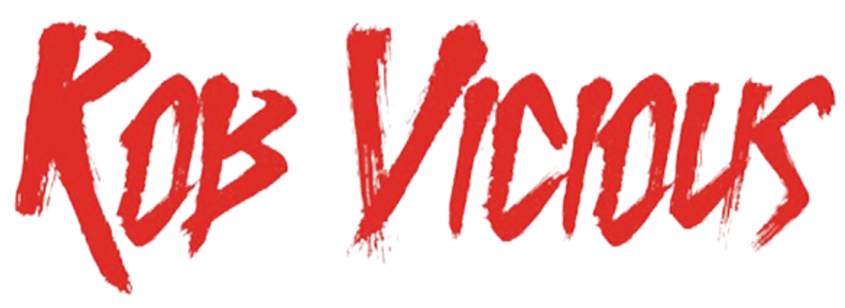
OFFICIAL BIO | UPDATED APRIL 2020

As life goes on, we learn countless lessons. Some impact us more than others. Critically acclaimed multiplatinum rapper and Shoreline Mafia member Rob Vicious points to one lesson as particularly formative.

“I learned you’ve got to do shit for yourself,” the Los Angeles MC exclaims. “I was tired of fucking holding things back. I decided to let that shit go. When I finally did, I took a more mature approach to my life and my music.”

A tireless grind positioned him to do so. During a turbulent childhood moving around the country between his native South Central, Tennessee, Arkansas, and Alabama, he taught himself FL Studio at 10-years-old and started producing. Despite this natural predisposition for music, he found his fair share of trouble as well. Sent to Juvenile Hall on robbery charges, he finished out his sentence on house arrest. At that point, he reached for a mic and began rapping in 2013. Two years later, OhGeesy recruited him as part of Shoreline Mafia.

Between the group’s stratospheric rise to platinum status and sold out arena stages, he delivered his 2018 debut mixtape, Shoreline Mafia Presents Rob Vicious: Traplantic. The project yielded the platinum smash “Bands” [feat. OhGeesy, Fenix Flexin, & Master Kato], which posted up 114 million Spotify streams by 2020. Between “Traplantic,” “Dear God,” “Drip,” and “C Notes” [feat. Fenix Flexin & OhGeesy], he clocked 200 million-plus solo streams. Additionally, Traplantic attracted widespread acclaim from the likes of HYPEBEAST, XXL, and more. RESPECT. Magazine crowned it a “soon-to-be-classic,” and Lyrical Lemonade exclaimed, “The 11 tracks not only reflect the gritty West Coast Shoreline sound, but is yet another showcase of the raw talent of the group.”

Throughout 2019, he went on a creative tear. Holed up in a Venice Beach, CA recording studio, he put down nearly one-hundred records, building a base for his debut album, Breakthrough [Atlantic Records]. He cut deeper than ever before, translating struggle into melody and singing with undeniable intensity at the same time.

“The delivery has got more emotion and pain in it,” he admits. “The sound is really open. I wanted to see how far I could take it, and I took that shit pretty far. I wanted to make you feel exactly like I was feeling. I was going through misery in my life, so I had to sing, because it felt better.”

Breakthrough fuses every side of Rob’s signature style. The bars hit as hard as they always have, but he also embraces a heightened melodic delivery. As a whole, the project lives up to its title, mirroring his artistic and personal evolution.

“On some honest shit, I was talking to my mom and explaining what I was going through,” he recalls. “She kept saying, ‘It’s alright. It’s a breakthrough’. I replayed that through my head for like three weeks. It explains everything perfectly. When you listen to this, it sounds like breaking through some shit, fighting demons, and combating pain from every angle—personal things, family, and friends. I honestly didn’t know what the fuck to do. I had to fight it, stick to the music, and talk about it. In a sense, it brought me some type of comfort.”

By taking the reins, he delivers the same catharsis and comfort for listeners everywhere on Breakthrough and more music to come. “I want you to know I’m making real music,” he leaves off. “It isn’t just party songs. It’s true.”

