ARDEN JONES MAKES VNCLM_ / ATLANTIC RECORDS
DEBUT WITH “ROLLERCOASTER”

FOLLOWING BREAKOUT SONG “PARALLEL PARKING”

LISTEN HERE: https://ardenjones.lnk.to/rollercoaster

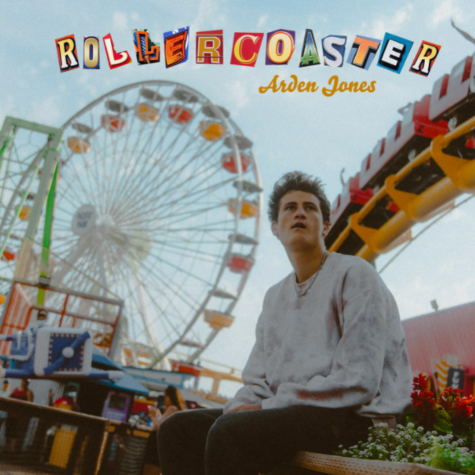
DL art

20-year-old rap/pop crossover artist Arden Jones releases his first single on vnclm_/Atlantic Records today, titled “Rollercoaster.” Listen HERE!

Since its January release, Arden’s feel good single “Parallel Parking” (released on vnclm_) went viral on TikTok and amassed more than 6 million streams on Spotify, as well as charting on Spotify’s Viral 50 charts in Australia and New Zealand. It was also featured on New Music Friday and Fresh Finds: Pop, Pop Sauce, Front Left, Good Vibes, softly, Summer Chillout, Varsity Bars, and young & free.

Arden Jones was born in Marin County, just north of the Golden Gate Bridge, to a family of musicians and writers. He spent his childhood around musicians, regularly performing himself and attending concerts and festivals in San Francisco and Oakland growing up. At home, Arden was exposed to rock, jazz, and blues from a young age. He taught himself to play guitar, piano, mandolin and stand-up bass, and was most inspired by rappers- everyone from 50 Cent and Tupac to J.Cole, Chance, Russ, XXXTentacion and Mac Miller. Jones began writing songs in high school, recording music in his room late into the night when he was supposed to be doing his homework.

Arden studied film in high school at the Marin School for the Arts and went to college at the Dodge Film School at Chapman but realized by the end of his freshman year that all he wanted to do was write music. He began releasing songs, first on SoundCloud and eventually on all platforms. Arden’s first release, “Parallel Parking” in January of 2021, launched his career as it went viral on TikTok and amassed millions of streams on Spotify and other platforms. Arden has always forged his own unique path – one of the main themes of his songs - and the success of his first release confirmed that it was time to drop out of college and move to Los Angeles to pursue music full-time.

Arden is a seeker. He represents every kid who sees a preset path and just can’t take it. He is the kid who rejects the empty route and must do things differently to feel free, alive, wild, happy and in love. When Arden’s not writing music, you can find him carving new paths on Pacific waves. Arden Jones has been called a “hook machine” for the way he can churn out songs daily, and he has developed his own layered sound and style, a lyric-based rap-pop crossover.

CONNECT WITH ARDEN JONES:
INSTAGRAM | YOUTUBE | FACEBOOK | TIKTOK | SOUNDCLOUD | PRESS SITE

Press contacts: jessica.nall@atlanticrecords.com, gabrielle.reese@atlanticrecords.com

