FOR IMMEDIATE RELEASE
DECEMBER 17, 2021

RISING POP SONGSTRESS BENNETT UNVEILS THE BUZZED MIXES

NEW MIX PACK COLLECTS MULTIPLE VERSIONS OF SMASH ANTHEM,
INCLUDING GRAMMY® AWARD-WINNING DUO ICONA POP’S
“BUZZED” (ICONA POP REMIX)”

OFFICIAL “BUZZED” MERCH DROPS TODAY

THE BUZZED MIXES AVAILABLE NOW AT ALL DSPS AND STREAMING SERVICES

WATCH BENNETT PERFORM “BUZZED” ACOUSTIC HERE

LISTEN TO “BUZZED” (ICONA POP REMIX)” HERE

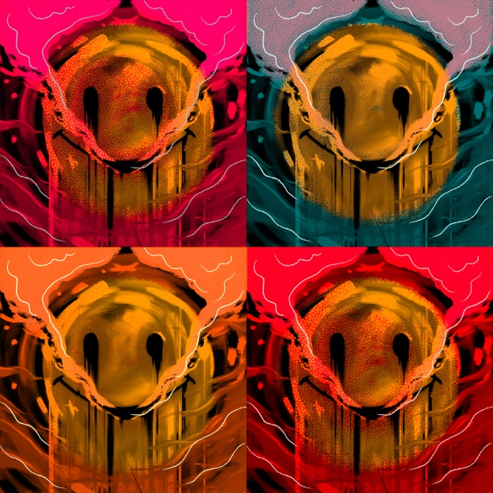

“Give her a listen before she blows up.” – LYRICAL LEMONADE

Rising pop/soul songstress BENNETT has unveiled a new mix pack celebrating her smash anthem, “Buzzed.” THE BUZZED MIXES is available now at all DSPs and streaming services HERE; an exclusive piece of official BUZZED merch drops today HERE.

THE BUZZED MIXES collects multiple versions of “Buzzed,” including the spirited new “Buzzed (Icona Pop Remix),” reimagined for dancefloors everywhere by GRAMMY® Award-winning pop icons Icona Pop. The mix pack further features an electrifying live take (streaming HERE), a stripped-down acoustic rendition, and an addition remix by Brisbane, Australia-based DJ Zaerd, each of which showcase the many facets of BENNETT’s distinctive artistry. “Buzzed” is also joined by a colorful music video, streaming now at YouTube.

BENNETT is like the friend who always understands exactly what you’re going through and knows what to say to make you feel better. Tears, toxic relationships, heartbreak, addiction, anxiety, and anxiousness absorb into her music and bleed back out as R&B-backed bops with bite. Under the influence of Lana Del Rey, Stevie Wonder, Frank Ocean, SZA, and her “favorite artist” The Weeknd, the Connecticut-based singer and songwriter made waves with her debut single, “Never Yours,” eventually earning close to 2.5M worldwide streams. BENNETT’s Atlantic Records debut EP, THINGS I NEVER SAID, dropped in 2020, with its lead single, “Give Me A Reason,” scoring over 6M global streams, 1M YouTube views, and high profile praise from Ones To Watch, Cool Accidents, and Elevator Mag, which simply declared, “It certainly doesn’t appear that stardom is far off for the enigmatic vocalist as her unique appeal is captivating.”

(DOWNLOAD HI-RES PHOTOS // PHOTO CREDIT: JIMMY FONTAINE)

CONNECT WITH BENNETT
WEBSITE | INSTAGRAM | FACEBOOK | TWITTER

PRESS CONTACT
SELAM BELAY // SELAM.BELAY@ATLANTICRECORDS.COM

# # #

