BENNETT TAPS GRAMMY-WINNING DANCE-POP DUO ON “BUZZED” (ICONA POP REMIX)

WATCH THE OFFICIAL VISUALIZER HERE

“We don’t dream we live these nightmares.
Tears in Benzes, buzz like lightyears.”

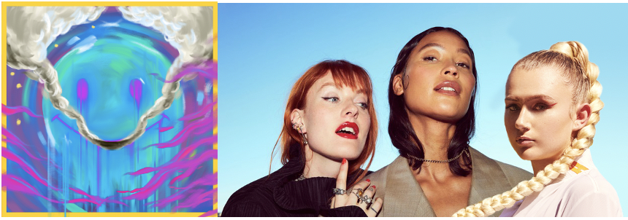

Today, pop/soul songstress, BENNETT, has released the anticipated remix of her anthemic summer single with help from the Grammy-winning dance power-duo Icona Pop. An anthemic dance-pop track with spunk, “Buzzed” (Icona Pop Remix) is available now at all DSPs and streaming services.

Download/stream “Buzzed” (Icona Pop Remix) now: https://BennettGotBops.lnk.to/BuzzedIPRemix
--
After signing to Atlantic Records, BENNETT dropped her debut EP THINGS I NEVER SAID in 2020. The single “Give Me A Reason” eclipsed 6 million global streams and almost 1 million YouTube views. OnesToWatch says, “Few artists are able to perk our ears up after releasing a single, let alone are able to continue delivering again and again,” while Elevator Mag posited, “It certainly doesn’t appear that stardom is far off for the enigmatic vocalist as her unique appeal is captivating.” Racking up millions of streams and garnering praise from Lyrical Lemonade and Cool Accidents to name a few, the singer and songwriter is well on her way.

For more information please visit https://www.bennettofficial.com/.

--
Icona Pop continue to slay since their 2013 full-length debut, This Is… Icona Pop, which garnered critical acclaim from the likes of Pitchfork and Rolling Stone as the duo performed on The Tonight Show Starring Jimmy Fallon, The Today Show, Good Morning America, and America’s Got Talent in addition to featuring on the iconic HBO series Girls and a popular Saturday Night Live sketch. They canvased the globe on sold out tours with Miley Cyrus, Katy Perry, and One Direction and joined Tiësto for the banger “Let’s Go” in 2014. Along the way, the duo has performed alongside everyone from Avicii to The Chainsmokers as well as gracing the stages of Ultra, Tomorrowland, Mark Ronson’s Club Heartbreak, and more. Since then, they have consistently filled the gap in music when it comes to upbeat, carefree, quality dance-pop. Over the past year, the girls have released a slew of singles including collabs with Steve Aoki, Hayden James, Sofi Tukker and Vize. 2022 Will be the 10-year anniversary of their 2012 global smash “I Love It”.

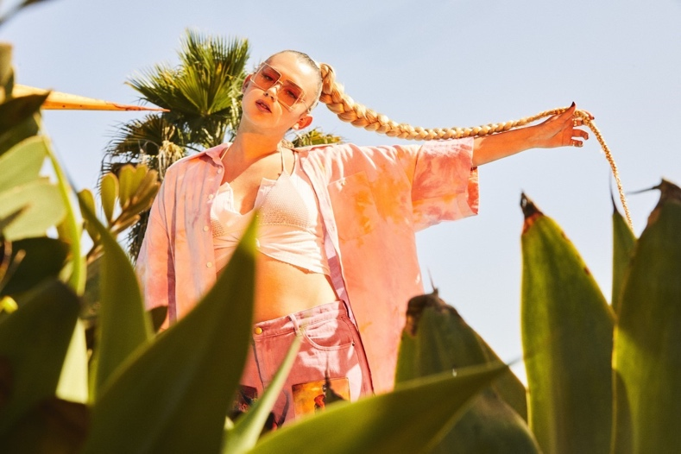
DOWNLOAD HI-RES PRESS PHOTOS HERE

CONNECT WITH BENNETT
WEBSITE | INSTAGRAM | FACEBOOK | TWITTER

PRESS CONTACT
SELAM BELAY // SELAM.BELAY@ATLANTICRECORDS.COM

# # #

