FOR IMMEDIATE RELEASE
MAY 24, 2021

TION WAYNE & RUSS MILLIONS TAP JACK HARLOW FOR LATEST
“BODY REMIX”

SINGLE CELEBRATES #1 IN THE UK, IRELAND, AUSTRALIA, AND NEW ZEALAND

BECOMES FIRST DRILL TRACK TO EVER TOP THE OCC SINGLES CHART AND THE FIRST UK RAP SONG TO REIGN AT #1 IN IRELAND + AUSTRALIA

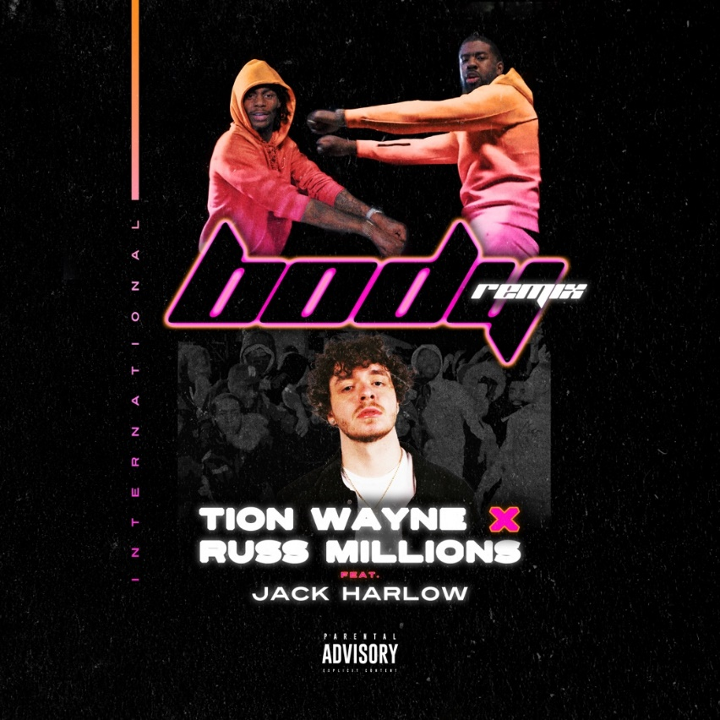

TION WAYNE and Russ Millions have announced a very special remix of the song that everyone is talking about - their early season smash hit Body - this time featuring US rap sensation Jack Harlow. With over 55.8M global streams to date, Body has gone down as not just one of the biggest songs of the year, but one of the most important. From making history as the first ever drill track to top the OCC Singles chart to becoming both the first UK rap song to top the Irish Singles Charts since 2017 as well as the first ever UK rap single to ever land a No.1 on the Australian Single chart, the track has gone on to break both records and cultural barriers across the globe. Now the single receives a very special US lift from Jack Harlow, who has celebrated his own career milestones such as receiving a GRAMMY nomination for his 5x-Platinum hit single “WHATS POPPIN”, off his critically-acclaimed gold-certified debut album That’s What They All Say, collaborating with the likes of Lil Baby, Big Sean, Adam Levine and Bryson Tiller and recently performing on Saturday Night Live in March of this year. This new version follows a very special all-star remix that included Bugzy Malone, Buni, Five Foreign, Darkoo, ArrDee and E1 & ZT from 3x3 released at the end of April.

LISTEN TO “BODY REMIX” FEAT JACK HARLOW

With news that the single has recently scored a third week at No.1 in the UK, Body sold over 81k units last week making it one of the biggest ever end-of-week volumes for a UK rap song of all time. Meanwhile, both Russ & Tion are the top artists on YouTube in the UK for a second week, above global superstars such s Eminem and Ariana Grande. Following in the footsteps of their previous massive collaboration Keisha & Becky, Body has quickly gained steam to become a true behemoth of an early season banger. Showing an ability to react both within UK hip hop culture and achieving commercial appeal, Body was the fastest video to hit over 10m views on GRM Daily since the platform’s creation and is currently A-List on Radio1, S-List at Capitol and also across the KISS Playlist.

TION WAYNE
A true titan of British rap, few artists within the scene can begin to touch Tion Wayne’s culture relevance and numbers. In a short amount of time, Tion has racked up multiple UK Top 10 singles, 2 silver records, 1 gold and 1 platinum, and over 500 million streams. With heavy support across BBC Radio 1 and 1Xtra and consistent premium placement on the popular Spotify playlists Hot Hits UK, Rap UK and Who We Be, he’s become a go to collaborator for some of the biggest and most exciting names working today including Stormzy, 6lack, Rema, NSG, Rudimental, Ms Banks amongst others.

At just 27 years old and the middle child to Nigerian immigrant parents, his drive to succeed has seen him overcome an insurmountable odd to build a fervent fan base that has stuck with him over the years and led him to sell out venues like Brixton Academy within record time. Most impressively, Tion has managed to do this despite not yet releasing his debut album.

CONNECT WITH TION WAYNE:
INSTAGRAM | TWITTER | SOUNDCLOUD

TION WAYNE PRESS CONTACT:
SELAM BELAY | SELAM.BELAY@ATLANTICRECORDS.COM

JACK HARLOW PRESS CONTACT:
JASON DAVIS | JASON.DAVIS@ATLANTICRECORDS.COM

