FOR IMMEDIATE RELEASE
FEBRUARY 16, 2022

BRELAND NAMED BREAKTHROUGH ARTIST FOR AMAZON; ONLY SECOND COUNTRY ARTIST RECOGNIZED IN THE
COVETED ALL-GENRE PROGRAM TO DATE

SET TO DEBUT + PERFORM NEW SINGLE "PRAISE THE LORD" LIVE AT THE 57TH ANNUAL ACM AWARDS ON MARCH 7TH

FEATURED IN MY OPRY DEBUT SEGMENT OUT NOW & COUNTRY MUSIC HALL OF FAME AND MUSEUM’S AMERICAN CURRENTS EXHIBIT OPENING MARCH 4TH

PRE-SAVE "PRAISE THE LORD" HERE

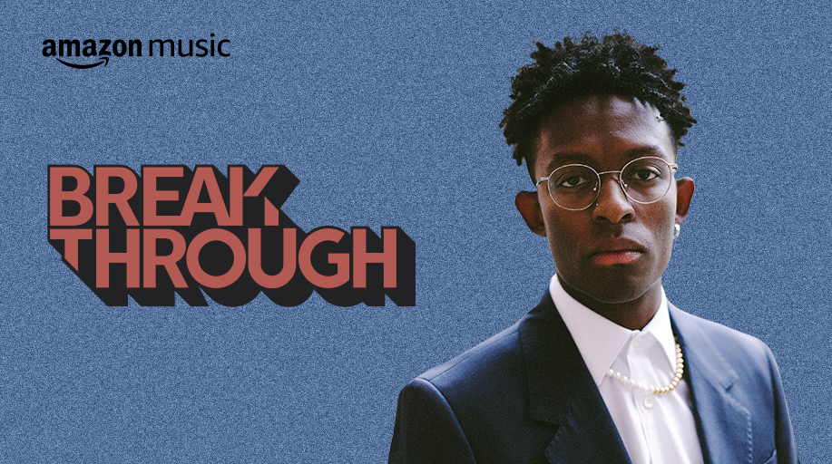
DOWNLOAD ASSET(s) HERE

LOS ANGELES, CA. (February 16, 2022) – Praises continue to stack up for Bad Realm Records / Atlantic Records artist BRELAND who was named Breakthrough Artist for Amazon on Monday (2/14). “BRELAND is a streaming-music star,” says Rolling Stone as they first announced the news. BRELAND now joins the short list of artists earning this coveted all-genre nod aimed at “amplifying and championing” the best new talent. Previous Breakthrough Artists include Gabby Barrett, Blxst, Remi Wolf, Arlo Parks, and more.

The honor means BRELAND will now receive substantial support of Amazon Music – including marketing campaigns, increased playlist visibility, high-profile Amazon Original tracks and more. He’ll also be a featured guest on the Country Heat Weekly podcast.

Continuing to make headlines, BRELAND will make his Academy of Country Music Awards performance debut on March 7. Marking the first major Country awards show to be exclusively live streamed, BRELAND will bring his one-of-a-kind energy to Las Vegas’ Allegiant Stadium as he performs his brand-new song “Praise The Lord.” Only on Prime Video, the two-hour commercial-free show begins at 8 p.m. EST.

Already creating a buzz on socials, BRELAND teased “Praise The Lord” on TikTok and has received incredible feedback and love from his fans across all platforms. The jubilant track is set to release the day of his performance on the ACMs and can be pre-added/pre-saved here now: https://breland.lnk.to/PraiseTheLord

Fans can also catch BRELAND in a new episode of My Opry Debut following his first appearance on the Grand Ole Opry out last Friday (2/11), and he’ll also be recognized by the Country Music Hall of Fame and Museum’s new American Currents: State of the Music exhibit. Opening March 4, the exhibit will feature BRELAND alongside collaborator and believer Keith Urban, in a section highlighting the connections between trailblazers of past, present, and future. The exhibit runs through February 5, 2023.

It’s all proof that BRELAND’s profile continues to grow exponentially. The PLATINUM-certified newcomer opened 2022 performing live on CBS’ New Year’s Eve Live: Nashville’s Big Bash, and he is currently on the road for Russell Dickerson’s ALL YOURS, ALL NIGHT TOUR. See full list of tour stops here.

ABOUT BRELAND:
With his PLATINUM debut “My Truck,” singer/songwriter/producer BRELAND has emerged as a bold new force on today’s music landscape. The Hip-Hop and Country hybrid hit #1 on Spotify’s Global Viral 50 in 2019, and a remix featuring Sam Hunt landed on best-of-the-year lists from NPR and The New York Times. Having signed to Bad Realm Records/Atlantic Records, he has collaborated with heavy-hitters such as Gary LeVox of Rascal Flatts, Nelly, Blanco Brown, Lauren Alaina, and Chase Rice. The New Jersey native has notched several career milestones with high profile looks on The Kelly Clarkson Show, ABC’s CMA Summer Jam, CMT Crossroads, ABC’s Jimmy Kimmel Live!, ABC’s Good Morning America, YouTube’s Artist on The Rise, a Chevy campaign that launched during NFL’s season opener, and most recently named a Breakthrough Artist by Amazon Music. He recently enlisted Keith Urban for the dynamic collaboration “Throw It Back” and is currently featured on Dierks Bentley’s single with HARDY, “Beers On Me.” Praised by Rolling Stone as “1,000 percent the whole package,” he made his Grand Ole Opry debut to a standing ovation and will also be recognized in the Country Music Hall of Fame’s American Currents: State of the Music exhibit opening March 4th.

# # #

CONNECT WITH BRELAND
WEBSITE | TWITTER | INSTAGRAM | FACEBOOK | YOUTUBE

PRESS CONTACTS
Fairley McCaskill | Fairley.McCaskill@atlanticrecords.com
Sara Beth Watson | sbwatson@sweetalkpr.com

