BROOKLYN’S OWN COACHDAGHOST ENDS THE YEAR WITH GROUNDBREAKING “S.H.Y.N.E. FREESTYLE”

CHECK OUT THE OFFICIAL VIDEO HERE

RAPPER ANNOUNCES FORTHCOMING GHOST STORIES MIXTAPE

“S.H.Y.N.E. FREESTYLE” AVAILABLE NOW AT ALL DSPS HERE

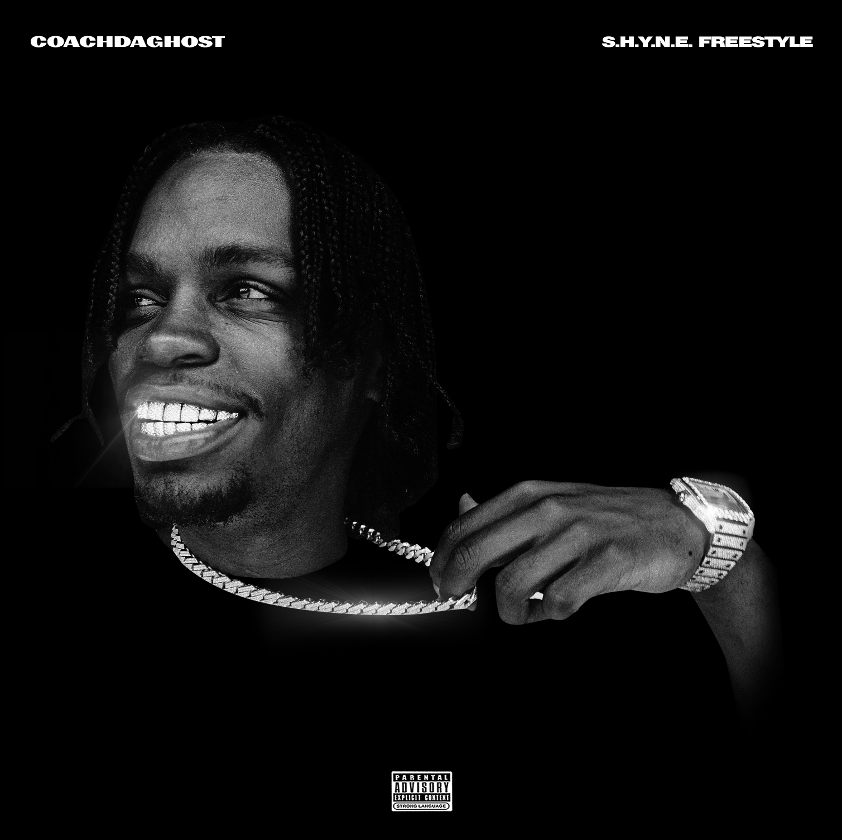

Today, the latest breakthrough rapper on the Brooklyn drill scene has released a hard-hitting new record, “S.H.Y.N.E. Freestyle.” Rising from Brownsville, 26-year old rapper CoachDaGhost is a driving force in the rap landscape, with a number of impressive co-signs from heavy hitters in the past year since beginning his career. Check out his new release “S.H.Y.N.E. Freestyle,” available now at all DSPs and digital retailers HERE. Additionally, Coach released an official companion video to celebrate the release; watch HERE. “S.H.Y.N.E. Freestyle,” produced by CoachDaGhost himself and famed drill producer Ghosty (UK), samples the classic rap record “Shyne” by Shyne—originally produced by the legendary Swizz Beatz.

His latest freestyle, which features the charismatic bars that put him on the map, arrives after tapping drill pioneer 22Gz earlier this year to shake the rap game with the chilling collaboration “Movie.” Watch the official video HERE.

Culture “CoachDaGhost” Bermudez might have just officially entered the industry, but he is no stranger to the game. His most notable release, “Hitlist,” arrived earlier this year, later inking him a deal with The Culturvated Agency, alongside talent such as 22Gz, Bizzy Banks, Maxthademon, Shawny Binladen and Masio Gunz. “Hitlist” has accumulated over 4.7 million views worldwide and attracted the likes of hip-hop enthusiasts everywhere. CoachDaGhost’s chilling bars are also most recognizable in the recent “Gooey Sauce,” which premiered via WorldStarHipHop, bringing in over 2.7 million views.

As talent under The Culturvated Agency, the young rapper’s future seems promising, with impressive numbers that are accentuated by his raw talent and street appeal.

# # #

FOR MORE INFORMATION, PLEASE VISIT:
INSTAGRAM
TWITTER
YOUTUBE

FOR ALL PRESS INQUIRIES, PLEASE CONTACT:
ARIANA.WHITE@ATLANTICRECORDS.COM

