**BIGWALKDOG SIGNS TO GLOBAL 1017 RECORDS/ATLANTIC RECORDS**

**NEW SONG “WHOLE LOTTA ICE” FEAT. LIL BABY AND POOH SHIESTY STREAMING NOW** [**HERE**](https://nam04.safelinks.protection.outlook.com/?url=https%3A%2F%2Fbigwalkdog.lnk.to%2FWholeLottaIce&data=04%7C01%7CTiana.Timmerberg%40atlanticrecords.com%7C563c7a0bc6aa472237d608d93ca5c08c%7C8367939002ec4ba1ad3d69da3fdd637e%7C0%7C0%7C637607504876404720%7CUnknown%7CTWFpbGZsb3d8eyJWIjoiMC4wLjAwMDAiLCJQIjoiV2luMzIiLCJBTiI6Ik1haWwiLCJXVCI6Mn0%3D%7C1000&sdata=uOwz4b1%2Br5lZu64m1nQXymprtelNGWhJVcmai3gZ%2FIo%3D&reserved=0)



[**STREAM / DOWNLOAD “WHOLE LOTTA ICE”**](https://nam04.safelinks.protection.outlook.com/?url=https%3A%2F%2Fbigwalkdog.lnk.to%2FWholeLottaIce&data=04%7C01%7CTiana.Timmerberg%40atlanticrecords.com%7C563c7a0bc6aa472237d608d93ca5c08c%7C8367939002ec4ba1ad3d69da3fdd637e%7C0%7C0%7C637607504876414716%7CUnknown%7CTWFpbGZsb3d8eyJWIjoiMC4wLjAwMDAiLCJQIjoiV2luMzIiLCJBTiI6Ik1haWwiLCJXVCI6Mn0%3D%7C1000&sdata=AV2Kb0%2Fcdo1D1Vq7mGcansa2km6eys5YpSgzZfUU4s8%3D&reserved=0)

[**WATCH “WHOLE LOTTA ICE”**](https://nam04.safelinks.protection.outlook.com/?url=https%3A%2F%2Fbigwalkdog.lnk.to%2FWholeLottaIceVideo&data=04%7C01%7CTiana.Timmerberg%40atlanticrecords.com%7C563c7a0bc6aa472237d608d93ca5c08c%7C8367939002ec4ba1ad3d69da3fdd637e%7C0%7C0%7C637607504876424711%7CUnknown%7CTWFpbGZsb3d8eyJWIjoiMC4wLjAwMDAiLCJQIjoiV2luMzIiLCJBTiI6Ik1haWwiLCJXVCI6Mn0%3D%7C1000&sdata=RLiy3byJ1NSpxgbqL4O1riY8LqZjqfzVxltT62kc%2FAY%3D&reserved=0)

BigWalkDog is celebrating the announcement of his signing to Gucci Mane’s Global 1017 Records in partnership with Atlantic Records. The Mississippi-bred artist is fresh off the release of “Whole Lotta Ice” feat. Lil Baby and 1017’s own Pooh Shiesty, streaming now [HERE](https://nam04.safelinks.protection.outlook.com/?url=https%3A%2F%2Fbigwalkdog.lnk.to%2FWholeLottaIce&data=04%7C01%7CTiana.Timmerberg%40atlanticrecords.com%7C563c7a0bc6aa472237d608d93ca5c08c%7C8367939002ec4ba1ad3d69da3fdd637e%7C0%7C0%7C637607504876424711%7CUnknown%7CTWFpbGZsb3d8eyJWIjoiMC4wLjAwMDAiLCJQIjoiV2luMzIiLCJBTiI6Ik1haWwiLCJXVCI6Mn0%3D%7C1000&sdata=9pBQYCONaKbgAOsw7gSBwGiUvr7Zzou3GCDC561zhrY%3D&reserved=0) alongside its companion video [HERE](https://nam04.safelinks.protection.outlook.com/?url=https%3A%2F%2Fbigwalkdog.lnk.to%2FWholeLottaIceVideo&data=04%7C01%7CTiana.Timmerberg%40atlanticrecords.com%7C563c7a0bc6aa472237d608d93ca5c08c%7C8367939002ec4ba1ad3d69da3fdd637e%7C0%7C0%7C637607504876434706%7CUnknown%7CTWFpbGZsb3d8eyJWIjoiMC4wLjAwMDAiLCJQIjoiV2luMzIiLCJBTiI6Ik1haWwiLCJXVCI6Mn0%3D%7C1000&sdata=xf5Q9SLCIXGqhrlvUxuYti5fYa%2BrDnau32Ldy7u62TU%3D&reserved=0). The iced-out music video has earned more than 700,000 views in its first 24 hours, and is currently #7 on YouTube’s trending music videos.

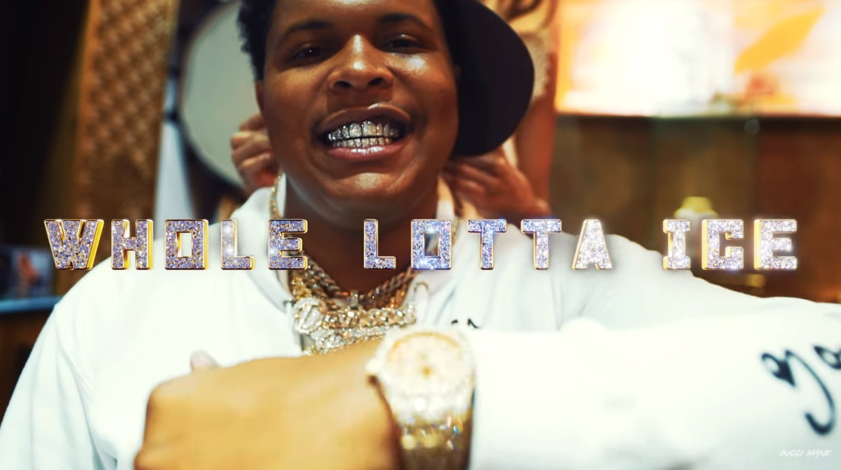

BigWalkDog joins 1017’s stacked roster of Pooh Shiesty, Foogiano, Enchanting, and Big Scarr. Compilation mixtape [*GUCCI MANE PRESENTS: SO ICY SUMMER*](https://nam04.safelinks.protection.outlook.com/?url=https%3A%2F%2Fguccimane.lnk.to%2FSoIcySummer&data=04%7C01%7CTiana.Timmerberg%40atlanticrecords.com%7C563c7a0bc6aa472237d608d93ca5c08c%7C8367939002ec4ba1ad3d69da3fdd637e%7C0%7C0%7C637607504876434706%7CUnknown%7CTWFpbGZsb3d8eyJWIjoiMC4wLjAwMDAiLCJQIjoiV2luMzIiLCJBTiI6Ik1haWwiLCJXVCI6Mn0%3D%7C1000&sdata=JQ%2F428Iubws%2BH1xiRU8SdwiV1O3TWvdk2jBonvynZ7w%3D&reserved=0) introduced the fresh crew with collaborations, solo tracks, and features from some of The New 1017’s signees.  After just a few months, The New 1017 crew has already seen major success with Pooh Shiesty and Foogiano featured on [*Rolling Stone*’s Breakthrough 25](https://nam04.safelinks.protection.outlook.com/?url=https%3A%2F%2Fwww.rollingstone.com%2Fcharts%2Fbreakthrough%2F2020-07-01%2F&data=04%7C01%7CTiana.Timmerberg%40atlanticrecords.com%7C563c7a0bc6aa472237d608d93ca5c08c%7C8367939002ec4ba1ad3d69da3fdd637e%7C0%7C0%7C637607504876444699%7CUnknown%7CTWFpbGZsb3d8eyJWIjoiMC4wLjAwMDAiLCJQIjoiV2luMzIiLCJBTiI6Ik1haWwiLCJXVCI6Mn0%3D%7C1000&sdata=qMV%2FmYG%2B7LN3N8nZHQ52KgimHF70ch7TvIlqHFxoi9w%3D&reserved=0) chart as the 3rd and 5th fastest rising artists of the month of July 2020, respectively, and Big Scarr as #1 in the month of April 2021. BigWalkDog first appeared on Gucci Mane’s most recent release [*ICE DADDY*](https://nam04.safelinks.protection.outlook.com/?url=https%3A%2F%2Fguccimane.lnk.to%2FIceDaddy&data=04%7C01%7CTiana.Timmerberg%40atlanticrecords.com%7C563c7a0bc6aa472237d608d93ca5c08c%7C8367939002ec4ba1ad3d69da3fdd637e%7C0%7C0%7C637607504876454696%7CUnknown%7CTWFpbGZsb3d8eyJWIjoiMC4wLjAwMDAiLCJQIjoiV2luMzIiLCJBTiI6Ik1haWwiLCJXVCI6Mn0%3D%7C1000&sdata=JCBOLdT3RXOW4hZSAvSMG011gN5vB17PeGL%2BdrKo%2FW8%3D&reserved=0)with a feature on opening track “Poppin.”