FOR IMMEDIATE RELEASE
JANUARY 31, 2020

BIRDS OF PREY: THE ALBUM UNITES
SASSY DUO SAWEETIE & GALXARA ON “SWAY WITH ME”
WITH BIRDS OF PREY (AND THE FANTABULOUS EMANCIPATION OF ONE HARLEY QUINN) STAR ELLA JAY BASCO REPRISING HER ROLE AS CASSANDRA CAIN IN THE OFFICIAL MUSIC VIDEO

WATCH “SWAY WITH ME” HERE
LISTEN TO “SWAY WITH ME” HERE

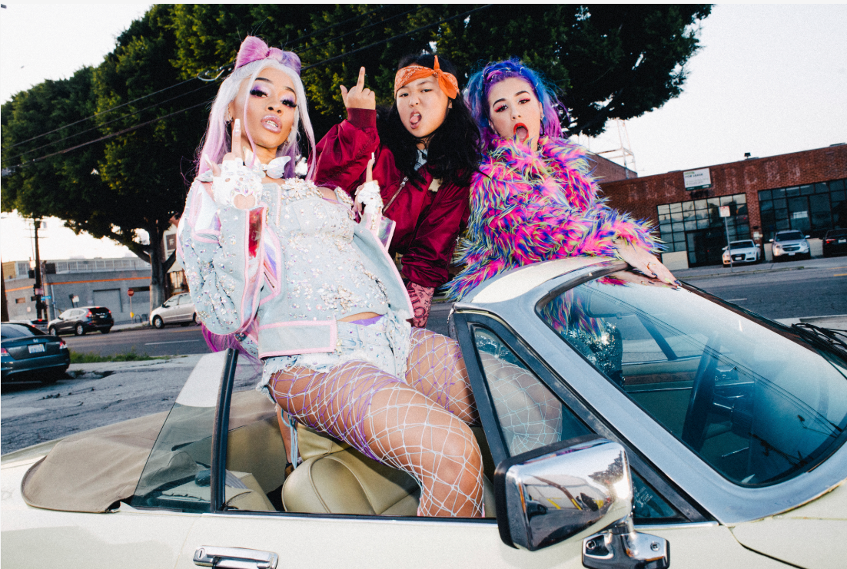
DOWNLOAD PHOTOS HERE

LAST WEEK SAWEETIE, GALXARA & ELLA JAY BASCO ATTENDED A NIGHT OF MUSIC AND MAYHEM IN HARLEYWOOD WITH FELLOW BADASS ALBUM ARTISTS MEGAN THEE STALLION, DOJA CAT AND CHARLOTTE LAWRENCE AS WELL AS MARGOT ROBBIE AND THE CAST OF THE FILM
WATCH THE RECAP OF THE EXPLOSIVE EVENT HERE

“SWAY WITH ME” ADDS TO ARSENAL OF ICONIC ANTHEMS, INCULDING “BOSS BITCH” FROM DOJA CAT, “DIAMONDS” FROM MEGAN THEE STALLION & NORMANI AND “JOKE’S ON YOU” FROM CHARLOTTE LAWRENCE, WHICH HAVE COLLECTIVELY AMASSED OVER 35 MILLION STREAMS

GROUNDBREAKING ALL-FEMALE SOUNDTRACK OUT NEXT FRIDAY WITH
MORE BRAND-NEW EXCLUSIVE MUSIC FROM HALSEY, SUMMER WALKER, LAUREN JAUREGUI
& MORE POWERHOUSE WOMEN

BIRDS OF PREY (AND THE FANTABULOUS EMANCIPATION OF ONE HARLEY QUINN) +
BIRDS OF PREY: THE ALBUM
ARRIVE EVERYWHERE ON FEBRUARY 7TH
PRE-ORDER THE ALBUM HERE
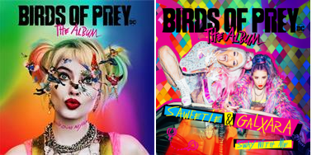
*DOWNLOAD HI-RES IMAGES HERE*

“MUSIC WAS A HUGE PART OF THE FILM SO WE HAD TO HAVE A LINEUP OF THE HOTTEST FEMALE ARTISTS” – MARGOT ROBBIE

“Birds of Prey: The Album is seeded with a murder's row of butt-kicking, all-female acts” – BILLBOARD

“The Birds of Prey soundtrack continues to gift us with a wealth of new music…” – TIME

“At the rate things are going, Birds of Prey is going to be the first spectacular soundtrack of 2020. Every song we’ve heard from the tracklist so far has been a massive bop.” – IDOLATOR

“‘Diamonds’ is breathtaking, brilliant, incredible.” – ELLE

“(‘Joke’s On You’ is a) cinematic anthem about turning a toxic relationship on its head.” – E!

“Doja Cat's 'Boss Bitch' is a ballsy bite back” – PAPER

BIRDS OF PREY: THE ALBUM continues to unleash mayhem week after week leading up to the soundtrack and film’s February 7th global release. Today, power duo comprised of rapper Saweetie and electro-pop artist GALXARA have unveiled their catchy and irresistible sample of Dean Martin’s iconic “Sway” for the new track “Sway With Me” available now HERE. “Sway With Me” arrives alongside an insanely fun music video featuring Ella Jay Basco reprising her badass and sassy character from the film, Cassandra Cain. The video also recreates the scene in the film that features the track -- watch it HERE.

“Sway With Me” follows Doja Cat’s feisty “Boss Bitch,” Charlotte Lawrence’s revenge anthem “Joke’s On You” and the instantly iconic lead single “Diamonds” by Megan Thee Stallion and Normani, which sent Twitter and YouTube into a frenzy upon release. Doja Cat’s “Boss Bitch” dropped last Thursday and received extensive praise immediately with TIME calling it the “ultimate confidence-boosting banger.” Lawrence’s track also garnered widespread acclaim with E! calling it a “cinematic anthem.” “Diamonds” made history as the first song to interpolate and sample Marilyn Monroe’s iconic “Diamonds Are A Girl’s Best Friend.” The single has already racked up over 19 million streams worldwide and the official video has amassed over 6.5 million views since its release.

Last week, Birds of Prey the film kicked off a global takeover with an exclusive event that turned Hollywood into Harleywood. Margot Robbie and the cast gave a special introduction to live performances by Doja Cat and Charlotte Lawrence, while fellow soundtrack artists Megan Thee Stallion, Saweetie, Galxara and Whipped Cream partied and immersed themselves in the world of Birds of Prey. Check out photos and video from the event.

“Sway With Me” was initially teased in the album’s official soundtrack trailer, alongside never-before-heard music from some of the most highly-anticipated tracks on BIRDS OF PREY: THE ALBUM.

BIRDS OF PREY: THE ALBUM’s massive rollout will culminate with its release next week on Friday, February 7th. The revolutionary album features will also include brand new tracks from Halsey, Summer Walker, Lauren Jauregui and Jurnee Smollett-Bell as her character in the film, Black Canary. See below for full tracklisting.

ABOUT BIRDS OF PREY (AND THE FANTABULOUS EMANCIPATION OF ONE HARLEY QUINN):
You ever hear the one about the cop, the songbird, the psycho and the mafia princess? Birds of Prey (And the Fantabulous Emancipation of One Harley Quinn) is a twisted tale told by Harley herself, as only Harley can tell it. When Gotham’s most nefariously narcissistic villain, Roman Sionis, and his zealous right-hand, Zsasz, put a target on a young girl named Cass, the city is turned upside down looking for her. Harley, Huntress, Black Canary and Renee Montoya’s paths collide, and the unlikely foursome have no choice but to team up to take Roman down.

Margot Robbie returns as Harley Quinn, alongside Mary Elizabeth Winstead as Huntress; Jurnee Smollett-Bell as Black Canary; Rosie Perez as Renee Montoya; Chris Messina as Victor Zsasz; and Ewan McGregor as Roman Sionis. Newcomer Ella Jay Basco also stars as Cassandra “Cass” Cain in her feature film debut.

Directed by Cathy Yan from a script by Christina Hodson, the film is based on characters from DC. Robbie also produced, alongside Bryan Unkeless and Sue Kroll. The film’s executive producers are Walter Hamada, Galen Vaisman, Geoff Johns, Hans Ritter and David Ayer.

Warner Bros. Pictures Presents a LuckyChap Entertainment Production, a Clubhouse Pictures Production, a Kroll & Co. Entertainment Production, Birds of Prey (and the Fantabulous Emancipation of One Harley Quinn). The film is being distributed worldwide by Warner Bros. Pictures.

For more information, please visit BIRDSOFPREYMOVIE.COM, FACEBOOK, TWITTER, and INSTAGRAM.

BIRDS OF PREY: THE ALBUM
TRACKLIST

- Doja Cat - Boss Bitch
- WHIPPED CREAM (feat. Baby Goth) - So Thick
- Megan Thee Stallion & Normani - Diamonds
- Saweetie & GALXARA - Sway With Me
- Charlotte Lawrence - Joke's On You
- Maisie Peters - Smile
- CYN - Lonely Gun
- Halsey - Experiment On Me
- Jucee Froot - Danger
- K.Flay - Bad Memory
- Sofi Tukker - Feeling Good
- Lauren Jauregui - Invisible Chains
- Jurnee Smollett-Bell - It’s A Man’s Man’s Man’s World
- Summer Walker - I’m Gonna Love You Just A Little More Baby
- ADONA - Hit Me With Your Best Shot

PRESS CONTACTS:
CHELSEY NORTHERN
CHELSEY.NORTHERN@ATLANTICRECORDS.COM

JESSICA NALL
JESSICA.NALL@ATLANTICRECORDS.COM

