FOR IMMEDIATE RELEASE
JUNE 11, 2021

BIZZY BANKS UNITES WITH PNB ROCK FOR “ADORE YOU”

SEDUCTIVE SUMMER SINGLE HERALDS ACCLAIMED BROOKLYN DRILL STAR’S
EAGERLY AWAITED NEW MIXTAPE, SAME ENERGY, OUT 7/16

SAME ENERGY AVAILABLE FOR PRE-ORDER NOW HERE

LISTEN TO “ADORE YOU (FEAT. PnB ROCK)” HERE
WATCH OFFICIAL MUSIC VIDEO HERE

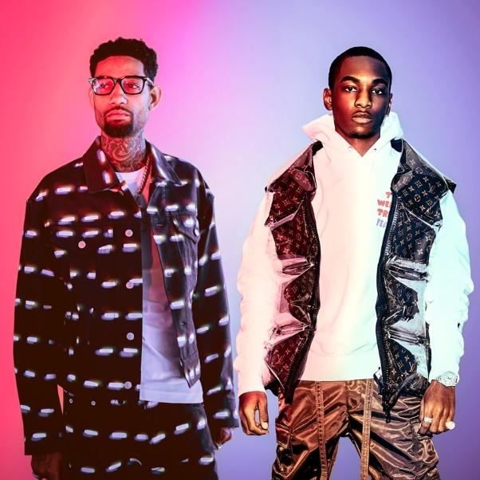
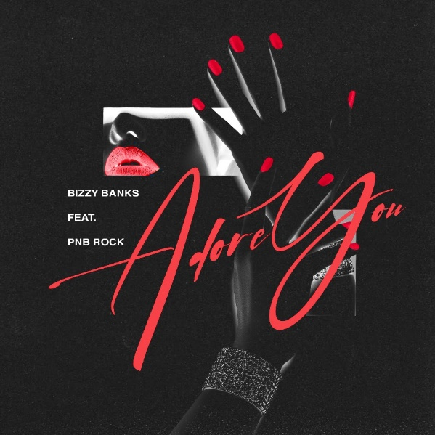

Acclaimed drill rapper Bizzy Banks is showing off his sensitive side by joining forces with multi-platinum superstar PnB Rock on an amorous new single. “Adore You (Feat. PnB Rock)” premieres today at all DSPs and streaming services HERE; an official music video co-starring both artists is streaming now at YouTube HERE.

“Adore You (Feat. PnB Rock)” heralds Banks’ eagerly anticipated new mixtape, SAME ENERGY, due to arrive 7/16; pre-orders are available beginning today HERE. The project was first heralded earlier this year with the acclaimed single, “Bandemic,” available for streaming and download HERE. The track – which currently boasts more than 7.5M global streams – received praise from a range of national publications, including LA Weekly, which wrote, “Banks holds nothing back on the new tune…it’s representative of the material he’s currently working on.” An official video – shot and edited by Useless Films – has already earned over 1.6M views via YouTube alone HERE.

In addition, SAME ENERGY will include the incendiary new single, “City Hot,” available now at all DSPs and streaming services HERE; an official music video is streaming now at YouTube HERE. Pitchfork recently noted Bizzy’s deep connection to his NYC hometown sound, writing, “His music is driven less by his personality and more by his fascination with the city’s rap tradition – heavy on slick wordplay, dramatic slice-of-life stories, and a competitive spirit that’s focused on coming up with the coolest way to say a thought.”

SAME ENERGY marks the eagerly anticipated follow-up to Bizzy’s breakthrough 2020 debut mixtape, G.M.T.O. (Get Money Take Over) Vol. 1., available now at all DSPs and streaming services HERE. The mixtape – which peaked at #24 on both Billboard’s “Heatseekers Albums Chart” and Apple Music’s “US Top Hip-Hop Albums” chart – features a stacked collection of hit singles including “Quarantine Freestyle,” Extra Sturdy,” “Movies,” “Don’t Start Pt. 2,” and “Top 5,” all accompanied by official visuals streaming now at YouTube. The mixtape has amassed 33M streams on all platforms

Along with its popular success, G.M.T.O. (Get Money Take Over) Vol. 1. proved a critically acclaimed sensation, with Pitchfork declaring it “The best Brooklyn drill mixtape of the year,” noting, “Over the course of 15 songs, East New York rapper Bizzy Banks tells grim stories of growing up on the block, drops in catchy hooks, and shows off refreshing production choices…On ‘Top 5,’ he offers some of the best rapping I’ve heard of late—every word leaves his mouth with life-and-death intensity.” In addition, Pitchfork named “Top 5” among its “36 Best Rap Songs of 2020,” praising Bizzy for “his balance of storytelling and flash.” Rolling Stone has also crowned Bizzy #10 on their Breakthrough 25 list which highlights the fastest-rising artists in the industry.

# # #

CONNECT WITH BIZZY BANKS
INSTAGRAM | TWITTER | YOUTUBE

FOR ALL INQUIRIES, CONTACT
ARIANA.WHITE@ATLANTICRECORDS.COM

