BRISTON MARONEY RELEASES “SINKIN’”
FOURTH SONG RELEASED OFF FORTHCOMING DEBUT ALBUM SUNFLOWER

ALBUM SLATED TO ARRIVE APRIL 9TH – ACCOMPANIED BY COMPANION
FULL-LENGTH VISUAL DIRECTED BY JOEY BRODNAX

“SINKIN’” ARRIVES WITH OFFICIAL MUSIC VIDEO

***
“Briston Maroney Is Writing Powerful Rock Songs With Grit And Heart” – NPR

“refreshingly raw” – Consequence of Sound

“…deceptively breezy Americana that’s somewhere on the continuum between John Prine and Kacey Musgraves…” – Talkhouse

***

“SINKIN’” – BUY/STREAM | WATCH

SUNFLOWER – PRE-ORDER | WATCH TRAILER FOR VISUAL ALBUM

photo credit Angelina Castillo

Canvasback Music recording artist Briston Maroney has today released new song “Sinkin’,” the fourth track to be released off his forthcoming debut album Sunflower, set for release on April 9th. The song is joined by an official video starring the Nashville-based artist alongside psychedelic visuals – watch HERE. The album pre-order is live now here, featuring merch and exclusive colored vinyl.

“Sinkin’” follows the album’s previous singles, “It’s Still Cool If You Don’t”, “Deep Sea Diver” and “Freeway,” which were met with critical acclaim from the likes of Paste, Talkhouse, Consequence of Sound, and more.

Released alongside the album announcement, most recent song “It’s Still Cool If You Don’t,” hit #1 at alternative specialty radio in its first week out of the gate and brought Briston his highest ever streaming week. The rest of his catalog also saw a huge spike, with every single song hitting a new one-day peak and bringing the Knoxville-native’s catalog up over 100 million global streams – all prior to the release of an album.

As with the entirety of Sunflower, today’s release was produced by John Congleton (St. Vincent, Angel Olsen). In addition to the acclaimed producer, Maroney also co-wrote with the likes of Manchester Orchestra’s Andy Hull and venerated songwriter Dan Wilson (Leon Bridges, Adele, The Chicks) on the creation of Sunflower. Recorded between the summer of 2019 and early 2020 in Los Angeles, the album is a culmination of the past decade of the now-23-year old’s life.

Maroney shares: “Coming to terms with the full scope of who the hell I am has been the most difficult thing I have ever had to do. It’s also the only thing has allowed me to fully experience true joy in my life. Sometimes processing everything emotionally the way I do, has kept me from understanding things logically, the way other people seem to so effortlessly. This has allowed me to see so much beauty and has at times also made me feel so far away from reality.

'Sunflower' is my attempt at a record about all of those moments, terrifying and serene alike. The times when I’ve felt connected to people and the world, the times I’ve loved, the times I have felt despair, the times I’ve been sure that I’ll never understand and am proved wrong. I am so thankful for the chance to let anyone kind enough to listen know that I love the hell out of life, for better or for worse. I hope it can be a friend to anyone who feels the same way!

Sunflower will arrive alongside a companion full-length feature film envisioned by Maroney and longtime visual collaborator Joey Brodnax, with each song bearing its own cinematic accompaniment. Watch the trailer for the visual album HERE.

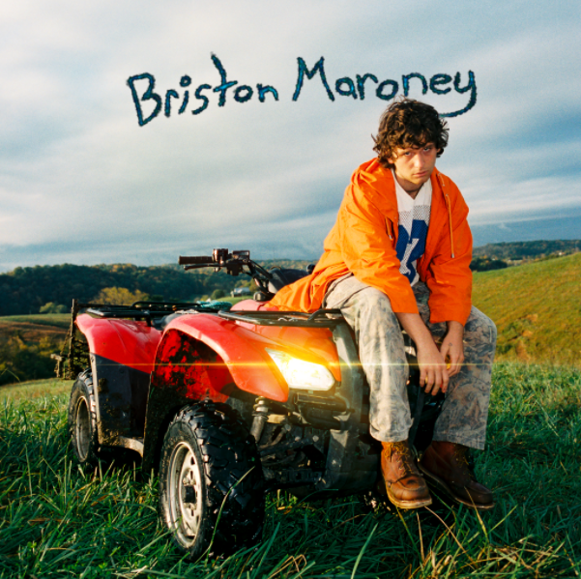
download hi-res album artwork

Co-written with Wilson and released in August, the album’s debut single “Deep Sea Diver” arrived with a Brodnax-directed video, which LADYGUNN praised for the way in which it “plays on the surreal serenity of our natural world.” The magazine continued, “In a trippy, aesthetically pleasing, and hypnagogic type way – both Joey Brodnax and Briston capture the beauty of everyday mundanities and make it look incredible.”

“Deep Sea Diver” was the first new release from Briston since his acclaimed third EP Miracle, released at the top of 2020. Produced by Jim Abbiss (Arctic Monkeys), that project was highlighted by tracks “Chattanooga” and “The Garden” – praised as “refreshingly raw” by Consequence of Sound.

Maroney’s “Freakin’ Out On the Interstate” has also experienced a resurgence of late. First released via his Carnival EP (2018), the song gained serious traction last year, garnering more than 2 million streams a week.

The song had previously been recorded for a performance for World Café – watch here – live at WXPN Studios in Philadelphia, leading NPR to declare “Briston Maroney is writing powerful rock songs with grit and heart.”

In 2019, Maroney was named to various critics’ year-end “Best Of” lists – including PAPER, Vulture, and Consequence of Sound. Off the back of his sophomore EP Indiana, he rose from playing house shows to sold-out clubs in the US, as well as an international headline tour and slots at marquee festivals including Austin City Limits and Pitchfork Paris.

ABOUT BRISTON MARONEY:

After a childhood spent between Tennessee and Florida, 23-year-old recording artist Briston Maroney landed in Nashville and developed a style steeped in the sweat and scrappy sounds of the city's DIY house parties, winning over fans one living room at a time.

Maroney’s 2018 EP Carnival – his take on the modern coming-of-age story and debut for Canvasback Music/Atlantic Records – amassed millions of streams and opened the door to tours with Wallows and Liz Cooper.

The following year saw the release of Indiana, highlighted by such tracks as “Fool’s Gold” (later featured on fellow Nashvillian Taylor Swift’s hugely popular Apple Music “Playlist by ME!”). Indiana was met with wide-ranging critical acclaim, with PAPER praising the EP for its “mixture of absolute tension and mounting significance” and NPR applauding his “buoyant guitar-pop” and “taut, hooky romanticism.” Indiana was ultimately cited on a number of 2019 “Best Of” lists, including Consequence of Sound, Vulture, and PAPER.

At the top of 2020, Maroney released his third EP Miracle, heralded by “Chattanooga” and “The Garden” which Consequence of Sound declared “refreshingly raw.”

An energetic live performer with a craft honed in basements, living rooms, and jam-packed clubs, Maroney spent much of 2019 on the road, including sold out headline shows both here and around the world, dates alongside Cold War Kids, and international festival performances spanning Austin City Limits Music Festival to Pitchfork Paris.

CONNECT WITH BRISTON MARONEY:
OFFICIAL I INSTAGRAM I YOUTUBE I FACEBOOK I TWITTER

FOR ALL PRESS INQUIRIES, PLEASE CONTACT:
Libby Kober | Libby.Kober@AtlanticRecords.com

