BRISTON MARONEY RELEASES DEBUT ALBUM SUNFLOWER

LP ARRIVES ALONGSIDE FEATURE-LENGTH COMPANION VISUAL SUNFLOWER: THE VISUAL ALBUM – DIRECTED BY JOEY BRODNAX

OFFICIAL VIDEO FOR “BOTTLE ROCKET” ALSO UNVEILED TODAY – WATCH HERE

SUNFLOWER FEATURES PRODUCTION FROM JOHN CONGLETON, WITH CO-WRITING FROM DAN WILSON, JENNY OWEN YOUNGS & MANCHESTER ORCHESTRA’S ANDY HULL + ROBERT MCDOWELL

MARONEY INCLUDED ON RECENTLY-ANNOUNCED BONNAROO 2021 LINEUP

***
“Briston Maroney Is Writing Powerful Rock Songs With Grit And Heart” – NPR

“…confessional, feel-good music that gets to the heart of being human…” – Line of Best Fit

“refreshingly raw” – Consequence of Sound

***
SUNFLOWER – BUY/STREAM | WATCH SUNFLOWER: THE VISUAL ALBUM

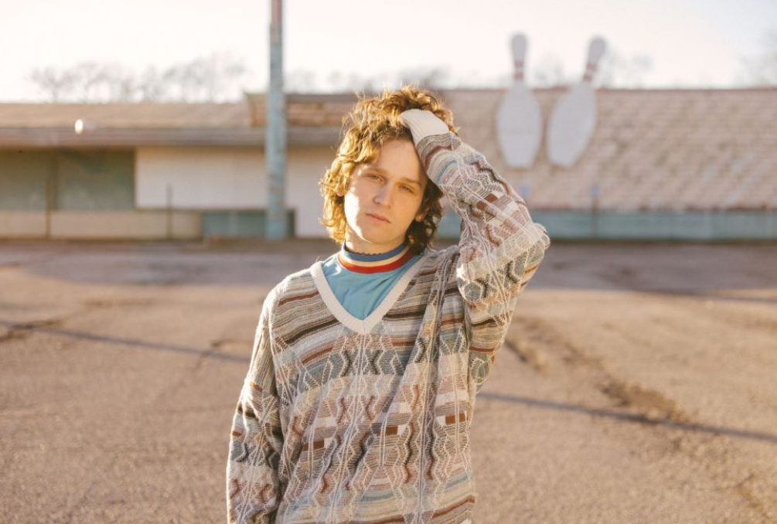
download hi-res press image; photo credit Angelina Castillo

Nashville-based Canvasback Music recording artist Briston Maroney has today released his debut album Sunflower – buy/stream here.

The album arrives alongside a feature-length companion film envisioned by Maroney and longtime creative collaborator Joey Brodnax – with each song on the album bearing its own cinematic accompaniment. Watch Sunflower: The Visual Album here. (Maroney has also released the visual for album track “Bottle Rocket” as a standalone video – watch here)

The album is available now for purchase here, alongside merch and exclusive colored vinyl.

Sunflower was produced by John Congleton (St. Vincent, Angel Olsen). In addition to the acclaimed producer, Maroney also co-wrote with the likes of Jenny Owen Youngs, Manchester Orchestra’s Andy Hull + Robert McDowell, and venerated songwriter Dan Wilson (Adele, The Chicks). Recorded between the summer of 2019 and early 2020 in Los Angeles, the album is a culmination of the past decade of the now-23-year old’s life.

Of the album, Maroney shares: “Coming to terms with the full scope of who the hell I am has been the most difficult thing I have ever had to do. It’s also the only thing that has allowed me to fully experience true joy in my life. Sometimes processing everything emotionally the way I do, has kept me from understanding things logically, the way other people seem to so effortlessly. This has allowed me to see so much beauty and has at times also made me feel so far away from reality.

'Sunflower' is my attempt at a record about all of those moments, terrifying and serene alike. The times when I’ve felt connected to people and the world, the times I’ve loved, the times I have felt despair, the times I’ve been sure that I’ll never understand and am proved wrong. I am so thankful for the chance to let anyone kind enough to listen know that I love the hell out of life, for better or for worse. I hope it can be a friend to anyone who feels the same way!

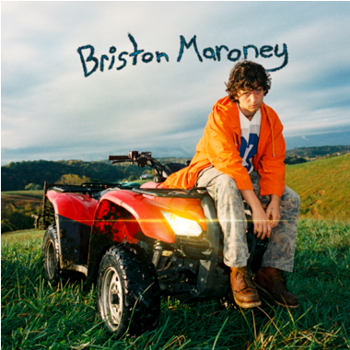
download hi-res album artwork

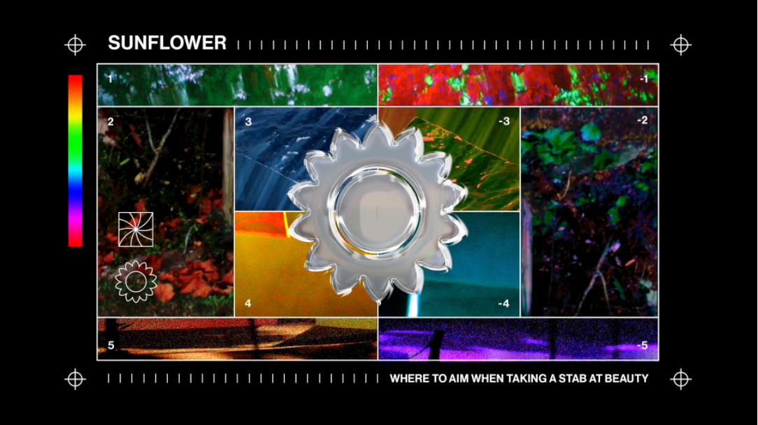
download hi-res film graphic here

Sunflower: The Visual Album premiered in full yesterday on NECAT – the Nashville Public TV Network – and will be airing in regular rotation on the channel throughout the coming days. Briston also recently gave an exclusive BandsInTown performance to fans, which featured a live debut of songs from the album.

Last week, Maroney was included in the long-awaited 2021 lineup announcement for Bonnaroo Music & Arts Festival, to take place in Manchester, TN this September.

Sunflower includes previously released songs “Sinkin’”, “It’s Still Cool If You Don’t”, “Deep Sea Diver” and “Freeway,” which were met with critical acclaim from the likes of Paste, Talkhouse, Consequence of Sound, and more.

Released in February alongside the initial album announcement, current single “It’s Still Cool If You Don’t” hit #1 at alternative specialty radio in its first week out of the gate and brought Briston his highest ever streaming week. The rest of his catalog also saw a spike, with every song hitting a new one-day peak and bringing the Knoxville-native’s catalog up over 100 million global streams – all prior to the release of a full-length album.

Co-written with Wilson and released last August, the project’s debut single “Deep Sea Diver” arrived paired with the first of many Brodnax-directed videos, which LADYGUNN praised for the way in which it “plays on the surreal serenity of our natural world.” The magazine continued, “In a trippy, aesthetically pleasing, and hypnagogic type way – both Joey Brodnax and Briston capture the beauty of everyday mundanities and make it look incredible.”

“Deep Sea Diver” was the first new release from Briston since his acclaimed third EP Miracle, released at the top of 2020. Produced by Jim Abbiss (Arctic Monkeys), that project was highlighted by tracks “Chattanooga” and “The Garden” – praised as “refreshingly raw” by Consequence of Sound.

Maroney’s “Freakin’ Out On the Interstate” also experienced a resurgence of late. First released via his Carnival EP (2018), the song gained serious traction last year, garnering more than 2 million streams a week. The song had previously been recorded for a performance for World Café – watch here – live at WXPN Studios in Philadelphia, leading NPR to declare “Briston Maroney is writing powerful rock songs with grit and heart.”

In 2019, Maroney was named to various critics’ year-end “Best Of” lists – including PAPER, Vulture, and Consequence of Sound. Off the back of his sophomore EP Indiana, he rose from playing house shows to sold-out clubs in the US, as well as an international headline tour and slots at marquee festivals including Austin City Limits and Pitchfork Paris.

ABOUT BRISTON MARONEY:

After a childhood spent between Tennessee and Florida, 23-year-old recording artist Briston Maroney landed in Nashville and developed a style steeped in the sweat and scrappy sounds of the city's DIY house parties, winning over fans one living room at a time.

Maroney’s 2018 EP Carnival – his take on the modern coming-of-age story and debut for Canvasback Music/Atlantic Records – amassed millions of streams and opened the door to tours with Wallows and Liz Cooper.

The following year saw the release of Indiana, highlighted by such tracks as “Fool’s Gold” (later featured on fellow Nashvillian Taylor Swift’s hugely popular Apple Music “Playlist by ME!”). Indiana was met with wide-ranging critical acclaim, with PAPER praising the EP for its “mixture of absolute tension and mounting significance” and NPR applauding his “buoyant guitar-pop” and “taut, hooky romanticism.” Indiana was ultimately cited on a number of 2019 “Best Of” lists, including Consequence of Sound, Vulture, and PAPER.

At the top of 2020, Maroney released his third EP Miracle, heralded by “Chattanooga” and “The Garden” which Consequence of Sound declared “refreshingly raw.”

An energetic live performer with a craft honed in basements, living rooms, and jam-packed clubs, Maroney spent much of 2019 on the road, including sold out headline shows both here and around the world, dates alongside Cold War Kids, and international festival performances spanning Austin City Limits Music Festival to Pitchfork Paris.

CONNECT WITH BRISTON MARONEY:
OFFICIAL I INSTAGRAM I YOUTUBE I FACEBOOK I TWITTER

FOR ALL PRESS INQUIRIES, PLEASE CONTACT:
Libby Kober | Libby.Kober@AtlanticRecords.com
Trish Mollo | Trish.Mollo@AtlanticRecords.com

