CHILDISH MAJOR INTRODUCES FIRST MUSICAL OFFERING OF 2021, “DISRESPECTFUL”
ACCOMPANIED BY OFFICIAL MUSIC VIDEO AVAILABLE NOW
Download/stream here
Watch/share now

“CAN I POP MY SHIT? I MEAN LIKE DAMN I’M FROM THE DIRT
PUT THE GUNS DOWN MAN IT’S KIDS AROUND ENOUGH US ON THE SHIRT
IF I EVER LEARNED A LESSON DAWG I KNOW I GOTTA WORK
HIT THE FACTORY TO PLAN AND GET THEM GRAMS AND GET TO WORK”

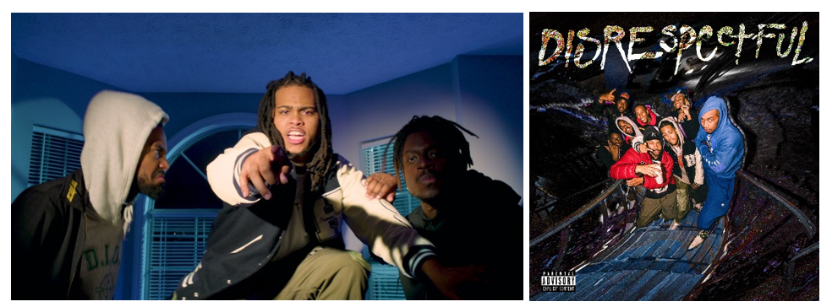
DOWNLOAD HI-RES ARTWORK HERE

After most recently being seen in IBM’s Superbowl commercial alongside Timbaland, CHILDISH MAJOR has made his return with his newest musical offering, “Disrespectful,” which also arrives with a companion visual available now. This track serves as just a taste of what’s to come from the Grammy-nominated artist/producer later this summer.

2020 also served as a strong year for Childish. He kicked it off with the carefree, feel-good track “Dem Know” which featured dancehall/recording artist BEAM and was both produced/engineered by Childish himself. He then slowed the tempo down a bit and followed up with “Shallow Dimes,” exploring his flexibility between rapping and singing. The music video also saw an appearance from Wondaland’s St. Beauty. Shortly after, he released the infectious “Wife You” that had everyone questioning their own insecurities when it comes to relationships. His most recent release, “Kick It” featuring Jace arrived as an official song seen on the Madden NFL 21 soundtrack.

For more information/the latest on Childish Major please visit https://www.childishmajorofficial.com/.
# # #
KEEP UP WITH CHILDISH MAJOR
INSTAGRAM | TWITTER | YOUTUBE | SOUNDCLOUD | WEBSITE

PRESS CONTACT
SELAM BELAY // SELAM.BELAY@ATLANTICRECORDS.COM

