CHILDISH MAJOR REVEALS THE THIRD AND FINAL INSTALLMENT OF THANK YOU, GOD. FOR IT ALL. DOCUMENTARY
FEATURES APPERANCES FROM GRAMMY-NOMINATED 6LACK, MULTI-DISCIPLINARY ARTIST MEZ & HERALDED JOURNALIST YOH PHILLIPS
WATCH THE OFFICIAL VIDEO FOR “PLAYER’S PRAYER” HERE
WATCH/SHARE PART 3: THANK YOU GOD FOR TOMORROW
WATCH/SHARE PART 2: THANK YOU GOD FOR THE PAST
WATCH/SHARE PART 1: THANK YOU GOD FOR THE NOW
STREAM/DOWNLOAD THANK YOU GOD, FOR IT ALL

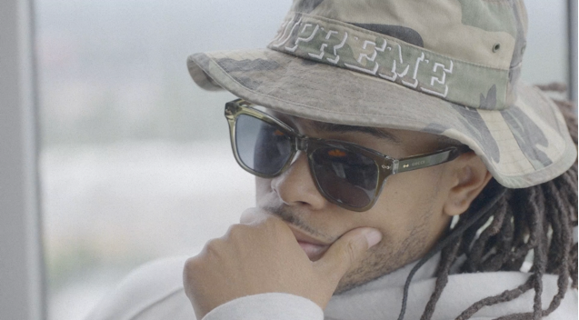

Today marks the release of the third and final installment of GRAMMY-nominated artist/ producer CHILDISH MAJOR’s three-part documentary which chronicles the journey to the release of his eagerly anticipated EP Thank You, God. For It All., available now at all DSPs and streaming services. This follow’s last Friday’s release of the official music video for “Player’s Prayer”.

Titled Thank You, God. For Tomorrow, episode 3 of the documentary is hosted on HipHopDX and centers on the spirituality that fuels the rapper’s optimism about his future career goals, the meaning of the Thank You, God. For It All mantra, and so much more. It also features candid conversations with Grammy-nominated 6lack, heralded music journalist Yoh Phillips and multi-disciplinary artist Mez.

For more information/the latest on Childish Major, please visit www.childishmajorofficial.com/.

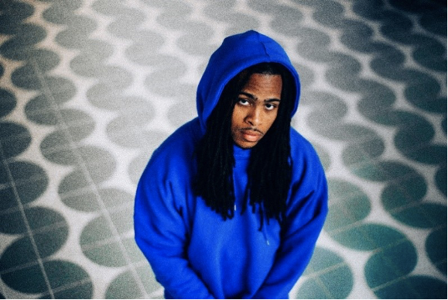
DOWNLOAD PRESS IMAGES HERE

CHILDISH MAJOR

Thank You God, For It All marks Childish Major’s third studio project and follows his debut release, WOO$AH,in 2017 and his second project, Dirt Road Diamond, in 2019.

The Grammy-nominated artist and producer celebrates early career milestones and his journey thus far with an abundance of gratitude in this new project. In the four years since his debut project, Childish Major has had his songs “Supply Luh” and “Know Nothing” featured in the hit HBO series, Insecure. His single “Kick It” featuring Jace is on the Madden NFL 21 soundtrack and he appeared in an IBM Super Bowl LV commercial alongside Timbaland. He also has been featured in Reebok (alongside Tayla Parx) and MCM (alongside close friend Billie Eillish) fashion campaigns.

Offering energetic anthems and soulful bops, this third project from Childish Major is full of intention and sincerity. Tracks such as the recently released “Disrespectful” sets the tone for the confidence and introspection weaved throughout the entire project. Fellow artists ScHoolboy Q and Yung Baby Tate are featured on the seven-song project. Thank You God, For It All opens with “Player’s Prayer,” a song and title that grounds you in the direct praise Childish is giving to God throughout the entire project. Childish Major eloquently raps about the fantastic truths of his evolving career in juxtaposition to the realities of his purpose. From start to finish this project is a grand display of Childish Major’s musical range and devotion to the craft.

# # #
CONNECT WITH CHILDISH MAJOR
INSTAGRAM | TWITTER | YOUTUBE | SOUNDCLOUD | WEBSITE

PRESS CONTACT
SELAM BELAY // SELAM.BELAY@ATLANTICRECORDS.COM

