FOR IMMEDIATE RELEASE
DECEMBER 3, 2021

AFRICA’S BOYFRIEND, CKAY, PRESENTS TWO NEW SINGLES

‘BY YOUR SIDE’ AND ‘EMILIANA’ OUT NOW

SET TO MAKE HIS U.S. TELEVISION DEBUT TONIGHT ON THE TONIGHT SHOW STARRING JIMMY FALLON

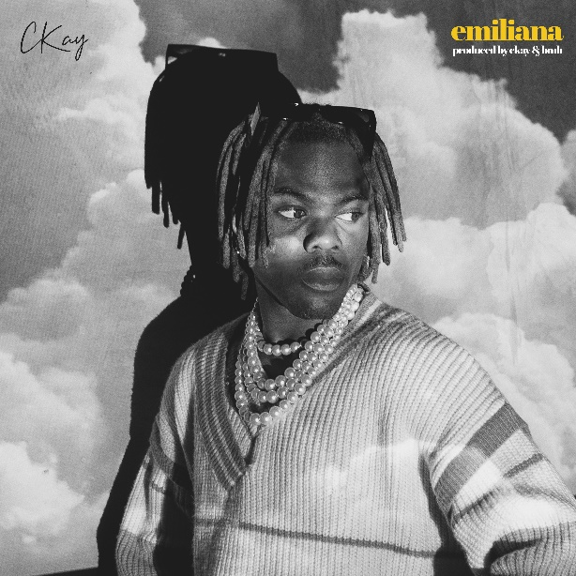

Listen To BY YOUR SIDE Here
Listen To Emiliana Here

CKay, presents two hot new singles titled ‘BY YOUR SIDE’ and ‘Emiliana.’ CKay is no stranger to making amazing music and both songs are a fitting follow up to the global chart topping ‘love nwantiti’ and his 2021 EP ‘Boyfriend’. Since that EP release, CKay has gone on to become one of the biggest stars in the world, boasting #1’s across the globe including a Global Shazam #1 with ‘love nwantiti’.

Last week saw CKay hit over 1 billion career streams, whilst he now boasts over 30 million monthly listeners on Spotify. World domination is definitely in the cards for this platinum selling artist. He is set to make his U.S. television debut tonight, performing a medley of the smash single ‘love nwantiti” and the brand-new track ‘Emiliana’ on The Tonight Show Starring Jimmy Fallon. Also airing this weekend, on Sunday, December 5th, are the 2021 MOBO Awards where CKay is nominated for ‘Best African Act’ alongside some of biggest names in the African music industry; solidifying the newcomer as a force to be reckoned with.

‘BY YOUR SIDE’ features South African rapper Blxckie and produced by Tumisho, whose current single ‘Sax Dance’ has gained popularity on TikTok. This banger has strong Amapiano influences that CKay seamlessly bodies and stamps with his emo -afro beats signature. Blxckie contributes his effortless flow on the track in both Zulu and English, providing the song with an additional take on the romantic situation. ‘BY YOUR SIDE’ was influenced by CKay having to make a decision between two girls. Although the situation was a bit messy, he ended up making the right decision.

‘Emiliana’ will have his fans completely in their feelings, and with his breezy style of afro beats, that won him acclaim and made him a household name last time out and evident here, it’s sure to have fans new and old swooning. ‘Emiliana' is a song about a long-distance relationship I was in. It's 2021 and teleportation hasn't been invented, which is so unfortunate’ - says CKay.
Recorded in both Nigeria and South Africa, both songs embody African music with a sound that travels across borders. ‘BY YOUR SIDE’ and ‘Emiliana’ are bound to take Africa to the World and are hot follow ups for reaffirming CKay as a global star.

About CKay
Chukwuka Ekweani, known publicly as CKay is the rising star in the ever-burgeoning Afrobeats scene. The selfdefined Emo-Afrobeat star is soaring up charts across the globe thanks to a viral remix of his single “Love Nwantiti”, and the UK is no exception.

The Nigerian singer, songwriter and producer originally released Love Nwantiti (Ah Ah Ah) back in 2019 as part of his debut EP CKay The First.

In 2021 the track began to really pick up steam. In late July a TikTok user remixed the single, which quickly went stratospheric across dance challenges, stan edits, makeup reveals and more - 2.5 million TikToks currently exist using just that particular mix (with hundreds of thousands more across other versions) - and users soon began seeking out the original.

CKay has continued to create a global presence with accomplishments such as the “most Shazamed song in the world”. This week ‘love nwantiti’ lands back at #1 on the Spotify Viral 50, and reaches a new peak of #9 (and #21 & #99) on the Global Spotify Top 200 with charts in over 60 markets, equivalent to a Global Top 3 position with all 3 versions’ streams combined. Now up to over 100m weekly streams across all versions, with over 70% still driven by search and library. On Tik Tok it amassed another 4m+ creates and a whopping 7.4bn views in the last 7 days.

CONNECT WITH CKAY:
TWITTER | FACEBOOK | INSTAGRAM

PRESS CONTACT:
ARIANA.WHITE@ATLANTICRECORDS.COM

