COACHDAGHOST UNLEASHES CHILLING NEW SINGLE AND VIDEO “MEDITATE”

CHECK OUT THE OFFICIAL VIDEO HERE

GHOST STORIES MIXTAPE COMING SOON

“MEDITATE” AVAILABLE NOW AT ALL DSPS HERE

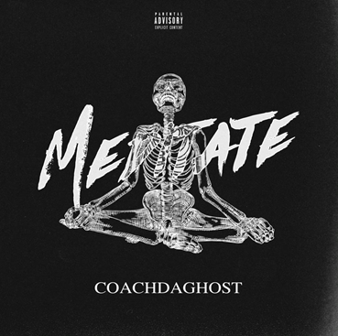

Today, CoachDaGhost further cemented himself as a rising force not only in the Brooklyn drill scene, but the music industry as a whole. The rapper released a brand new single “Meditate,” along with its official music video; check it out HERE. The fiery new single is now available via all digital retailers and streaming platforms HERE.

“Meditate” arrives after the introduction of “S.H.Y.N.E. Freestyle,” an immediate hit with over 2.9 million global streams and 1M+ views on the official YouTube video. CoachDaGhost continues to showcase the raw lyricism and street appeal that brought him to the main stage, attracting the likes of heavy hitters in music since the start of his career. The 26-year-old rapper from Brownsville continues to impress, with “Meditate” serving as a sneak peak into his upcoming mixtape, Ghost Stories.

“S.H.Y.N.E. Freestyle,” produced by CoachDaGhost himself and famed drill producer Ghosty (UK), samples the classic rap record “Shyne” by Shyne—originally produced by the legendary Swizz Beatz. The freestyle, which features the charismatic bars that put him on the map, arrives after tapping drill pioneer 22Gz to shake the rap game with the standout collaboration “Movie," which has amassed over 6.4 million global streams and 2.5 million video views. Watch the official video HERE.

- - -

Culture “CoachDaGhost” Bermudez might have just officially entered the industry, but he is no stranger to the game. His most notable release, “Hitlist,” arrived earlier this year, later inking him a deal with The Culturvated Agency, alongside talent such as 22Gz, Bizzy Banks, Maxthademon, Shawny Binladen and Masio Gunz. “Hitlist” has accumulated over 5.7 million views worldwide and attracted the likes of hip-hop enthusiasts everywhere. CoachDaGhost’s chilling bars are also most recognizable in the recent “Gooey Sauce,” which premiered via WorldStarHipHop, bringing in over 3.3 million views.

# # #

FOR MORE INFORMATION, PLEASE VISIT:
INSTAGRAM
TWITTER
YOUTUBE

FOR ALL PRESS INQUIRIES, PLEASE CONTACT:
ARIANA.WHITE@ATLANTICRECORDS.COM

