**CASPR RELEASES NEW SONG “DUCT TAPE LIPS”**

[**DOWNLOAD/STREAM: “Duct Tape Lips”**](https://nam04.safelinks.protection.outlook.com/?url=https%3A%2F%2Fcaspr.lnk.to%2FDuctTapeLips&data=04%7C01%7CBrian.Sommer%40atlanticrecords.com%7Cfe89e5762148456b7e7a08d93cdc6c3a%7C8367939002ec4ba1ad3d69da3fdd637e%7C0%7C0%7C637607739677998410%7CUnknown%7CTWFpbGZsb3d8eyJWIjoiMC4wLjAwMDAiLCJQIjoiV2luMzIiLCJBTiI6Ik1haWwiLCJXVCI6Mn0%3D%7C1000&sdata=IoCW1oTFOTIRktWXMHOVHzGdPpdjD0GbZ8l32klse18%3D&reserved=0)

*Written by Caspr, Andrew Watt & Omar Apollo*

*Produced by Andrew Watt & Omar Apollo*



[DOWNLOAD ARTWORK HERE](https://nam04.safelinks.protection.outlook.com/?url=http%3A%2F%2Fpress.atlanticrecords.com%2Fcaspr%2F&data=04%7C01%7CBrian.Sommer%40atlanticrecords.com%7Cfe89e5762148456b7e7a08d93cdc6c3a%7C8367939002ec4ba1ad3d69da3fdd637e%7C0%7C0%7C637607739678008405%7CUnknown%7CTWFpbGZsb3d8eyJWIjoiMC4wLjAwMDAiLCJQIjoiV2luMzIiLCJBTiI6Ik1haWwiLCJXVCI6Mn0%3D%7C1000&sdata=o1lPnmNiYdy4a3RrDqs%2FN0bS6d4RhtYo6%2FfxXliw%2FFE%3D&reserved=0)

**New York, NY – July 2, 2021 –** New York-based alternative songwriter & recording artist, **Caspr**, has returned with his new song, **“Duct Tape Lips,”** available now: [**LISTEN HERE**](https://nam04.safelinks.protection.outlook.com/?url=https%3A%2F%2Fcaspr.lnk.to%2FDuctTapeLips&data=04%7C01%7CBrian.Sommer%40atlanticrecords.com%7Cfe89e5762148456b7e7a08d93cdc6c3a%7C8367939002ec4ba1ad3d69da3fdd637e%7C0%7C0%7C637607739678008405%7CUnknown%7CTWFpbGZsb3d8eyJWIjoiMC4wLjAwMDAiLCJQIjoiV2luMzIiLCJBTiI6Ik1haWwiLCJXVCI6Mn0%3D%7C1000&sdata=a1vXMNdH7AESEV8hfpOqqbazKhzmvD%2FObivnY7ZqEhI%3D&reserved=0).

The brooding new song, produced by **Andrew Watt *(Justin Bieber, Post Malone, Miley Cyrus, JuiceWRLD)*** & **Omar Apollo**, arrives as a follow up to the artist’s previous release, “**Coke Nose**,” which was released in May. “Coke Nose” is produced by **Travis Barker *(blink-182, Machine Gun Kelly, jxdn)*** & **Omer Fedi *(The Kid Laroi, Machine Gun Kelly, 24KGoldn),***  and arrived alongside a [**polarizing music video**](https://nam04.safelinks.protection.outlook.com/?url=https%3A%2F%2Fyoutu.be%2FOZlbI6qSRK8&data=04%7C01%7CBrian.Sommer%40atlanticrecords.com%7Cfe89e5762148456b7e7a08d93cdc6c3a%7C8367939002ec4ba1ad3d69da3fdd637e%7C0%7C0%7C637607739678018398%7CUnknown%7CTWFpbGZsb3d8eyJWIjoiMC4wLjAwMDAiLCJQIjoiV2luMzIiLCJBTiI6Ik1haWwiLCJXVCI6Mn0%3D%7C1000&sdata=cfPwElTT83jg75WBfAfZU1%2BvAwfBo1G8bYbJ4ryDpcY%3D&reserved=0) directed by **Richard Quintero**. **“Coke Nose”** was praised by **Office Magazine** for its, *“seamless blend of emo sentimentality, post-punk guitar lines and a bouncy pop-rap rhythm.”*

[**DOWNLOAD/STREAM: “COKE NOSE”**](https://nam04.safelinks.protection.outlook.com/?url=https%3A%2F%2Fcaspr.lnk.to%2FCokeNose&data=04%7C01%7CBrian.Sommer%40atlanticrecords.com%7Cfe89e5762148456b7e7a08d93cdc6c3a%7C8367939002ec4ba1ad3d69da3fdd637e%7C0%7C0%7C637607739678028389%7CUnknown%7CTWFpbGZsb3d8eyJWIjoiMC4wLjAwMDAiLCJQIjoiV2luMzIiLCJBTiI6Ik1haWwiLCJXVCI6Mn0%3D%7C1000&sdata=ihMudINNK1Dx%2B0h4R2SmpzPKhRxsyHHhjI99FESOBfE%3D&reserved=0)

[**WATCH: “COKE NOSE”**](https://nam04.safelinks.protection.outlook.com/?url=https%3A%2F%2Fwww.youtube.com%2Fwatch%3Fv%3DOZlbI6qSRK8%26feature%3Dyoutu.be&data=04%7C01%7CBrian.Sommer%40atlanticrecords.com%7Cfe89e5762148456b7e7a08d93cdc6c3a%7C8367939002ec4ba1ad3d69da3fdd637e%7C0%7C0%7C637607739678028389%7CUnknown%7CTWFpbGZsb3d8eyJWIjoiMC4wLjAwMDAiLCJQIjoiV2luMzIiLCJBTiI6Ik1haWwiLCJXVCI6Mn0%3D%7C1000&sdata=LdcQGEYG4NKakaPP9%2Fm6rqlI193iliuHdyumhwvJtIY%3D&reserved=0)

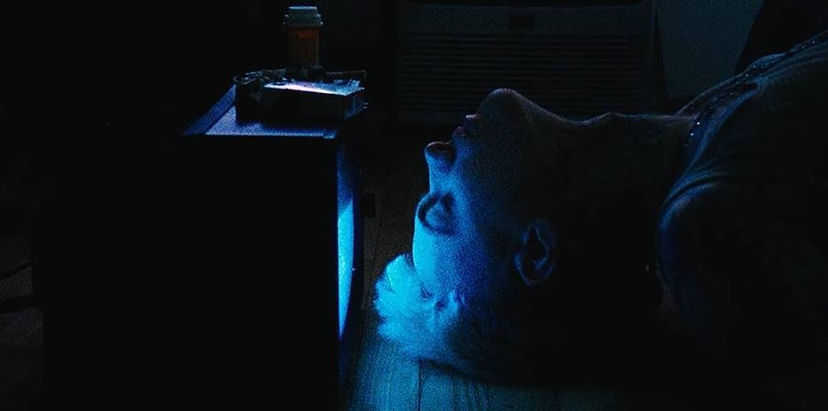

**ABOUT CASPR:**

Over the past few years, New York artist Caspr (formerly known as PPG Casper) has been building a cult-like fanbase via Soundcloud drops, music videos and underground shows. It was only a matter of time before Travis Barker and Andrew Watt caught wind and helped shape Caspr’s vision and sound to what you hear now. A unique songwriter, artist and vocalist, Caspr draws inspiration from his experiences and environment which he formulates into intricate stories of heartache, love, loss, late nights, long days and the struggles of everyday life.

**Press Contact:** Jason Davis – [jason.davis@atlanticrecords.com](mailto:jason.davis@atlanticrecords.com)

* * *

[**DOWNLOAD PRESS PHOTOS HERE**](https://nam04.safelinks.protection.outlook.com/?url=http%3A%2F%2Fpress.atlanticrecords.com%2Fcaspr%2F&data=04%7C01%7CBrian.Sommer%40atlanticrecords.com%7Cfe89e5762148456b7e7a08d93cdc6c3a%7C8367939002ec4ba1ad3d69da3fdd637e%7C0%7C0%7C637607739678038384%7CUnknown%7CTWFpbGZsb3d8eyJWIjoiMC4wLjAwMDAiLCJQIjoiV2luMzIiLCJBTiI6Ik1haWwiLCJXVCI6Mn0%3D%7C1000&sdata=mwoOvaUM7hT%2BxlxN%2FrKItd6tB4DZOgF2No%2Bh7W%2FqcXY%3D&reserved=0)

[Photo Credit: Yulissa Benitez]

**CONNECT WITH CASPR:**

[INSTAGRAM](https://nam04.safelinks.protection.outlook.com/?url=https%3A%2F%2Fwww.instagram.com%2Fiamcaspr%2F%3Fhl%3Den&data=04%7C01%7CBrian.Sommer%40atlanticrecords.com%7Cfe89e5762148456b7e7a08d93cdc6c3a%7C8367939002ec4ba1ad3d69da3fdd637e%7C0%7C0%7C637607739678038384%7CUnknown%7CTWFpbGZsb3d8eyJWIjoiMC4wLjAwMDAiLCJQIjoiV2luMzIiLCJBTiI6Ik1haWwiLCJXVCI6Mn0%3D%7C1000&sdata=0Yrn7jRLPsunvEqrE7EvcaxuIgxjl4jjJjNclC5jVW8%3D&reserved=0) | [TWITTER](https://nam04.safelinks.protection.outlook.com/?url=https%3A%2F%2Ftwitter.com%2FIamcaspr%3Fref_src%3Dtwsrc%255Egoogle%257Ctwcamp%255Eserp%257Ctwgr%255Eauthor&data=04%7C01%7CBrian.Sommer%40atlanticrecords.com%7Cfe89e5762148456b7e7a08d93cdc6c3a%7C8367939002ec4ba1ad3d69da3fdd637e%7C0%7C0%7C637607739678048379%7CUnknown%7CTWFpbGZsb3d8eyJWIjoiMC4wLjAwMDAiLCJQIjoiV2luMzIiLCJBTiI6Ik1haWwiLCJXVCI6Mn0%3D%7C1000&sdata=RHrBxvaCyIIjkM9HjmEMEFuxcTViEXQxjtc5%2B084tAY%3D&reserved=0) | [FACEBOOK](https://nam04.safelinks.protection.outlook.com/?url=https%3A%2F%2Fwww.facebook.com%2Fiamcaspr%2F&data=04%7C01%7CBrian.Sommer%40atlanticrecords.com%7Cfe89e5762148456b7e7a08d93cdc6c3a%7C8367939002ec4ba1ad3d69da3fdd637e%7C0%7C0%7C637607739678058374%7CUnknown%7CTWFpbGZsb3d8eyJWIjoiMC4wLjAwMDAiLCJQIjoiV2luMzIiLCJBTiI6Ik1haWwiLCJXVCI6Mn0%3D%7C1000&sdata=jrCzLsvJxKTqcaPIfBtA3HVgW%2FJx3laAqBux7B1fQgE%3D&reserved=0) | [YOUTUBE](https://nam04.safelinks.protection.outlook.com/?url=https%3A%2F%2Fwww.youtube.com%2Fchannel%2FUCbdpzIKJo_a5q9v0GyU_bnw&data=04%7C01%7CBrian.Sommer%40atlanticrecords.com%7Cfe89e5762148456b7e7a08d93cdc6c3a%7C8367939002ec4ba1ad3d69da3fdd637e%7C0%7C0%7C637607739678058374%7CUnknown%7CTWFpbGZsb3d8eyJWIjoiMC4wLjAwMDAiLCJQIjoiV2luMzIiLCJBTiI6Ik1haWwiLCJXVCI6Mn0%3D%7C1000&sdata=SrpY6vc1R9RN0eDXveq6hS7bgY75ucskFgN34ddiWpQ%3D&reserved=0) | [PRESS SITE](https://nam04.safelinks.protection.outlook.com/?url=http%3A%2F%2Fpress.atlanticrecords.com%2Fcaspr&data=04%7C01%7CBrian.Sommer%40atlanticrecords.com%7Cfe89e5762148456b7e7a08d93cdc6c3a%7C8367939002ec4ba1ad3d69da3fdd637e%7C0%7C0%7C637607739678068367%7CUnknown%7CTWFpbGZsb3d8eyJWIjoiMC4wLjAwMDAiLCJQIjoiV2luMzIiLCJBTiI6Ik1haWwiLCJXVCI6Mn0%3D%7C1000&sdata=DdUN%2FEWfsF8LsxIY07hNVcVFW3VBqghv5PmtlUyTYDk%3D&reserved=0)

# # #