FOR IMMEDIATE RELEASE

NOVEMBER 23, 2021

CATIE TURNER REVEALS “GOD MUST HATE ME”

ACCLAIMED SINGER-SONGWRITER RELEASES MOST HONEST TRACK YET

LISTEN TO “GOD MUST HATE ME” HERE
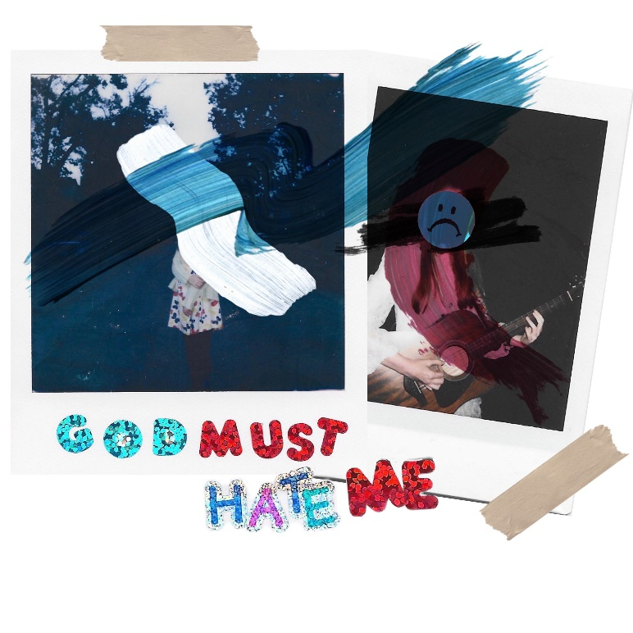
DOWNLOAD ARTWORK HERE

Rising singer-songwriter Catie Turner has released her most confessional and personal track yet. Last week Turner teased the track on her wildly hilarious TikTok. The emotional, heart wrenching video reached over 1 million views within 24 hours of posting. “God Must Hate Me” is available now HERE.

“’God must hate me’ may be, in my opinion, the most vulnerable song ive released yet - which is scary yet exhilarating all at the same time,” Catie shared. “Some may roll their eyes at the melodramatic title, and believe me, when I’m in a good headspace I can laugh at myself too, but “God Must Hate Me” is about those times where the feelings are so omnipotent, you really start to believe it. That you were made wrong. That you’re not good enough. And, that maybe, a higher power being angry with you is a pill easier to swallow than personal responsibility.”

Catie recently released a moving duet with pop artist JORDY. “(Wish I Didn’t Have To) Lie” was co-written by Turner and JORDY and landed the pair on the cover of Spotify’s coveted Sad Hour playlist as well as critical acclaim.

Catie performed the duet with JORDY at Los Angeles’ legendary venue, The Troubadour, as well as solo sets at LA’s Roxy Theatre and New York’s Bowery Ballroom. Catie is currently working on her next project – for all updates please visit: https://www.catieturner.com/.

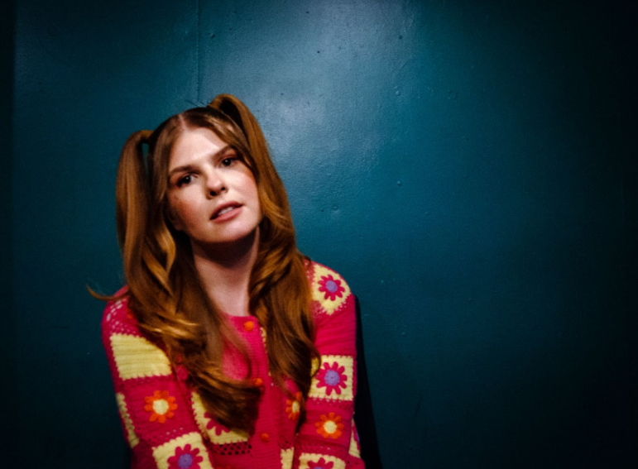
DOWNLOAD PRESS PHOTOS HERE

Upcoming Tour Dates
on JORDY’s Mind Games Tour

December 2021
2 – Alliston, MA – Brighton Music Hall
4 – Brooklyn, NY – Elsewhere
5 – Brooklyn, NY – Elsewhere
7 – Philadelphia, PA – Kungfu Necktie
8 – Washington, DC – Songbyrd Music House
10 – Atlanta, GA – The Masquerade
13 – Nashville, TN – High Watt

ABOUT CATIE TURNER:
Beloved for her potent, personal lyricism and soulful vocals, Catie Turner is a uniquely gifted singer and writer whose offbeat charm and tongue-in-cheek songcraft has now drawn over 70 million global streams and counting.

Catie first began writing songs and playing guitar in her hometown of Langhorne, PA, providing her a means to cope with the myriad pressures placed upon young women. The 20-year-old artist captured national attention in 2018 as one of the standout stars of ABC's American Idol, kicking off the season with a stunning audition performance of her own extraordinary composition, “21st Century Machine,” immediately winning over judges Lionel Richie, Luke Bryan, and Katy Perry, who applauded her a “genius songwriter.” 2019 brought her remarkable solo debut EP, THE SAD VEGAN, highlighted by the moving pop anthem “Prom Queen.” The track, which exploded across all platforms, was named one of TIME’s “5 Songs You Need To Listen To This Week,” and landed Catie a spot on Idolator’s “On The Verge: 40 Artists To Watch In 2020.”

Most recently, Catie released her Atlantic Records debut EP Heartbroken and Milking It. The project included widely praised tracks such as “Play God,” named by Billboard as one of “10 Cool New Pop Songs to Get You Through the Week” and hailed by Hollywood Life as an “enchanting new song…with a dreamy production capturing the cloudy haze one feels when struggling with the affairs of the heart, Catie captures the turmoil of someone who knows it’s time to let go but can’t just yet.”

The project saw further acclaim from American Songwriter which stated, “Turner’s ethereal pop-shere aims toward an arrival of sorts, while her stripped-down lyricism suggests a pinnacled confidence,” and Ones to Watch praising, “Catie Turner's music moves through the world with an infectious sincerity, invisible to the passerby but deeply affective to those it happens to grace. It's a testament to her gift for immaculate pop-minded songwriting that carries with it an empathy well beyond her age, and it is a gift she is more than happy to share on her major label debut EP, Heartbroken and Milking It.”

Perhaps TIME said it best, “There is a universal message that resonates well into adulthood in Catie Turner's aching, existential honesty… The intimate directness of her voice, over a supple acoustic melody, suggests wisdom beyond her years.”

Catie is hard at work on her next project. Stay tuned for more from this rising star!

# # #

CONNECT WITH CATIE TURNER
OFFICIAL | INSTAGRAM |TIK TOK | FACEBOOK | TWITTER | YOUTUBE

For Catie press inquiries, please contact:
Kelly McWilliam, Kelly.McWilliam@atlanticrecords.com
Paige Rosoff, Paige.Rosoff@atlanticrecords.com

