FOR IMMEDIATE RELEASE

APRIL 9, 2021

CATIE TURNER CELEBRATES HER “MAMA” IN EMOTIONAL NEW SINGLE

JUST AHEAD OF MOTHERS DAY, ACCLAIMED SINGER-SONGWRITER PAYS TRIBUTE TO HER MOTHER, AND MOTHERS EVERYWHERE WITH SWEET AND MOVING NEW SINGLE

“MAMA” ARRIVES ALONGSIDE ALFREDO FLORES (JUSTIN BIEBER, ARIANA GRANDE) DIRECTED VIDEO

LISTEN TO “MAMA” HERE
WATCH THE VIDEO HERE
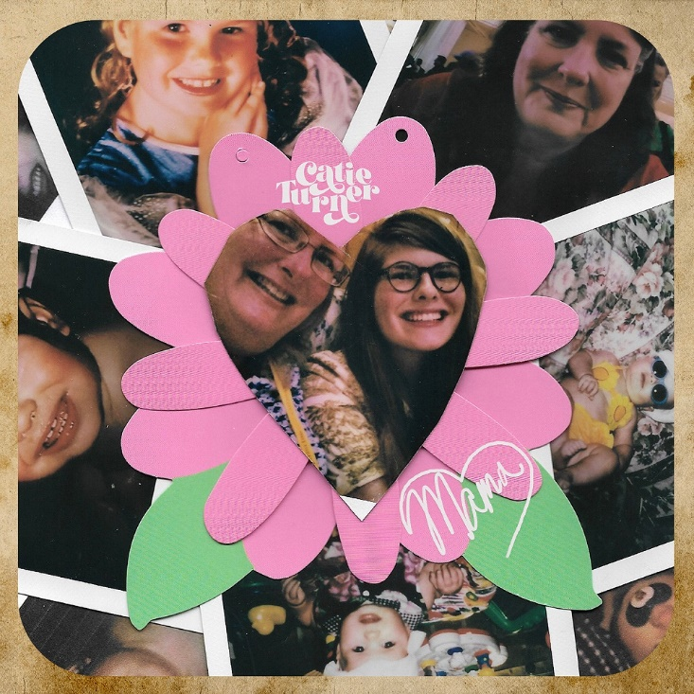
DOWNLOAD ARTWORK HERE

“There is a universal message that resonates well into adulthood in Catie Turner's aching, existential honesty… The intimate directness of her voice, over a supple acoustic melody, suggests wisdom beyond her years.”
- TIME

“A public voice for the sentiments of the masses of everyday life.”
- AMERICAN SONGWRITER

On Catie Turner’s new track, “Mama,” Turner pays tribute to her own mother, and mothers everywhere. Arriving just in time for Mother’s Day, the sweet track honors the bond growing daughters have with their mothers, who they will always need, no matter how far they move away or how old they get. “Mama” arrives alongside an Alfredo Flores (Justin Bieber, Ariana Grande) directed video streaming now HERE.

“I write too many songs about men who break my heart, so my mom deserves a song because she is the one there through it all,” Catie said. “This is my Mother’s Day present to her and all the other incredible moms out there.”

“There’s no better feeling as a Mother than to feel appreciated,” Catie’s mother, Cathy, shared. “When Catie first played me this song on Mother’s Day in 2017, I was completely emotional. Now with her moving out to LA and becoming an adult, I want nothing more than to see her become the amazing independent woman she is and share this song with the other incredible Mom’s around the world.

“Mama” marks the latest in an extraordinary series of new singles from Turner, including the experimental pop earworm, “Hide & Seek.” “Hide and Seek” “pairs frustration and longing,” declared Euphoria, “with Turner asking herself in the lyrics just how far she would go to make the other half of her relationship reciprocate her love…It’s both daunting and relatable, giving listeners the perfect outlet for the anger and heartbreak that comes with potentially unrequited love and wondering how to strengthen a broken bond.”

Turner kicked off 2021 with the premiere of “Play God.” Named by Billboard as one of “10 Cool New Pop Songs to Get You Through the Week,” the tender track is now joined by an official performance video, streaming now at Turner’s hugely popular YouTube channel HERE. Hollywood Life hailed “Play God” as an “enchanting new song,” writing, “With a dreamy production capturing the cloudy haze one feels when struggling with the affairs of the heart, Catie captures the turmoil of someone who knows it’s time to let go but can’t just yet.”

“One Day” arrived late last year, was joined by an official companion video following an exclusive premiere and interview with Turner on Philadelphia’s WPVI-TV/6ABC. The song was met by applause from such national outlets as American Songwriter, which wrote, “‘One Day’ is an elegant, clear example of how Turner’s down-to-earth feelings and every day experiences haven’t gotten lost in favor of topics or sounds that are more aggressive, trendy, or edgy, solely to surprise the millions now listening and watching,”

Widely acclaimed for her potent, personal lyricism and soulful vocals, the multi-talented Turner recently relocated to Los Angeles where she is currently hard at work creating more new music, with additional releases slated throughout the year.

“I am staying true to myself,” Turner recently told Parade, “and, apparently, it’s working for me. Work hard and get used to the backlash, because you could be the most perfect person in the world, and you would still have people who find issues with that. So, you need to believe in yourself, know your talents and always follow your heart.”

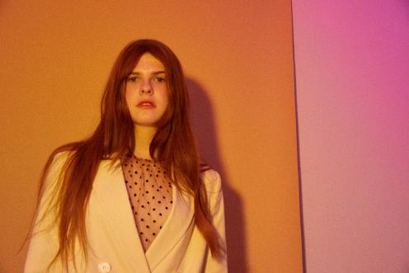
DOWNLOAD PRESS PHOTOS HERE

CONNECT WITH CATIE TURNER
OFFICIAL | INSTAGRAM | FACEBOOK | TWITTER | YOUTUBE

For press inquiries, please contact:
Kelly McWilliam, Kelly.McWilliam@atlanticrecords.com
Paige Rosoff, Paige.Rosoff@atlanticrecords.com

