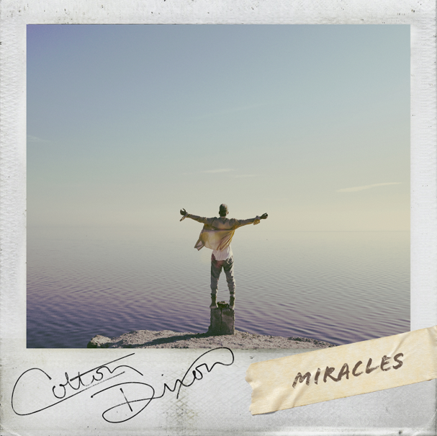

COLTON DIXON UNVEILS "MIRACLES"

Invites Fans Join Live YouTube Chat and Music Video Premiere

"Miracles" is Dixon's Atlantic Record's Debut and First New Music in Nearly Three Years

Nashville, TN (January 24, 2019) - Colton Dixon has unveiled his first new music in nearly three years with "Miracles." The hopeful, catchy new track was co-written with Michael Jade and the late busbee, who also wrote Dixon's first No. 1 single, "You Are." The track, his Atlantic Record's debut, is also accompanied by a stunning music video, which Dixon will premier during a live chat with fans tonight at 6pm ET. To listen to the track, click here, and to watch the video tonight after 6pm ET, click here.

“‘Miracles’ is a song that has meaning and depth, but it just feels fun musically,” Dixon says. “Some things are more than coincidence. I believe there is a God who loves you and looking out for you. I’m pointing out to others that there’s more to life than meets the eye. I believe miracles happen all around us. I’d like to encourage all of us to slow down a bit, so we can see and appreciate the miracles for what they are.”

###

ABOUT COLTON DIXON:
Colton Dixon quickly became a household name in 2012 when he was voted a fan favorite and made it to the top seven on Season 11 of Fox's hit show AMERICAN IDOL. His career has been on the fast track ever since, now boasting over 100 million streams across all platforms. Dixon's 2013 debut, A Messenger, set the record for biggest first-week sales by a new solo Christian act, becoming the No. 1 selling album by a new Christian artist. Dixon is also a Steinway & Sons artist, following in the footsteps of legendary artists such as Harry Connick, Jr. and Billy Joel. Dixon's sophomore effort Anchor included the most played Hot AC single of 2014, “More Of You," which spent three weeks at No. 1, as well as "Through All of It," his fourth consecutive No. 1 at Hot AC Radio. In 2013, Dixon won a Dove Award for Best Rock/Contemporary Album Of The Year, along with two additional nominations. In 2015, Anchor was honored with the Dove Award for Rock/Contemporary Album of the Year. Dixon received back-to-back K-LOVE Fan Award nominations for Male Artist of the Year in 2014 and 2015, followed by the release of his third studio album Identity, which included the top 5 single “All That Matters,” whose video was premiered by PEOPLE magazine.

Get Connected with Colton Dixon:
Twitter: https://twitter.com/coltondixon
Facebook: https://www.facebook.com/coltondixonmusic?fref=ts
YouTube: https://www.youtube.com/user/ColtonDixonMusicVEVO
Instagram: https://instagram.com/coltondixonmusic/
Media Contact:
the media collective
Velvet Kelm
velvet@themcollective.com
615-591-7989
www.themcollective.com

