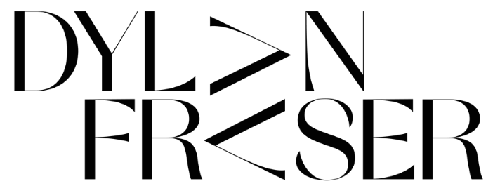
ANNOUNCES
‘THE WORLD ISN’T BIG WHEN YOU KNOW HOW IT WORKS’ EP
OUT AUGUST 20th ON ASYLUM/ATLANTIC
(PRE-ORDER)
RELEASES HIS NEW TRACK ‘NIGHTMARE’
FOLLOWING ITS FIRST SPIN ON ANNIE MAC’S RADIO 1 SHOW
LISTEN HERE
ALONGSIDE THE OFFICIAL VIDEO FOR ‘NIGHTMARE’
WATCH HERE
DYLAN TO TEAM-UP WITH EDINBURGH SCHOOL OF ARTS’
MASTERS CLASS 2021 FOR ‘NIGHTMARE’ ARTWORK EXHIBITION IN JULY
“The next big superstar… Dylan is the real f**king deal. The sky is the limit”
LADYGUNN

“‘The audacity of this UK newcomer to deliver a sound that's as fully formed and self-assured as this incredibly smooth alt-pop track… Get into him now so you brag to all your friends about knowing him first when he inevitably breaks big.”
E!

“Dylan gives off an inspiring yet humble vibe, portraying vulnerability and conversations around anxiety, throughout the process of discovering himself as an artist. Dylan’s newest single ‘Gucci Sweater’ is testament to his righteous voyage for artistic fulfillment.”
CULTR

“…an artist with his sights set on stardom…”
Dork

Hotly tipped Scottish newcomer Dylan Fraser announces his new EP, ‘The World Isn’t Big When You Know How It Works’, set for release on August 20th (pre-order). To coincide with the announcement, Dylan has dropped his new track ‘Nightmare’ (listen here) alongside the official video (watch here) following its first spin on Annie Mac’s Radio 1 show last night.
After the release of his shimmering track ‘I’d Rather Be Here’ last month (which secured ‘Record of the Week’ on Annie Mac’s Radio 1 show), ‘Nightmare’ is a further glimpse into Dylan’s artistry and second body of work, with the official video – directed by Joseph Delaney (Ashnikko) - serving us with a symbolic interpretation of feeling trapped, be that in your own thoughts or within society, as he details “I’m in a nightmare but I didn’t fall asleep”.
On the forthcoming EP, The World Isn’t Big When You Know How It Works, Dylan Fraser has teamed-up with his close collaborator Jonah Summerfield for production duties alongside Johan Lenox (Kanye West, Travis Scott) for string arrangements on ‘Mantelpiece’ and Dave Hamelin (070 Shake) for production on ‘Supersonic’.
Speaking about the forthcoming project, Dylan says: “The new EP finds me destructing experiences in my life, be that relationships, anxiety or the weight of the world. Nobody prepares you for growing up; you have to figure it out as you go, and these seven tracks are a representation of my life in real time, doing just that.”
Additionally, to celebrate the release of ‘Nightmare’, next month, Bathgate-born Dylan Fraser will be teaming-up with this year’s masters students from the Edinburgh School of Arts, who’ll each be interpreting the track to produce unique artworks – these will be virtually exhibited via his official website in July (date to follow soon).
An artist whose creative and musical output perfectly entwine, Dylan is a true visionary, with his early catalog already pointing towards a skyward trajectory. Following the release of his debut EP ‘The Storm’ last October, the 19-year-old quickly became a talking point amongst music royalty such as Sir Elton John and Sam Smith, as well as radio vanguards: Annie Mac, Jack Saunders, and Zane Lowe. The EP – now surpassing six million streams - launched with his feverish debut ‘Vipers’, which later earned a sync on the FIFA 21 Soundtrack.
The World Isn’t Big When You Know How It Works EP tracklisting:
- Nightmare
- I’d Rather Be Here
- Pipeline
- That’s Just Life
- Supersonic
- Only A Fool
- Mantelpiece

About Dylan Fraser
Functioning around introspection, destination, and self-validation, Dylan’s early catalogs find the Scottish-born artist unpack his journey from his small town of Bathgate to his newfound reality as an artist with the world at his feet, trying to make sense of the people and situations he’s faced along the way.
First picking up a guitar at just 12-years-old (a hand-me-down from his mom, who, subsequently, taught him his first four chords,) Dylan set his sights on a music career from early childhood. Holed away in his bedroom, he would reimagine his favorite songs, by his favorite artists - everyone from Radiohead to Lorde to Kanye West - dreaming of city lights whilst plotting a path out of his satellite town.

Press Contacts:
libby.kober@atlanticrecords.com
trish.mollo@atlanticrecords.com

