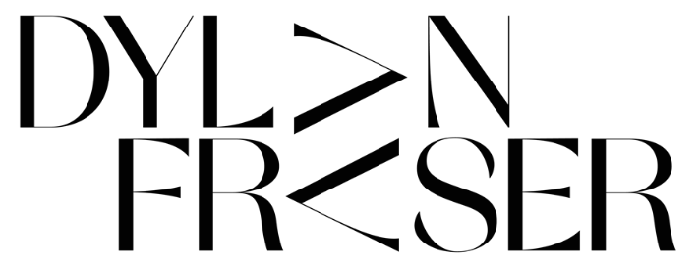
DROPS NEW TRACK ‘I’D RATHER BE HERE’
LISTEN HERE // LYRIC VIDEO
NEW EP COMING THIS SUMMER
download hi res artwork here
“The next big superstar… Dylan is the real f**king deal. The sky is the limit”
LADYGUNN

“‘The audacity of this UK newcomer to deliver a sound that's as fully formed and self-assured as this incredibly smooth alt-pop track… Get into him now so you brag to all your friends about knowing him first when he inevitably breaks big.”
E!

“Dylan gives off an inspiring yet humble vibe, portraying vulnerability and conversations around anxiety, throughout the process of discovering himself as an artist. Dylan’s newest single ‘Gucci Sweater’ is testament to his righteous voyage for artistic fulfillment.”
CULTR

“…an artist with his sights set on stardom…”
Dork

Today, emerging Scottish alt-pop artist Dylan Fraser drops his new track ‘I’d Rather Be Here’ (listen here) – the track will feature on his upcoming second EP arriving this summer. Today’s release comes accompanied by an official lyric video (watch here).
On his new track, 19-year-old Dylan Fraser juggles with the push and pull of teenage life as he reflects on a formative relationship. Mixing the distorted with the euphoric, his multi-layered synth shines on the cinematic ‘I’d Rather Be Here’, as he marries his textured vocals with a dreamy guitar. A true visionary, the accompanying artwork – a visual representation of the song’s narrative - was self-directed by Dylan.
Dylan says – “I’d rather be here is about someone who meant a lot to me but wasn’t necessarily good for my mental state. There was a lot of negativity and it was really starting to wear me down. It put me in a tricky situation, as when you care so deeply for someone, it can sometimes feel better to stay in a shitty situation than to address it head on out of fear of losing that person. This particular experience sparked the lyric “I’d rather be here than nowhere at all.”
Entering the music scene a little over six months ago, Scottish-born Dylan Fraser is showing huge promise for the year ahead. An artist in his infancy, he’s already reaped a slew of acclaim following the release of his debut EP The Storm at the end of 2020, resulting in shout outs from Sam Smith and Sir Elton John; radio support from Annie Mac, Zane Lowe and Jack Saunders, alongside a sync on the latest FIFA Soundtrack with his first-ever release, ‘Vipers’.
The Storm EP - released in October and now boasting five million global streams – was our first glimpse into Dylan’s world. Functioning around introspection, destination, and self-validation, the EP saw Dylan unpack his journey from his small town of Bathgate, Scotland to his newfound reality as an artist with the world at his feet, trying to make sense of the people and situations he’s faced along the way. Waterfalled over a number of months, he transitioned through seven track drops over the course of the EP with ‘Vipers’, ‘Face Tattoo’, ‘I Do These Things For Me’, ‘The Storm’, ‘Intentions’, ‘Losing Sleep’ and, most recently, ‘Gucci Sweater’.

assets: https://press.atlanticrecords.com/dylan-fraser/

contacts: libby.kober@atlanticrecords.com
trish.mollo@atlanticrecords.com

