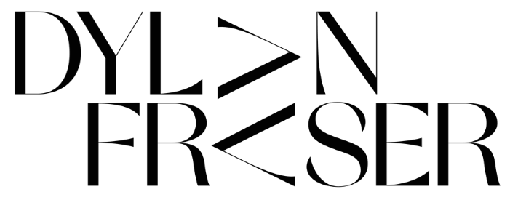

RELEASES “I DO THESE THINGS FOR ME”
LISTEN HERE

DEBUT SINGLE “VIPERS” INCLUDED ON FIFA 2021 SOUNDTRACK

ANNOUNCES DEBUT EP ‘THE STORM’ – OUT OCTOBER 23rd
ON ATLANTIC RECORDS

“The next big superstar… Dylan is the real f**king deal. The sky is the limit”
LADYGUNN

“…structured, folk-rooted leanings against propulsive electronics,
reminiscent of Radiohead in places…”
Clash

“‘The audacity of this UK newcomer to deliver a sound that's as fully formed and self-assured as this incredibly smooth alt-pop track… Get into him now so you brag to all your friends about knowing him first when he inevitably breaks big.”
E!

Scottish newcomer Dylan Fraser has announced details of his debut EP ‘The Storm,’ set for release on October 23rd via Atlantic Records.

The alt-pop artist has also dropped a new track “I Do These Things For Me” in conjunction with today’s announcement. The song finds Dylan dismantling online behaviors in search for authenticity – listen here.

19-year-old Fraser is quickly making waves, unleashing his first-ever tracks “Vipers” and “Face Tattoo” in August and September, respectively.

Earlier this week, it was announced that “Vipers” will feature on the all-new FIFA 21 Official Soundtrack, alongside artists like Dua Lipa and Diplo. Watch an acoustic performance of “Vipers” released in tandem with EA Sports here.

This follows strong praise across press, streaming, and radio support from BBC Radio 1, Australia’s Triple J, and Apple Music 1’s Zane Lowe - with “Face Tattoo” premiering via a ‘World First.’

Today’s release and Fraser’s looming EP seamlessly extend on from these previous releases. Over five tracks, Fraser’s cross-genre dexterity shimmers as he seamlessly shifts through propulsive electronics, high-energy guitar and hypnotic beats.

Inviting us into his own world, Dylan’s music functions around themes of introspection, determination and self-validation as he unpacks his journey from his small town of Bathgate, Scotland to his newfound reality as an artist with the world at his feet, trying make sense of the people and situations he’s faced along the way.

Fraser says – “I like to think of The Storm as my headspace. It’s full of crazy ups and downs and this is me trying to piece it all together and make sense of the world”

The Storm tracklist:
- The Storm
- Intentions
- Vipers
- Face Tattoo
- I Do These Things For Me

About Dylan Fraser
Dylan Fraser is a small-town kid with wide-eyed ambition. Born and raised in Bathgate, Scotland, he had his sights set on a career in music from early childhood. First picking-up a guitar at just 12-years-old (a hand-me-down from his mom, who, subsequently, taught him his first four chords,) Dylan would reimagine his favorite songs, by his favorite artists, in his bedroom - everyone from Radiohead to Phoebe Bridgers to Kanye West - dreaming of city lights and plotting a path out of his small, satellite town.

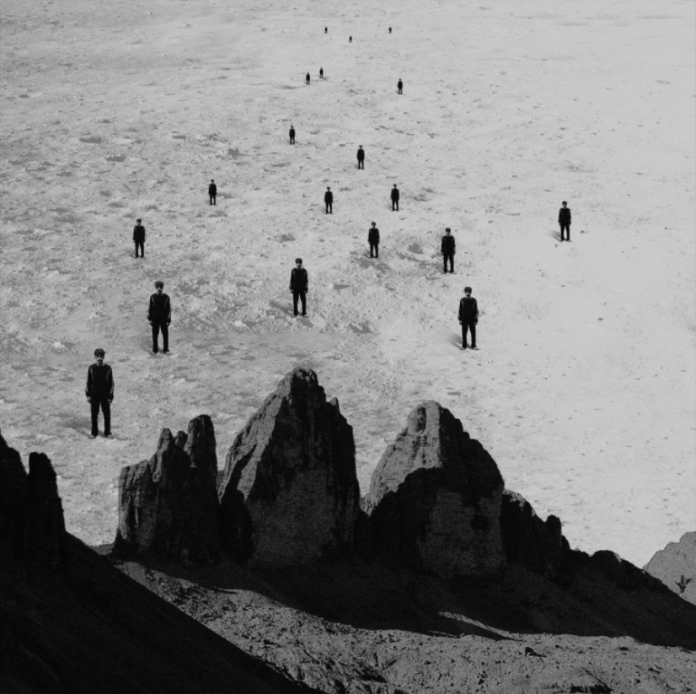
download “I Do These Things For Me” artwork

assets: https://press.atlanticrecords.com/dylan-fraser/
contact: libby.kober@atlanticrecords.com

