RELEASES HIS NEW EP
‘THE WORLD ISN’T BIG WHEN YOU KNOW HOW IT WORKS’
LISTEN HERE

UNVEILS PERFORMANCE VIDEO FOR EP TRACK
‘ONLY A FOOL’ FEAT. SAMIA
WATCH HERE

UK SHOWS:
INHALER SUPPORT TOUR – SEPTEMBER 2021
BBC INTRODUCING SHOW @ THE LEXINGTON, LONDON – 4th NOVEMBER

DOWNLOAD EP ARTWORK & PRESS IMAGERY:
https://we.tl/t-leWwkpF1km

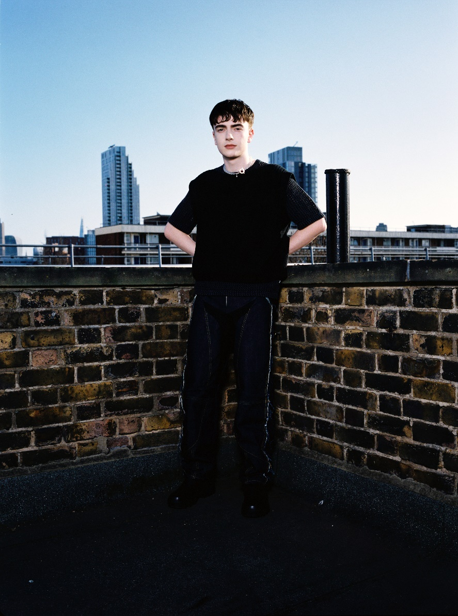

“I’m not a betting man, but it’s not a bet when it’s a sure thing, and this artist is a sure thing” – Zane Lowe

“It’s not often that I come across a new artist whose every song is as strong as the last. Having only released music for six months and began by creating tracks from his bedroom, Dylan Fraser is a force to be reckoned with.” – Marie Claire

“The audacity of this UK newcomer to deliver a sound that's as fully formed and self-assured as this incredible smooth alt-pop track... Get into him now so you can brag to all your friends about knowing him first when he inevitably breaks big.” – E!

“At the ripe age of 18, Dylan is the real f**king deal. The sky is the limit” – Ladygunn

Today, Scottish alt/pop up-and-comer, Dylan Fraser, has released his new seven-track EP, The World Isn’t Big When You Know How It Works (listen here).

Hot off the heels from supporting Holly Humberstone at London’s Omeara last month, genre-abandoning Dylan Fraser channels brooding soundscapes, industrial electronics and euphoric guitar across his second offering; a body of work that documents the trappings of young adulthood. After waterfalling a number of EP tracks over the course of the summer - ’ I’d Rather Be Here’’, ‘Nightmare’ and ‘Supersonic’ - today’s focus track, ‘Only A Fool’, comes packaged with a feature from New York-based singer/songwriter Samia and takes shape as a haunting, pared back ballad that builds from gentle piano and strings to bruising harmonies and melancholic beats.

Dylan says - “I wanted to make a ballad. I feel like everyone has to have one, but I wanted it to feel really beautiful but very dark and twisted at the same time. I was watching this random shitty horror movie on TV and it had that super cliche scene where the girl in the white dress runs across the road in the car headlights and I remember just singing “driving in the dark just waiting for the girl in the white night gown to cross the road” and thinking it would make a weird, twisted love song.”

The World Isn’t Big When You Know How It Works EP finds Dylan Fraser team-up with his close collaborator Jonah Summerfield for production duties alongside Johan Lenox (Kanye West, Travis Scott) for string arrangements on ‘Mantelpiece’ and Dave Hamelin (070 Shake) for co-production (alongside Dylan) on ‘Supersonic’. Speaking about the EP upon its announcement a few months’ back, Dylan said: “The new EP finds me destructing experiences in my life, be that relationships, anxiety or the weight of the world. Nobody prepares you for growing up; you have to figure it out as you go, and these seven tracks are a representation of my life in real time, doing just that.”

Dylan Fraser’s early output is already pointing towards a skyward trajectory. Following the release of his debut EP ‘The Storm’ last October, the 20-year-old Apple ‘Up Next’ artist (August 2021) quickly became a talking point amongst music royalty such as Sir Elton John and Sam Smith, and made waves amongst radio vanguards: Annie Mac, Jack Saunders and Zane Lowe. The Storm EP – now surpassing seven million streams - launched with his feverish debut ‘Vipers’, which later earned a sync on the FIFA 21 Soundtrack.

An artist whose creative and musical output perfectly entwine given Dylan self-directs his own artworks, most recently, he teamed-up with this year’s Master’s students from the Edinburgh School of Arts in his native Scotland, who each interpreted his track ‘Nightmare’ to produce unique creations – these are now available to view on his official website.

The World Isn’t Big When You Know How It Works EP tracklisting:

- Mantelpiece
- Pipeline
- I’d Rather Be Here
- That’s Just Life
- Supersonic
- Nightmare
- Only A Fool (feat. Samia)

About Dylan Fraser
Functioning around introspection, destination and self-validation, Dylan’s early catalog finds the Scottish-born artist unpack his journey from his small town of Bathgate to his newfound reality as an artist with the world at his feet, trying make sense of the people and situations he’s faced along the way.

First picking-up a guitar at just 12-years-old (a hand-me-down from his mom, who, subsequently, taught him his first four chords,) Dylan set his sights on a music career from early childhood. Holed away in his bedroom, he would reimagine his favorite songs, by his favorite artists - everyone from Radiohead to Lorde to Kanye West - dreaming of city lights whist plotting a path out of his satellite town.

