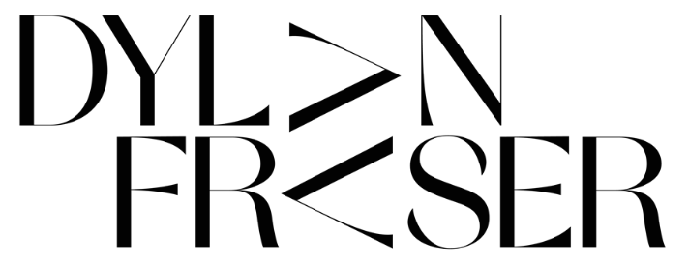

RELEASES DEBUT EP ‘THE STORM’

BUY/STREAM EP: HERE

WATCH OFFICIAL VISUALIZER FOR
TITLE TRACK “THE STORM”: HERE
DEBUT SINGLE “VIPERS” INCLUDED ON FIFA 2021 SOUNDTRACK

“The next big superstar… Dylan is the real f**king deal. The sky is the limit”
LADYGUNN

“…structured, folk-rooted leanings against propulsive electronics,
reminiscent of Radiohead in places…”
Clash

“‘The audacity of this UK newcomer to deliver a sound that's as fully formed and self-assured as this incredibly smooth alt-pop track… Get into him now so you brag to all your friends about knowing him first when he inevitably breaks big.”
E!

Scottish alt-pop newcomer Dylan Fraser today unveils his debut EP ‘The Storm,’ out now via Atlantic Records (buy/stream).

The EP includes two previously unreleased tracks: “Intentions” and title track “The Storm,” the latter of which arrives with a stunning visualizer – watch HERE.

The 19-year-old is quickly making waves and today’s release seamlessly extends on from his summer drops: “Vipers,” “Face Tattoo,” and “I Do These Things For Me.”

Over the EP’s five tracks, Fraser’s cross-genre dexterity shimmers as he seamlessly shifts through propulsive electronics, high-energy guitar and hypnotic beats. Inviting us into his own world, Dylan’s music functions around themes of introspection, determination and self-validation as he unpacks his journey from his small town of Bathgate, Scotland to his newfound reality as an artist with the world at his feet, trying make sense of the people and situations he’s faced along the way.

Dylan says – “I like to think of The Storm as my headspace. It’s full of crazy ups and downs and this is me trying to piece it all together and make sense of the world”

Earlier this month, it was announced that Dylan’s debut track “Vipers” will feature on the all-new FIFA 21 Official Soundtrack, alongside artists like Dua Lipa and Diplo. Watch an acoustic performance of “Vipers” released in tandem with EA Sports here.

This follows strong praise across press, streaming, and radio support from BBC Radio 1, Australia’s Triple J, and Apple Music 1’s Zane Lowe - with “Face Tattoo” premiering via a ‘World First.’

The Storm tracklist [download EP artwork]
- The Storm
- Intentions
- Vipers
- Face Tattoo
- I Do These Things For Me

About Dylan Fraser
Dylan Fraser is a small-town kid with wide-eyed ambition. Born and raised in Bathgate, Scotland, he had his sights set on a career in music from early childhood. First picking-up a guitar at just 12-years-old (a hand-me-down from his mom, who, subsequently, taught him his first four chords,) Dylan would reimagine his favorite songs, by his favorite artists, in his bedroom - everyone from Radiohead to Phoebe Bridgers to Kanye West - dreaming of city lights and plotting a path out of his small, satellite town.

assets: https://press.atlanticrecords.com/dylan-fraser/

contacts: libby.kober@atlanticrecords.com
trish.mollo@atlanticrecords.com

