DAINE RISES ABOVE NEGATIVITY ON NEW TRACK ‘NEW GROUND’

DEBUT MIXTAPE QUANTUM JUMPING RELEASED ON MARCH 18TH

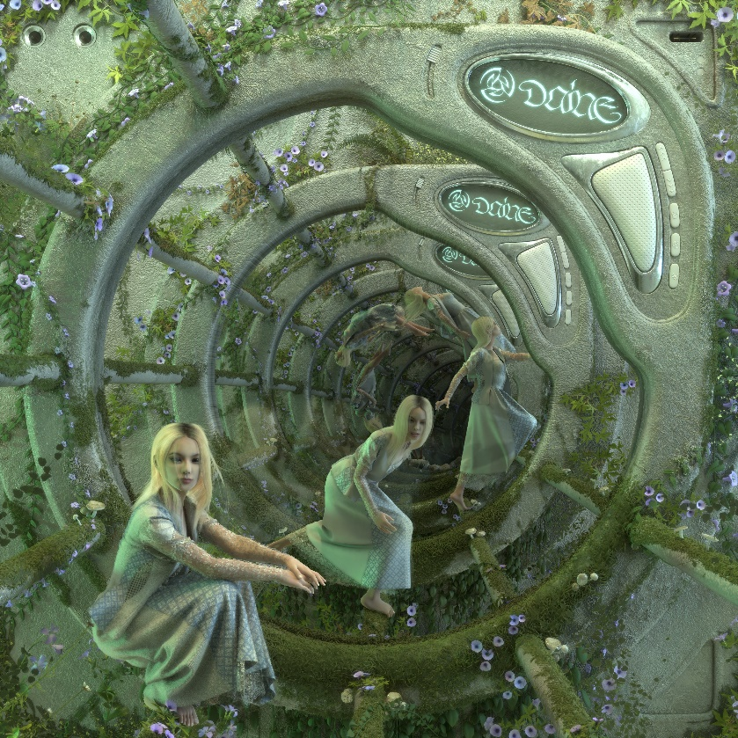

Watch the video HERE
Buy/Stream the track HERE

“A future emo icon” - NME
“Teen angst’s freshest voice” - V Magazine
“It feels healing and painful; like looking directly at a solar flare.” - The Guardian
“A nihilistically detached voice” - The FADER
“daine’s creative spin on such a distinctive sound evokes an irresistible nostalgia” - Pigeons & Planes

An artist who found her audience within the COVID-19 pandemic, daine has become a guiding voice in a hybrid scene of creatives who are splicing their diverse tastes and talents for a truly postmodern take on contemporary music. A rapidly ascending voice in the alternative and electronic pop scenes thanks to her output and her Nocturne online parties which have featured the likes of Charli XCX, Oklou, umru and more, daine will finally release her debut mixtape Quantum Jumping on March 18th 2022. A chronological timeline of the very first songs she wrote at the age of 16, the release charts a burgeoning artist growing in real time, finding her own source of expression and finding her own space in a world she felt ostracized within. The latest taste of this forthcoming project is released today in the form of a new single, ‘New Ground’.

A marked departure from the melancholic sonics of her previous releases, ‘New Ground’ takes on a redemptive tone, with daine addressing those who left her behind while providing a new twist on nostalgic lyrical tropes of second wave emo. The track ranks among one of the more upbeat in daine’s canon, allowing her to spotlight another element of her songwriting talent while expanding the sonic landscape of what’s possible with her sound. Her signature reverberated guitar picks are offset by an uptempo drum track that is punctuated only by daine’s disaffected yet impactful vocal and a pair of blazing guitar solos that take the track to a powerful new level.

A self-professed “tombstone to her adolescence,” daine’s forthcoming debut mixtape places a sonic world of daine’s own design on full display while marking her out as one of 2022’s most exciting breakout stars. Pushing the boundaries of alternative music, pop, electronic sounds and more, daine’s genre-eschewing compositions are a perfect encapsulation of the boundless creativity at her fingertips. With her demand to subvert expectations only growing with each release, the possibilities on where she may go next are endless.

daine: Website | Twitter | Instagram

