TIËSTO & KAROL G JOIN FORCES FOR
EPIC POP DANCE ANTHEM “DON’T BE SHY”

LISTEN HERE!
WATCH THE VIDEO HERE!
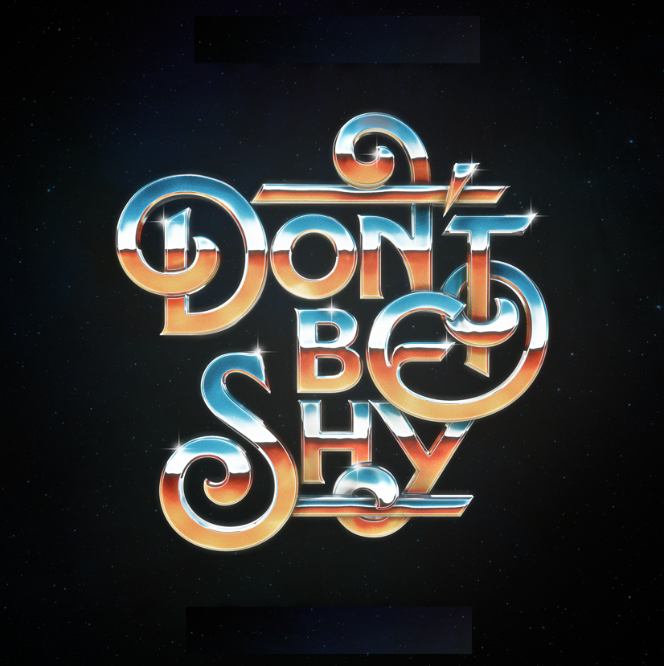

(August 12, 2021)— Tiësto and Karol G are making history with their new collaboration “Don’t Be Shy”! The song marks the first English song ever for multiplatinum superstar Karol G, as well as her first foray into dance music. It also celebrates the first Latin Artist collaboration for GRAMMY® Award-winning, platinum-certified, international icon, Tiësto. In true Tiësto fashion, he continues to expand across genres and styles, constantly evolving his music and craft.

Listen to the hot summer track here!

The duo also recently shot a music video in Miami, FL, directed by the phenom Director Christian Breslauer. This music video takes place at a very special museum, full of surprises, an intoxicating dance performance by stunning Karol G and appearances from Tiësto and Comedian, Blake Webber. Watch it here!

Tiësto will celebrate the release of this new single this Saturday at Ayu Dayclub as part of his Las Vegas residency and partnership with Zouk Group and Resorts World Las Vegas with a special launch party to kick off his summer performances entitled "Don’t Be Shy Las Vegas.” The official music video for the track will debut on the resort’s 100,000-square-foot West Tower LED screen in conjunction with the song’s debut on Aug. 12 at 9 a.m. PT.

“Karol G is such a talented superstar and the perfect addition to this song – When I first heard her smooth vocals on “Don’t Be Shy” I was instantly hooked. I am thrilled to share this collab with both of our fans around the entire world” said Tiësto.

“Working with Tiesto has been one of the most beautiful surprises that has happened to me this year. I feel like I manifested it,” said Karol G. “My playlist includes various songs of his and I listen to them often. When I was approached with the idea to work together and on top of that to sing a song in English my excitement was on another level. First, for the opportunity to be able to work with Tiesto and second because it would be my first time singing a song completely in English. I’ve always wanted to be known for my music in Spanish, but I also feel like right now it’s the perfect time to experiment, expanding and conquering a different audience.”

The song is the second from Tiësto’s partnership with Atlantic Records. It follows the September 2020 release of Tiësto’s multi-platinum Global hit,“The Business”, which has garnered over 1 Billion streams to date. The song debuted in the top 10 in 10 countries upon release, reaching #1 on the US Dance Charts. The official music video for “The Business” has clocked over 132 Million views on Youtube alone, thus far!

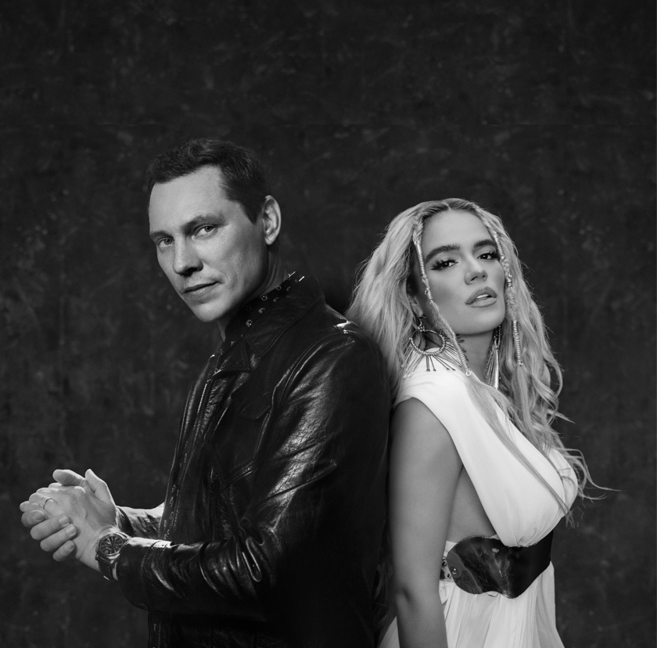

About Tiësto
Tiësto is a Grammy® Award-winning, platinum-certified, international icon. The DJ and producer is the only artist to ever hold the titles of “The Greatest DJ of All Time” courtesy of Mixmag, “#1 DJ” according to Rolling Stone, and “The Godfather of EDM,” as proclaimed by Billboard. From his underground dance floor bangers to his high-profile Las Vegas residency and crossover success, Tiësto created the blueprint that defines what it means to be a success in today’s dance music world. In Tiësto's true fashion, he continues expand across genres, always evolving his craft. With over 36 million albums sold, 8 Billion cumulative streams, and a social platform with an audience exceeding 30 million fans spanning the globe, he continues to revolutionize the dance music landscape. Tiësto’s latest single—and first release since signing with Atlantic Records—"The Business” has dominated airplay and charts worldwide since its September release, garnering over 1 billion streams to date. It has also held a steady position on Apple & Spotify’s “Today’s Top Hits” & “Today’s Hits” playlists, and hit #1 at US Dance Radio. “The Business” is certified Platinum in 15 countries and gold in 8 countries and has held a place on the Top 10 official singles chart in 10 countries as well as Top 50 on Spotify in 31 countries. Stay tuned for more new music from Tiësto coming this year.

About Karol G
Internationally recognized as the most prominent female artist of the moment, Karol G has become not only a pop culture icon but also an important and influential powerhouse in Latin music globally. She has collaborated with notable artists like Anuel, Bad Bunny, J Balvin, Luis Fonsi, Nicki Minaj, Nicky Jam, Ozuna, Quavo, The Jonas Brothers and many more. She is the singer-songwriter of Latin music’s biggest hits, including “Tusa” with Nicki Minaj, which became the #1 Latin song of 2020, after staying at the helm of all global charts.

Karol G is the winner of a Latin GRAMMY and a multitude of other awards, including 50 Diamond certifications from the RIAA in the United States. With so many indispensable achievements, the superstar has made a seamless transition into international markets, breaking language barriers and dismantling stereotypes. Closing 2020, she was proclaimed the #1 Latin artist in the world for the second year in a row by Billboard. Karol G is one of the top-selling female artists, with more than 20 billion streams globally and more than 80 million fans across social networks.

Further asserting herself as an international powerhouse, her most recent album, “KG0516” made history with the biggest debut for a Spanish album by a Latin female artist. The album seized the #1 spot on Spotify's "Top Global Album Debuts," Apple Music's "Top Latin Albums" and Billboard's "Top Latin Albums." Becoming the best performing album in Spanish by a Latin female act, “KG0516” closed its first week of release with more than 24 thousand units sold, and currently has more than 11 billion combined audio and video streams across digital music platforms.

CONNECT WITH TIËSTO:
Instagram | Facebook | Twitter | Spotify| YouTube

CONNECT WITH KAROL G
Instagram | Facebook | Twitter | Spotify | YouTube

FOR MORE INFORMATION:
Cara Hutchison
Cara.Hutchison@ledecompany.com

Paige Rosoff – Atlantic Records/Big Beat Records
Paige.Rosoff@atlanticrecords.com

